Jackson Center Presbyterian Church
July 26, 2026 9th Sunday after Pentecost

Pastor Bill Spangler Organist – Jane Buckley
Welcome/Announcements
Prelude "

Call to Worship
L: Do not be afraid, little flock, for it is your Father’s good pleasure to give you the kingdom.
P: We gather to store up treasures in heaven, where our hearts are securely kept.
L: Be dressed for action, with your hearts awake and your lamps lit.
P: We watch and wait, alert to God's unexpected arrival in our midst.
L: Let us worship the One who comes to serve us and guide our feet in peace.
P: Come! Let us worship the Lord together!

*Hymn of Praise What a Friend We Have in Jesus #435
*Prayer of Confession (in unison, followed by a moment of silence)

God of Redemption, You, call us to wash ourselves clean, so that our transgressions fall away. May we cease doing evil, learn to do good, and seek justice. You call us to rescue the oppressed, defend the orphan, and plead for the widow. May we not forget these responsibilities you’ve set before us. We are grateful for the reminder from the prophet Isaiah that, though our sins are like scarlet, you’ll make us like snow! Even though they are red like crimson, you make them like wool! May we be obedient and willing followers, pleasing unto you. Amen.

*Assurance of Pardon
*Gloria Patri #623
Children’s Sermon

Presentation of our Tithes and Offering
""
*Doxology #625
*Dedication

Pastoral Prayer and the Lord’s Prayer

*The Apostles’ Creed (#12 little blue book)

Old Testament Lesson Psalm 91

*Hymn of Preparation Sweet Hour of Prayer #433

New Testament Lesson Colossians 4: 1-6, Matthew 6:9-16

Morning Message Before You Speak

*Closing Hymn Take My Life and Let it Be (v; 1,3,6) #379

*Benediction
*Musical Benediction "God Will Take Care of You"
*Organ Postlude

*Those who are able to stand comfortably, may do so
(Please silence your devices for worship)

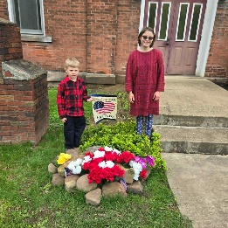
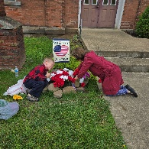
Jackson Center Presbyterian Church
1227 Franklin Rd. PO Box 66
Jackson Center, Pennsylvania 16133

Pastor Bill Spangler
Call/Text (724) 300-0396
sportsboi854@gmail.com
jcpc66@outlook.com

Social Media/Website
http://www.thejcpcpa.com

Church Staff:

Ministers: All members
Lead Pastor: Bill Spangler
Clerk of Session Jan Lawrence
Organist/Pianist Jane Buckley

The Session of Elders:
Bill Spangler (Pastor), Jan Lawrence (Clerk of Session), Ellen Swartz, Paul Buckley, Wayne Mittelmeier

The Deacons:
Jane Buckley, Abbey Clark, Evelyn Boggs, Barb Dye

Membership at JCPC
Becoming a member of Jackson Center Presbyterian Church only requires a public profession of faith in Jesus Christ. To learn more about membership at JCPC, feel free to contact Pastor Bill.

