Jackson Center Presbyterian Church
June 7, 2026 2nd Sunday after Pentecost

Pastor Bill Spangler Organist – Jane Buckley
Welcome/Announcements

Prelude "Simple Gifts"

Call to Worship
L: Joy comes to those who hope in God.
P: For the Lord is a Keeper of promises.
L: Our God is a God of healing and help and hope!
P: The Lord will reign forever; our God will keep faith with all
generations.
L: Let us praise the Lord both now and forevermore!
ALL: Let us Worship God!

*Hymn of Praise For, the Beauty of the Earth #560

*Prayer of Confession (in unison, followed by a moment of silence)

Holy and merciful God, in your presence we confess our sinfulness, our shortcomings, and our offenses against you. You alone know how often we have sinned in wandering from your ways, in wasting your gifts, in forgetting your love. Have mercy on us, O Lord, for we are ashamed and sorry for all we have done to displease you. Forgive our sins, and help us to live in your light, and walk in your ways, for the sake of Jesus Christ our Savior. Amen.

*Assurance of Pardon
*Gloria Patri #623

Children’s Sermon Marilyn and Marmee Snyder

Presentation of our Tithes and Offering
"Jesus Is the Sweetest Name I Know"

*Doxology #625
*Dedication

Pastoral Prayer and the Lord’s Prayer

*The Apostles’ Creed

Old Testament Lesson Isaiah 40:28-31

*Hymn of Preparation Fairest Lord Jesus #88

New Testament Lesson 1 Peter1: 1-12

Morning Message “Praise to God for a Living Hope”

*Closing Hymn Joyful, Joyful, We Adore Thee #1

*Benediction
*Musical Benediction "God Will Take Care of You"
*Organ Postlude

*Those who are able to stand comfortably, may do so
(Please silence your devices for worship)
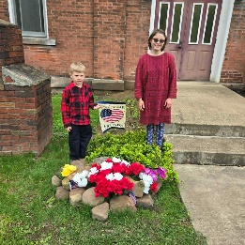
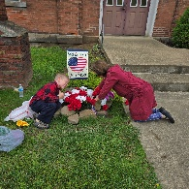
Jackson Center Presbyterian Church
1227 Franklin Rd. PO Box 66
Jackson Center, Pennsylvania 16133

Pastor Bill Spangler
Call/Text (724) 300-0396
sportsboi854@gmail.com
jcpc66@outlook.com

Social Media/Website
http://www.thejcpcpa.com

Church Staff:

Ministers: All members
Lead Pastor: Bill Spangler
Clerk of Session Jan Lawrence
Organist/Pianist Jane Buckley

The Session of Elders:
Bill Spangler (Pastor), Jan Lawrence (Clerk of Session), Ellen Swartz, Paul Buckley, Wayne Mittelmeier

The Deacons:
Jane Buckley, Abbey Clark, Evelyn Boggs, Barb Dye

Membership at JCPC
Becoming a member of Jackson Center Presbyterian Church only requires a public profession of faith in Jesus Christ. To learn more about membership at JCPC, feel free to contact Pastor Bill.

