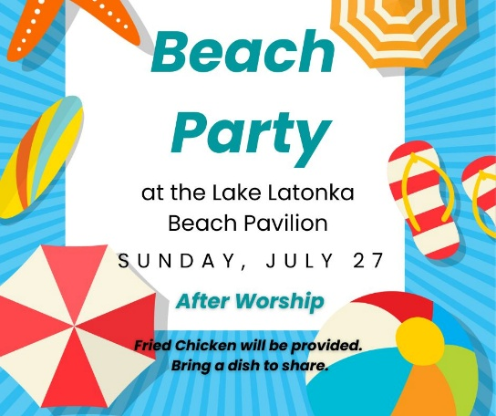

**Save the Date**

**July 31** Urban Plunge, 2025

**Leading in Worship**

Pastor Bill Spangler

Rev. Dr. Catherine Craley

Organist Jane Buckley

**Nursery**

Children are always welcome in our worship service. We also have a nursery available during the 10:00 a.m. worship service.

**Adult Sunday School Class**

Join us for a Sunday Morning Adult Sunday School class from 9:00 a.m. – 9:45 a.m.  in the downstairs fellowship hall. All are welcome.

**“Get the Scoop”**

Want the "scoop" on Trinity’s Capital Campaign or the projects we have lined up for this summer? Click the "Get the Scoop" button in the Weekly Update. We will keep that information updated for you as we progress. You can also find this information on Trinity's website under the "About" page.

***CHRISTMAS IN JULY***

***July 27, 2025 10:00 A.M.***

***GATHERING IN GOD’S NAME***

*For life that reminds us how fragile*

*we are and also how strong we can be:*

*Glory to God in the highest.*

**Piano Prelude** "Good Christian Men, Rejoice" Medieval Hymn, arr. Hugh Livingston, Jr.

**Organ Prelude** "Greensleeves" 16th Century English Hymn arr. Carl Simone

**Welcome and News of the Church Family**

**Lighting of the Christ Candle**

**Responsive Call to Worship**

**L:** The people who once lived in darkness have been given a great light!

**P:** **Praise be to God who has heard our cries.**

**L:** Our souls sing out God’s praise!

**P: God has brought us a light of Hope and Peace.**

**L:** Today, in this place, the Light of God’s Love is given to us!

**P:** **And we shall see that light and let it shine through our lives. AMEN.**

**\*Hymn of Praise #145** “O Come, All Ye Faithful”

**Christmas Prayer of Confession** *(unison)*

**Lord of Christmas Peace, we have done wrong. We have tarnished the gift you gave freely. We have buried you so deeply in our hearts, the world doesn't see you. We have not followed Christ, we have ignored your teachings, we have lived lives of apathy against your love, we have built fences and fortresses to push people away, and we have silenced the screams of those in need. Forgive us. Free us to a life lived in Joy through Jesus Christ our Lord. Amen.**

**Silent Prayer**

**Assurance of Grace** *(unison)*

**No matter how challenging life becomes, Jesus is always near, ready to support and guide us, offering His grace and strength. In Jesus Christ, we are forgiven. Thanks be to God!**

**\*Gloria Patri** “Gloria Patri” Greatorex

**Children’s Message**

**Moment of Offering and Thanksgiving:**

**Prayer of Dedication**

**\*Doxology** “Doxology” Old Hundredth

**Special Music** "Infant Holy, Infant Lowly"W. Lezy,arr. Lloyd Larson

*Combined Hand Bell Choir, Cary Cooper, director*

**Pastoral Prayer and the Lord’s Prayer**

***HEARING GOD’S WORD***

**First Scripture Reading** Isaiah 9:2-7

**Hymn of Preparation #157** “Away in a Manger”

**Second Scripture Reading**  John 8:12-19

**Meditation** “The Birth of a King” Pastor Bill Spangler

**Service of Lights**

***GOING IN GOD’S GRACE***

**\*Closing Hymn #125** “Joy to the World”

\***Benediction** And let all God’s people say…**Alleluia, Amen**

**\*Postlude** "Hark! The Herald Angels Sing" Mendelssohn arr. Stanley E. Paxton

