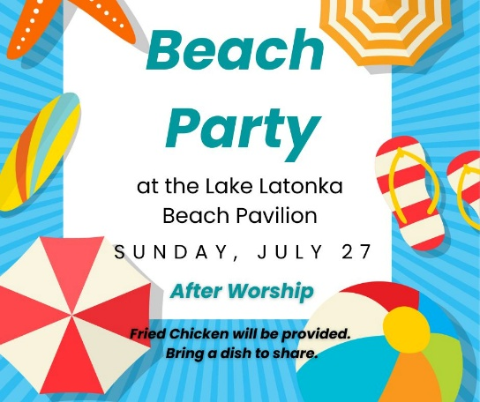

**Save the Date**

**July 27** Beach Party at Lake Latonka after Worship for Trinity and Jackson Center.

Fried chicken will be provided. Please bring a dish to share.

**“Get the Scoop”**

Want the "scoop" on Trinity’s Capital Campaign or the projects we have lined up for this summer? Click the "Get the Scoop" button in the Weekly Update. We will keep that information updated for you as we progress. You can also find this information on Trinity's website under the "About" page.

**Trinity’s Weekly Update**

If you’d like to receive the Trinity Presbyterian Church Weekly Update email, please email the Trinity Church office at [trinitymercer@hotmail.com](mailto:trinitymercer@hotmail.com) to sign up.

**Adult Sunday School Class**

Join us for a Sunday Morning Adult Sunday School class from 9:00 a.m. – 9:45 a.m.  in the downstairs fellowship hall. All are welcome.

**Nursery**

Children are always welcome in our worship service. We also have a nursery available during the 10:00 a.m. worship service.

***FOURTH SUNDAY AFTER PENTECOST***

***July 6, 2025 10:00 A.M.***

***GATHERING IN GOD’S NAME***

We come to you hungry, O God, our Provider.

Sit us down. Quiet our minds and hearts. Feed us.

Nourish us in this holy place that we may be filled with you. Amen.

**Piano Prelude** "Mine Eyes Have Seen the Glory" Wm. Steffe , arr. Lani Smith

**Organ Prelude** “Let There Be Peace on Earth” Sy Miller and Jill Jackson

**Welcome and News of the Church Family**

**Responsive Call to Worship**

In worship, we meet the world head on.

**In the midst of seeming scarcity, we find abundance.**

**In the midst of harsh critique, we find acceptance.**

In the midst of a frantic busyness, we find a spacious … silence …

**And in the midst of a world that can seem so unkind, we find the greatest love.**

The Bread of Life is with us!

**Let us worship the living God!**

**\*Hymn of Praise #571** *(vs. 1-4)* “My Country, ‘Tis of Thee”

**Prayer of Confession** (*unison)*

**Gracious and merciful God, we complain that we don’t have enough, yet what you offer us is more than enough. We doubt that you will provide what we need, yet you give nourishment in abundance each day. We forget to trust you and attempt to rely on ourselves alone. Bread of Heaven, rain down, that we might be fed and forgiven. Hear us, O Lord, as we confess to you in silence, of an area in our lives where it is hard to trust you to provide for us.**

**Silent Prayer**

**Assurance of Grace**

Hear the Good News of the Gospel, in Jesus Christ, we are forgiven. Thanks be to God!

**O God, you provide for us in abundance. Our blessings overflow!**

**\*Gloria Patri** “Gloria Patri” Greatorex

**Children’s Message**

**Commissioning of the Alaska Mission Team**

**Moment of Offering and Thanksgiving:**

**Prayer of Dedication**

**\*Doxology** “Doxology” Old Hundredth

**Pastoral Prayer and the Lord’s Prayer**

**Special Music** "America, the Beautiful"             arr. Lani Smith

*Jane Buckley, piano, and Jim Sankey, organ*

***HEARING GOD’S WORD***

**First Scripture Reading**

**Hymn of Preparation** “This is My Song” see insert

*to the tune “Be Still My Soul”*

**Second Scripture Reading**

**Meditation** Rev. Dr. Catherine Craley

***GOING IN GOD’S GRACE***

**\*Closing Hymn** “Five Thousand Folks Were Following Jesus” see insert

\***Benediction** And let all God’s people say…**Alleluia, Amen**

**\* Organ Postlude** "God Bless America"             Irving Berlin

**About Today's Postlude**

"God Bless America" was first performed by Kate Smith on her radio show on November 10, 1938 the day before Armistice Day, the holiday that commemorated the 20th anniversary of the end of World War I. Smith wanted to sing a new patriotic song and approached composer Irving Berlin, who dug out and revised the lyrics to a tune he had written 20 years earlier for a musical revue but then had decided not to include it. The resulting song, “God Bless America,” became an instant hit.

Armistice Day was proclaimed by President Woodrow Wilson in 1919; Congress passed a law in 1938 to make it a legal holiday, then changed the name in 1954 to Veterans Day to include all veterans.



**Leading in Worship**

Rev. Dr. Catherine Craley

Pastor Bill Spangler

Organist Jane Buckley

Organist Jim Sankey

**Dr. Craley on Study Leave**

Dr. Craley will be away on Study Leave starting tomorrow Monday, July 7 - Sunday, July 13. If you need assistance with a pastoral emergency during her absence, please call the Trinity church office (724-662-2680) or Dr. Craley's cellphone using the number listed in the directory.

**Please Keep Our Alaska Mission Team in Your Prayers**

Jeff and Marcia Colson

Ginny Highfield

Laurie Mahen

Debbie Moose

Michael Moose

Walt and Luanne Rock

**Men’s Breakfast**

All men are welcome to join us for a Men’s Breakfast at Jackson Center Presbyterian Church on Saturday, July 19, at 8:00 a.m.

**Urban Plunge 2025, July 31st**

On Thursday, July 31st, our youth are invited to join us for a day serving in the city of Pittsburgh. We will spend the morning cooking and serving a meal to about 150 neighbors at the East End Cooperative Ministry in East Liberty. After serving, we will learn more about the ministry from its Director, Rev. Darnell Leonard. Then, we will head out for a late lunch in the neighborhood. Our adventure is open to rising 7th graders and above. This includes our college students and young adults! We plan to be together from 7:30 a.m. - 4:00 p.m. Space is limited so sign up today using the link in our Weekly Update. Thanks to the Watsons for the gift of our transportation.

**Five Thousand Folks Were Following Jesus**

Five thousand folks were following Jesus,  
Five thousand folks were following Jesus,  
Five thousand folks were following Jesus,  
It was dinner time!

Five barley loaves and two fishes,  
Five barley loaves and two fishes,  
Five barley loaves and two fishes,  
That is all we have!

Give it to the Lord and He will use it,  
Give it to the Lord and He will use it,  
Give it to the Lord and He will use it,  
It’s enough for Him.

Break the bread and thank the Father,  
Break the bread and thank the Father,  
Break the bread and thank the Father,  
Pass the food around.

Twelve full baskets were left over,  
Twelve full baskets were left over,  
Twelve full baskets were left over,  
More than enough for everyone!

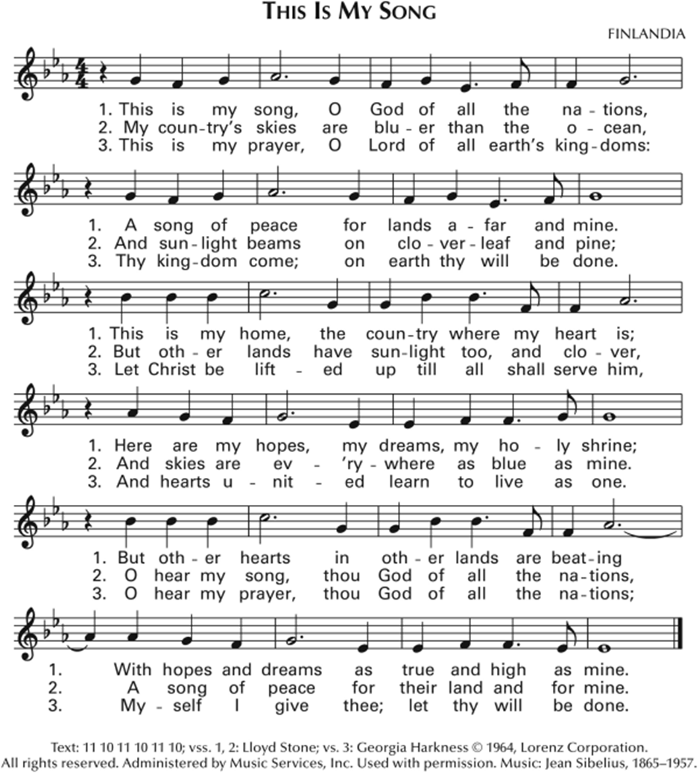

**Five Thousand Folks Were Following Jesus**

Five thousand folks were following Jesus,  
Five thousand folks were following Jesus,  
Five thousand folks were following Jesus,  
It was dinner time!

Five barley loaves and two fishes,  
Five barley loaves and two fishes,  
Five barley loaves and two fishes,  
That is all we have!

Give it to the Lord and He will use it,  
Give it to the Lord and He will use it,  
Give it to the Lord and He will use it,  
It’s enough for Him.

Break the bread and thank the Father,  
Break the bread and thank the Father,  
Break the bread and thank the Father,  
Pass the food around.

Twelve full baskets were left over,  
Twelve full baskets were left over,  
Twelve full baskets were left over,  
More than enough for everyone!