

Change of Bank Details

Client ABN/ACN:

Business Owner Name:

“I give authority to SMTA Mobile Tax Accountants to change my bank details on my ATO profile as the following”

BSB:

ACC:

Name:

Bank Name:

Date:
Signature

Should you have any questions regarding this letter please contact us at email admin@smta.com.au | 1300 032 752

Please send a signed copy to the above and we will initiate the process.

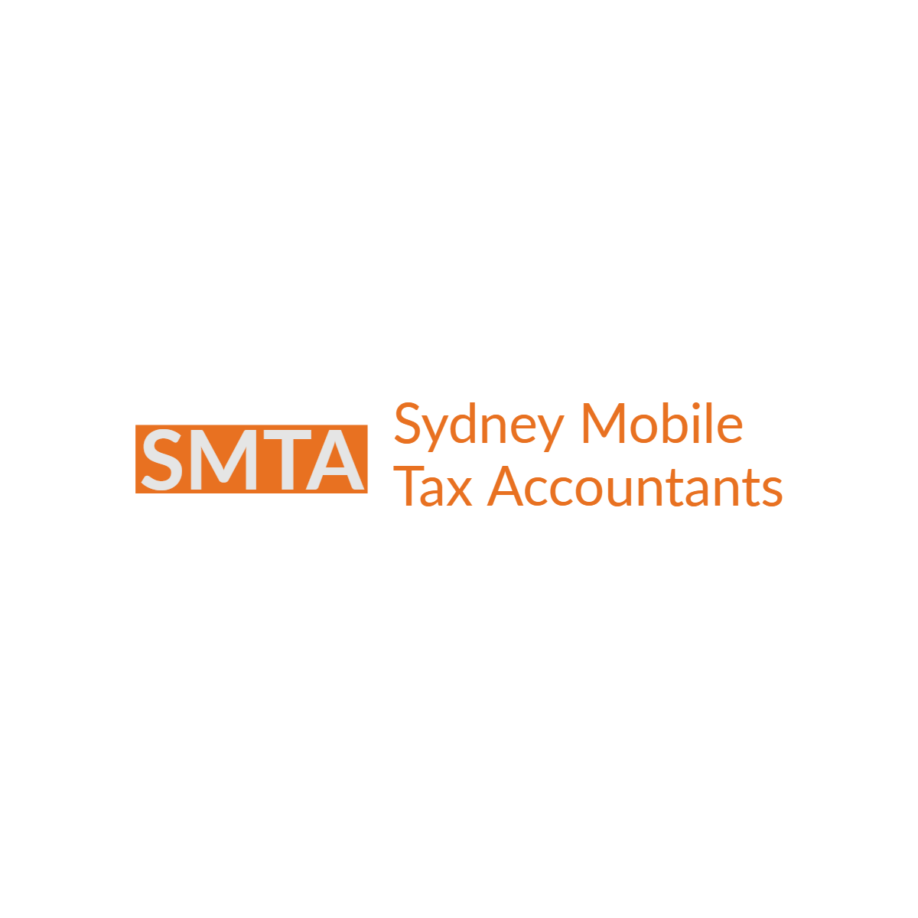

Tel: 1300 032 752 | A: 1/40 Harris Street, Fairfield NSW 2165 | ACN: 661914450| W: www.smta.com.au | E: admin@smta.com.au

