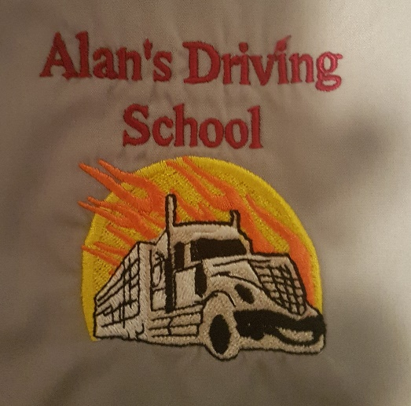 | Head Office  123 Duke Avenue  Portage La Prairie  MB, R1N 0S5  1-204-930-2473  Training Location: -  64143, Road 41W/Simplot Rd  Box 472  Portage La Prairie  R1N 3B7

Training Application

Applicant Information
Full Name: |  |  |  | Date:
 | Last | First | M.I.

Preferred name:

Address:
 | Street Address | Apartment/Unit #

 | City | Province | Post Code

Phone: |  | Email

Cell: ___________________________________

Driving License Number ________________________ D.O.B___________SIN ____________
NOTE. A deposit of $400 is required to reserve you spot for the next course. This is NON-Refundable.

I certify that my answers are true and complete to the best of my knowledge.

Signature: |  | Date:

