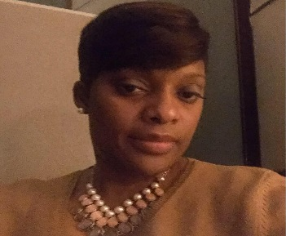

Greetings Women Elevated,
I am Aaron, Annquarnette, I was born and raised in Chicago, IL on 16 September 1972 to Patricia and Clifford Wilson. I am the second oldest of 7 children and have seven nieces and nine nephews. I spent my teenage and young adult years in Decatur, Georgia, from 1989-1993. I am happily married to SFC Aaron, Michael Julian, with four lovely children of GOD: NaJee 19, Tyler 18, Kiya 17, and Justice 12.
I enlisted for active duty in November 1994 as a 91B. I enlisted to get away from my high school and college sweetheart in which was a result of an abusive relationship. My duty assignments include 123rd FSB, 1st AD, Dexheim Germany, Medical Troop RSS 2nd ACR, FT. Polk, LA, 86th Combat Support Hospital, FT. Campbell, KY; USA MEDDAC, FT. Eustis, VA, St. Louis, Military Enlistment Processing Station (MEPS), ST Louis, MO, and currently assigned to 86th CSH, 501st Area Support Medical Company (ASMC), FT. Campbell, KY.
A veteran to deployments, has served three tours to the Balkan Region; Task Force Eagle, Task Force Falcon and Task Force Bourgas. Three tours in the Middle East, in support of Operation Iraqi Freedom.
Military Education: Warrior Leaders Course (WLC), Advance Leaders Course (ALC), Senior Leaders Course (SLC), Alcohol Drug Abuse Treatment (ADAT), Master Fitness Trainer (MFT), Emergency Medical Technician-Basic(EMT-B), Equal Opportunity Representative Course(EOR), Master Driver Trainer Course (MDT), Hazmat and Master Resiliency Trainer Course (MRT), Sexual Harassment Assault Response Prevention (SHARP) Course, Basic Health Care Science Pilot- Program Course, Casualty Assistant and Notification Officer Course, First Sergeant and Commander’s Leadership Course.
Civilian Education: AAS General Studies from Central Texas Community College; AAS Liberal Arts from Austin Peay State University; Basic Health Care Science Certificate Program from Baylor University; Professional Degree Completion, Bachelor of Health Sciences (Cum Laude) from TUI University.
Hobbies: Writing poetry, reading, mentoring youth and motorcycle riding.
Show of Interest: I desire to collaboratively work with joint-service veteran women of all ethnicities. I aim to provide maximum support in transitioning from active duty service to a civilian way of living. The idea of working together for a common goal in understanding the transition process allows us to create lasting bonds. The direct interaction with other sisters serve as a conduit in shaping future transitional successful outcomes. Most importantly I would like for Women Elevated (WE) to exceed expectations in making its mark in the present and future while establishing a lasting imprint.
Sincerely,

