**Supply List 2020**

**In general, if you have already your own supplies, use them, as long as you know they are in a good quality, for maximum fun and best results. The instructor believes in “LESS IS MORE”, you can up grade any time you like later.**

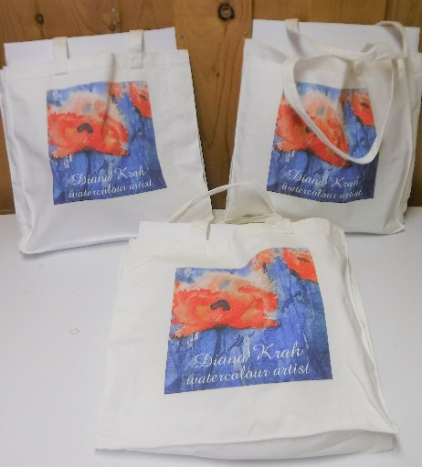**Please bring to the workshops:  
  
For your convenience:   
Ready to start painting, art supply kits!**Exclusive to Diana Krah art students. **No Hassle Supply Kit  
Everything you need to start painting,  
in good quality, CND $ 85,oo  
Artist Kit  
Everything you need + Specialty brushes, more paper, more paints CND $ 125,oo  
  
Pre order – kits will be brought to the live workshops!**

**Supply list:  
For sketching and notes**  
**Pencil, sharpener, eraser, type writing paper and/or sketch book**

**Paints   
Colours are often named differently depending on the brand.   
Please bring 3 primary watercolours in transparent property!   
(Cobalt blue, Alizarin Crimson, Aurelian Yellow)**

**For advanced workshop: “Technique that inspires.”   
Please bring 5 or more colours + neutral tint and Chinese white!  
(Raw sienna, lemon yellow, phalo blue, transparent orange, red ochre, sepia, yellow ochre, opera pink, red magenta, dioxane purple, green gold, phalo turquois + others, are some of my favorite colours, but it is your choice to up grade as you please)**

**In general, if you have a warm and a cool version of red/blue/yellow, then you will have a great start.**

**Recommend paint brands are:   
Windsor Newton & Cotman, Schinke, Holbein, QOR, Daniel Smith.**

**Brushes   
Please bring ONLY “watercolour brushes”!!!!! Synthetics are fine, in a good quality.   
No oil or acrylic brushes, please!**

**1 x smaller round brush size 8, 9, 10 synthetic watercolour brush  
1 x larger round brush size 12, 14 or 16 synthetics   
Make sure the brushes have a nice pointy tip!**

**Specialty brushes: For advance workshop: “Technique that inspires.”  
Dagger striper, rigger/liner brush, flat brush or mop brush. Less is more, but in good quality!**

**Recommended brand: Princeton, but a good supply store has others, too.**

**Paper  
Watercolour cold press rough, minimum 140 lb per square inch.  
Please bring several sheets, size minimum letter size and larger.   
Recommended brand: Arches**

**Please use cheap, light weight paper only for colour swaps or sketching!**

**Miscellaneous supplies   
Painters tape = to fix the paper on to the board (3M, green) works great  
Board = can be wood or plastic (should be sturdy and have smooth surface) a bit larger than letter size, bring 2 or 3 boards to tape the paintings to, makes work easier.  
Water container = 2 water containers  
Mixing pallet  
Paper towel   
Sponge household**

**For advanced workshop: “Technique that inspires.”  
Household salt fine, plastic old credit card, ceran wrap or gift card, plastic spoon, sponge**

**Supplier:  
Edmonton = Delta art supplies, The Paint Spot, Michael’s  
Online = Blick Art Supplies, Cheap Joe’s**

**Please note:**

**During the live workshops participants will have the opportunity to buy extra  
paper, brushes, paint refills, boards, specialty brushes and other. Cash only.  
As long as quantities last.**

**Order your supply kit = click here**