2021-2021

**1080 Pat’s Lane, Suite 4  
Conway, AR 72032  
(501) 358-6363  
Pre-K Supply List**

**$15 Supply Fee (Due each semester/ quarterly)**

**2 Boxes Crayons (8-count)**

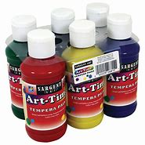**6 Glue sticks and 1 bottle of glue**

**1 Art-Time Paint Set, 6-pack (less than $6)**

**1 Box of Ziplock bags (quart-size)**

**2 Lg Pack of Construction paper**

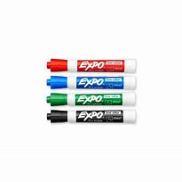**2 Kindergarten practice writing tablets**

**1 Box Markers**

**1 Package of Dry erase markers (4-Pack)**

**1 Roll Paper towels**

**5 Plastic folders w pockets**

**2 Packs of Baby wipes (quarterly)**

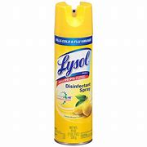**2 Boxes of Tissue (quarterly)**

**1 Bottle of Disinfecting Spray (quarterly)**

**1 Tube of Sunscreen**

**Personal Items (Label each item)**

**1 Complete change of clothes**

**1 Backpack labeled with child’s name (regular-sized, no wheels)**

**1 Labeled water bottle**

**1 Small blanket AND fitted crib sheet/cot sheet for rest-time**

**(Blankets and sheets go home on Fridays to be washed by parents and are needed back at the center each Monday)**