

COACH RON GUNN’S
ANNUAL (INCREDIBLE)
ALOHA HANG LOOSE
HAWAIIAN FANTASY RUN/WALK
Dowagiac, Michigan

MONDAY
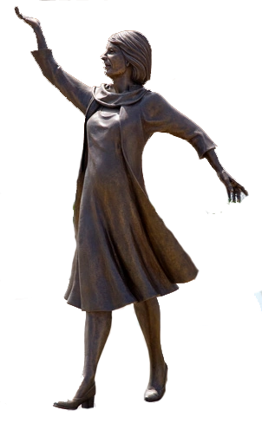
JAN 1
10:00AM

DISTANCES: 6.0 to 7.0 Mile Feature (for those who can handle the hot sun).
5.2 Mile Novice (for those who need a trailing trade wind).
3.2 Mile Fun (for those who had too many Mai Tais).
DIVISIONS: Run or walk for Kane, Wahine and Keiki (men, women, and children).
COURSE: Flat, scenic course that winds it’s way through the Hawaiian Islands, including Volcanoes National Park, Diamond Head, Haleakula, and Kaanapali (hilly, treacherous roads and trails around the Dowagiac area).
ENTRY FEE: Donations to the Track Coaches Retirement Center on Kaanapali Beach (voluntary donation to the Dowagiac Elks Veterans charity).
AWARDS: Leis for those who run wiki wiki in their division. (Leis, really!)
REGISTRATION: Race is limited to the first 50,000 to appear at Ala Moana Park in Nike flip flops. (Check in at Dowagiac Elks Club. Modern restrooms available)
START: Start at 10:00AM with the traditional blowing of the Conch Shell.
WAIVER: All participants must use a sun lotion with SPF of at least 30 and bring a certificate for falling coconut insurance (sign waiver for treacherous conditions).
SPONSOR: Hawaiian Airlines (Dowagiac Elks Lodge)
REHYDRATION: This year's run/walk will again have a post race luau and a cash bar available. Please bring a dish to share and plan stay after your run/walk for some great food and fellowship.
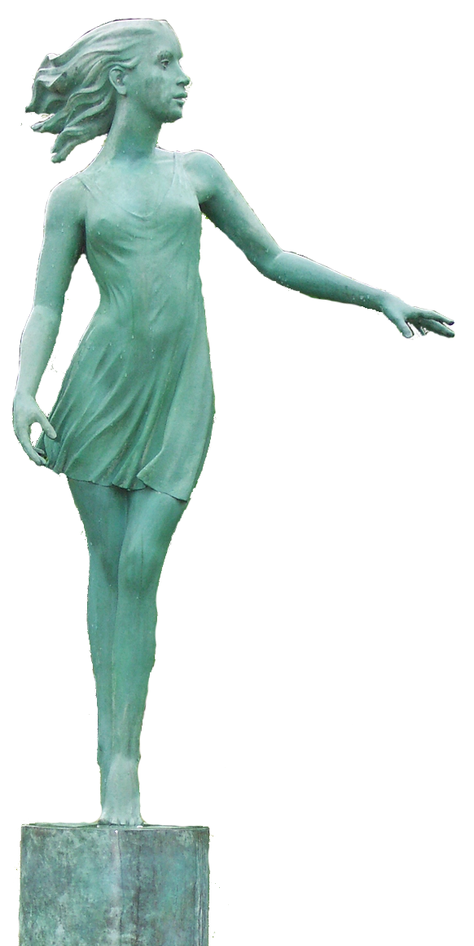
PURPOSE: This is a fun and positive way to start the New Year on an upbeat fitness note before settling down to watch that minor sport on TV. This is a lowly organized fun run and walk. There will be no traffic control and probably no aid stations. No results will be recorded and times will be called if the race director isn’t busy doing the hula.
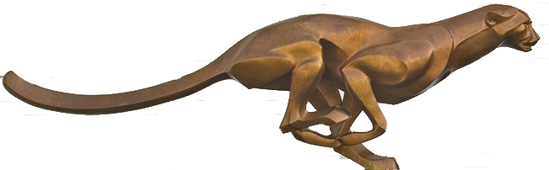
FIRE UP!

(MORE ON PAGE 2)
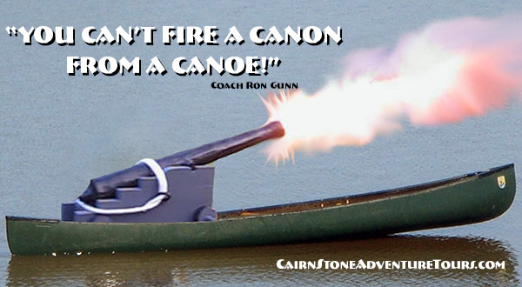

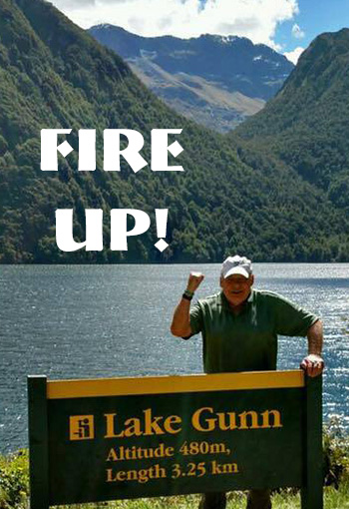
LOCATION: The 44th Annual Aloha, Hang Loose, Fantasy Run & Walk starts and finishes at Dowagiac Elks Lodge, 300 Riverside Drive, Dowagiac, MI 49047 (corner of Hill St. & Riverside Dr.).
DIRECTIONS: From the light downtown (E. Division & Front St. & M51 & M62) go east on Division about 0.5 miles (5 blocks) to Riverside Drive, south on Riverside to Hill St. If coming north on M62 from Cassopolis turn south on Riverside Drive about 0.3 miles past VFW/Colby St.
COURSE: If the weather allows we will have the courses include a portion of the beautiful Roadrunner trails. In case of a tsunami we will use the 7.1 mile Dowagiac Sculpture course.
POTLUCK: Resumes this year! Masks, distancing and hand washing are common sense precautions that are encouraged, we will resume our traditional post run/walk potluck lunch and fellowship. Bring a favorite dish to share and plan to connect or reconnect with fellow runners and hikers.
DONATIONS: If you are unable to attend but wish to donate to support our Veterans please send a check payable to; Dowagiac Elks with Veterans on memo line and mailed to the address above. Muchos Gracias!
The Spirit of Aloha
“During my first trip to the Hawaiian Island many years ago I was hiking with young son Jeff along the Black Sand Beach. We stopped to rest at a bench and out of nowhere a Hawaiian woman appeared and gave Jeff a bird figure woven of a reed-like plant and then she simply walked away. This was my first real experience with the spirit of Aloha.
Aloha is the most beautiful word in the Hawaiian language. It means many things depending on how it is said. Most visitors to the Islands think that it means hello, good-by, love or friendship. However, the real meaning goes much farther. Perhaps the best way to describe the meaning of Aloha is listed below:
Aloha means welcome, what I have you may have, share with me.
Loko maikai means what I say comes from my heart. I have good intentions.
Olu olu means happy, happy doing for others, a Hawaiian heritage.
Ha aba a means humility and meekness, we are happy to serve.
Aloha means love, near or far, you are always in my heart.
According to the old Kahunas (priests) Aloha literally means Divine breath of life. What a beautiful expression! So the next time someone tells you Aloha, remember what the original meaning is: 'God has breathed in us the ultimate Aloha, His Holy Spirit,' how wonderful!”
Coach Ron Gunn

