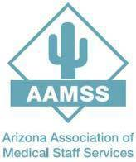 | PROGRAM CONTENT & SPEAKER PROFILES  AAMSS 2026 Fall Conference • November 13, 2026 • Banner Estrella Medical Center
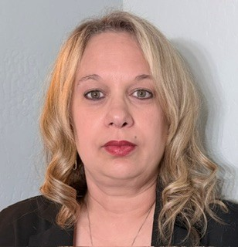 | Kelly Chatlos, MBA, BSHA  Director, Accreditation & Regulatory • Phoenix Children’s
ABOUT THE SPEAKER
Kelly Chatlos, MBA, BSHA, serves as Director of Accreditation & Regulatory at Phoenix Children’s, where she provides strategic leadership and organizational oversight for accreditation and regulatory compliance across the health system. Prior to joining Phoenix Children’s, she served as a Healthcare Accreditation Team Lead Generalist Surveyor with DNV Healthcare, surveying acute care and critical access hospitals for compliance with DNV NIAHO standards and ISO 9001 principles. Her experience includes accreditation readiness, regulatory compliance, quality management, risk analysis, continuous improvement, and organizational change.
PRESENTATION
TJC to DNV: Same Goal, Different Approach
SESSION DESCRIPTION
This session will explore the key similarities and differences between The Joint Commission and DNV accreditation models. Participants will gain a practical understanding of how each organization approaches accreditation, standards, surveys, and continuous quality improvement related to the medical staff office. The session will highlight what healthcare organizations can expect when transitioning from The Joint Commission to DNV, including differences in survey methodology, compliance expectations, documentation, and organizational readiness. Attendees will leave with practical insights and strategies to successfully navigate the DNV accreditation process while maintaining a strong focus on patient safety, quality, and regulatory compliance.
LEARNING OBJECTIVES
• Compare the survey processes, methodologies, and approaches used by The Joint Commission and DNV.
• Identify common accreditation requirements and areas where expectations or approaches may differ.
• Recognize how the transition from The Joint Commission to DNV may impact leadership, staff, documentation, and day to day operations.
• Apply practical strategies to prepare for a DNV survey and maintain continuous readiness.
• Explain how DNV’s focus on quality management and continuous improvement supports patient safety and regulatory compliance for the medical staff office.

PROGRAM CONTENT & SPEAKER PROFILES
AAMSS 2026 Fall Conference • November 13, 2026 • Banner Estrella Medical Center
 | Joni Ortiz, CPCS, CPMSM  Corporate Director of Credentialing and Privileging • Community Health Systems
ABOUT THE SPEAKER
Joni Ortiz is a Corporate Director of Credentialing and Privileging, providing leadership and oversight to Medical Staff Offices across a 70-hospital healthcare system. Her career in Medical Staff Services began as a temporary credentialing specialist, and she progressed through leadership roles to her current corporate position. Joni is also a professional bodybuilder and entrepreneur; competing in nearly 30 bodybuilding competitions and earning her professional card have reinforced lessons in discipline, consistency, resilience, and mental toughness that she carries into her professional and personal life.
PRESENTATION
Leading Beyond the Title: The Hidden Influence of Medical Staff Professionals
SESSION DESCRIPTION
MSPs are no longer simply managing processes - they are managing risk, influencing decisions, and driving organizational excellence. This engaging session examines how MSPs can use their expertise and influence to manage risk, strengthen organizational performance, and drive excellence. Through personal stories, practical insights, and interactive reflection, attendees will explore building credibility, navigating difficult conversations, developing confidence, and becoming a trusted strategic partner to physicians and healthcare leaders. Participants will leave empowered to recognize their influence, strengthen their leadership presence, and embrace the responsibility they have in protecting patients and shaping the future of Medical Staff Services.
LEARNING OBJECTIVES
• Identify how the evolving responsibilities of Medical Staff Professionals contribute to managing organizational risk, supporting patient safety, and driving healthcare excellence.
• Describe at least three strategies for leading and influencing physicians, executives, and interdisciplinary stakeholders without relying on formal authority.
• Apply practical strategies for building professional credibility, navigating difficult conversations, and strengthening confidence in high-pressure leadership situations.
• Recognize opportunities within their current roles to expand their influence, demonstrate leadership, and serve as strategic partners in advancing Medical Staff Services.

PROGRAM CONTENT & SPEAKER PROFILES
AAMSS 2026 Fall Conference • November 13, 2026 • Banner Estrella Medical Center
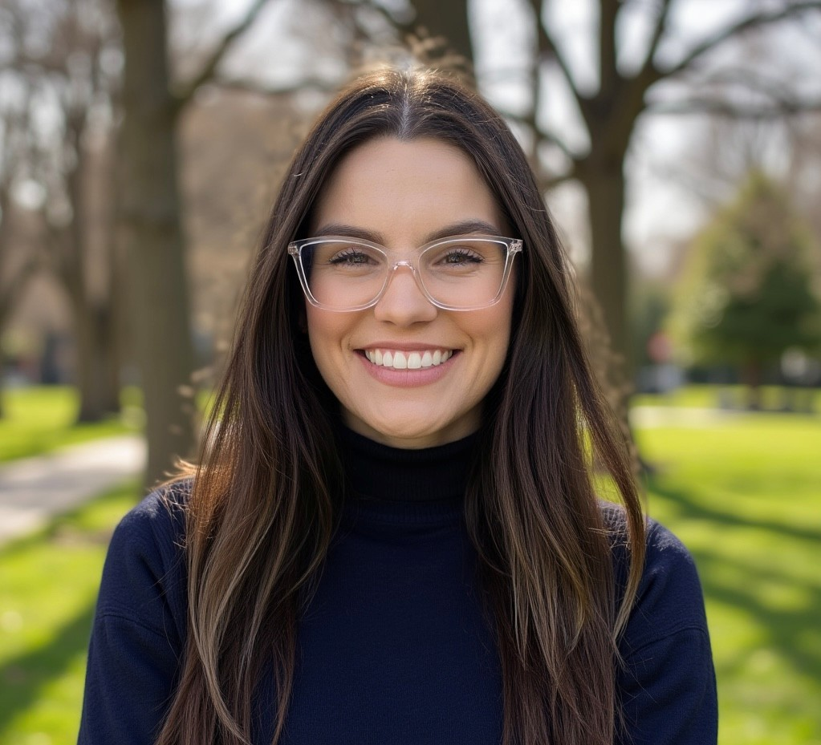 | Mallory Stoff, MS  Peer Review Program Manager • Phoenix Children’s
ABOUT THE SPEAKER
Mallory Stoff, MS, serves as Peer Review Program Manager at Phoenix Children’s, where her work supports practitioner performance evaluation and peer review processes. Her session brings a practical, systems-focused approach to building OPPE and FPPE processes that are meaningful, sustainable, and responsive to organizational data and capabilities.
PRESENTATION
OPPE & FPPE That Actually Work: Building a Meaningful & Sustainable Performance Process
SESSION DESCRIPTION
Operationalizing OPPE and FPPE can be challenging. Organizations must balance regulatory expectations with meaningful performance measurement, data limitations, specialty-specific needs, physician engagement, and sustainable workflows. There is no single set of metrics or processes that works for every organization. This session explores practical strategies for integrating OPPE and FPPE into a meaningful, sustainable performance evaluation process. We will explore how to select appropriate measures, recognize data limitations, interpret performance signals, and determine when focused evaluation may be warranted. Through practical examples and lessons learned, attendees will gain strategies for building processes that move beyond compliance while evolving with their organization’s data, processes, and capabilities.
LEARNING OBJECTIVES
• Differentiate the roles of OPPE, peer review, and FPPE within a comprehensive provider performance evaluation process.
• Evaluate potential performance measures by considering clinical relevance, data reliability and limitations, attribution, volume, benchmarking, and intended use.
• Apply a structured approach to interpret performance signals and determine when additional review or focused evaluation may be warranted.
• Identify strategies for developing sustainable performance evaluation processes through effective governance, interdisciplinary collaboration, physician engagement, and alignment with organizational capabilities.

PROGRAM CONTENT & SPEAKER PROFILES
AAMSS 2026 Fall Conference • November 13, 2026 • Banner Estrella Medical Center
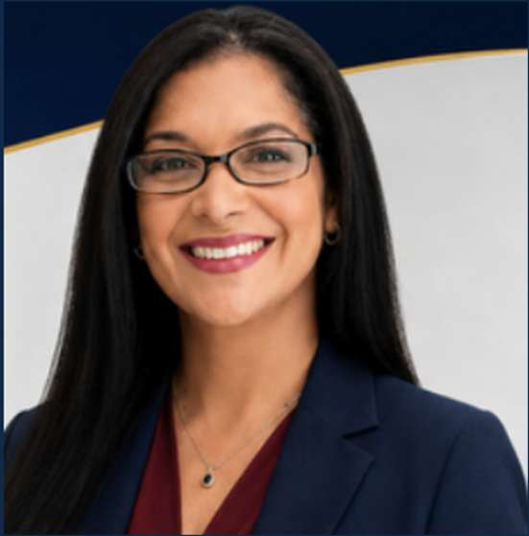 | Mia Perez-Arroyo, Esq.  Civil Rights & Health Law Litigator • Former California DOJ Lead Prosecutor • Tribal Court Judge
ABOUT THE SPEAKER
Mia Perez-Arroyo, Esq., is an attorney, judge, educator, and former California Department of Justice Lead Prosecutor. During approximately twenty years as a California Deputy Attorney General, she represented the State of California in complex healthcare regulatory, licensing, disciplinary, and civil litigation involving multiple healthcare-related licensing boards and regulatory entities. Her work included matters involving the Medical Board of California and other regulated healthcare professions, including acupuncture, physical therapy, respiratory care, and additional healthcare disciplines. She evaluated complaints, litigated licensing, and enforcement matters, worked extensively with expert witnesses, and prosecuted professional discipline cases involving patient safety, misconduct, competence, documentation, and regulatory compliance. She currently serves as Chief Judge of the Texas Band of Yaqui Indians and formerly taught Trial Advocacy as an adjunct professor at USC Gould School of Law. She earned her J.D. from UCLA School of Law and has been selected as a panelist for the 2026 UCLA Law Women LEAD Summit.
PRESENTATION
Before Credentialing Goes Wrong: Recognizing Legal Risk Before It Becomes Patient Harm, Regulatory Action, or Litigation
•SESSION DESCRIPTION
Medical Staff Services professionals are often the first - and sometimes the only - people positioned to recognize warning signs before they become patient-safety events, licensing investigations, accreditation findings, peer review disputes, malpractice litigation, or institutional liability. This interactive program uses anonymized case examples, decision points, and practical checklists to help attendees recognize risk earlier, ask better questions, create a defensible record, and escalate concerns appropriately.
The presentation will also address the institutional context in which credentialing decisions occur. Attendees will compare practical considerations affecting practitioners and Medical Staff Services professionals in tribal healthcare facilities, private hospitals, and public/state-operated institutions. The objective is not to suggest that every facility within a category is governed identically. Rather, the session will teach participants to identify the source of authority, understand the applicable framework, recognize when institutional rules may differ, and know when specialized legal guidance is required.
LEARNING OBJECTIVES
• Identify credentialing and privileging red flags that may create legal, regulatory, accreditation, or patient-safety risk.
• Explain how documentation, omissions, and escalation decisions may be evaluated during a licensing investigation or disciplinary proceeding.
• Distinguish peer review confidentiality and privilege concepts from fair-hearing and procedural due-process obligations.
• Apply a structured method for determining when a concern should be escalated to leadership, compliance, risk management, legal counsel, or another governing authority.
• Compare key credentialing and regulatory considerations affecting tribal, private, and public/state-operated healthcare settings without assuming a single uniform framework.
• Use practical lessons from healthcare licensing enforcement to strengthen everyday credentialing and provider-enrollment practice.
PROGRAM CONTENT & SPEAKER PROFILES
AAMSS 2026 Fall Conference • November 13, 2026 • Banner Estrella Medical Center
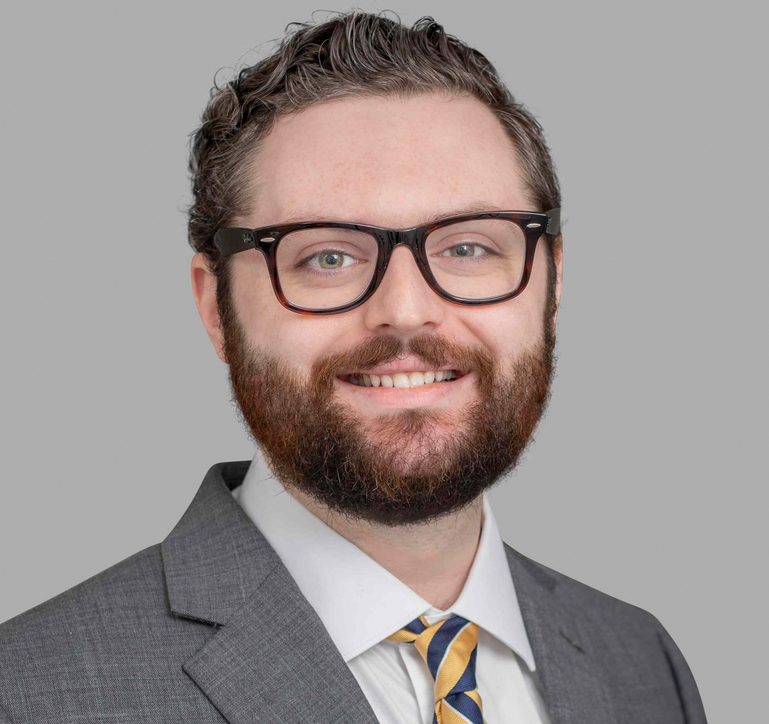 | Jonathan D. Craig-Mendes, JD, DMSc©, MBA, HEC-C  Clinical Ethicist • Banner Health System
ABOUT THE SPEAKER
Jonathan Craig-Mendes is a full-time Clinical Ethicist currently practicing at Banner Health, where he joins a team of professionals with varied backgrounds charged with navigating the conflict and uncertainty that arises in complex medical care environments. In addition to his consultation work, Mr. Craig-Mendes was recently appointed a Professor of Practice at the University of Arizona’s James E. Rogers College of Law, where he teaches on healthcare ethics.
Mr. Craig-Mendes is a lawyer by training, and subsequently attended in-hospital clinical ethics fellowship training at Wellstar Health System in Atlanta, GA. Before this, he participated in the Fellowships at Auschwitz for the Study of Professional Ethics program, where he studied the specific ways doctors and lawyers contributed to the enablement of the holocaust. Prior to his work in ethics, Mr. Craig-Mendes was a Law Fellow at the Manhattan District Attorney, where he worked in the Cybercrime and Identity Theft division of the Investigations Bureau.
PRESENTATION
The Growing Professionalization of Independent Ethics Consultation
SESSION DESCRIPTION
The management of ethical issues and conflicts is an accreditation requirement set by The Joint Commission, but the form that this resolution mechanism takes is left up to individual hospitals and health systems to decide. Solo-practitioner clinical ethics consultation—that is, the use of specifically-trained individuals to provide ethics recommendations and document in the EMR—is a relatively modern development compared to the traditional ethics committee model. Even so, the independent ethicist consult model recently become the standard and recommended format for addressing ethical conflict in healthcare (per the American Society of Bioethics and Humanities).
This session aims to educate members of the Medical Staff Services community on the “how” and “why” of this development and how partnering with independent-practitioner ethics colleagues might provide a myriad of advantages for an attendee’s health system.
LEARNING OBJECTIVES
• Understand the historical development of solo-practitioner clinical ethicists as a specific professional discipline.
• Assess the benefits and drawbacks of the solo-consultant ethics model vs. the ethics committee/subcommittee model.
• Appreciate potential opportunities for inter-disciplinary collaboration between the attendee’s role and that of the solo-practitioner ethicist.

PROGRAM CONTENT & SPEAKER PROFILES
AAMSS 2026 Fall Conference • November 13, 2026 • Banner Estrella Medical Center
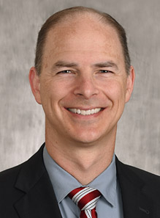 | Nathan Page, MD  Medical Staff President • Phoenix Children’s
ABOUT THE SPEAKER
Nathan Page, MD, FAAP, earned a degree in Linguistics from Brigham Young University and his medical degree from Washington University School of Medicine in St. Louis. He completed otolaryngology-head and neck surgery residency at Washington University/Barnes-Jewish Hospital and a pediatric otolaryngology fellowship at Rady Children’s Hospital. Board certified in Complex Pediatric Otolaryngology, he directs the Cochlear Implant Program at Phoenix Children’s. Dr. Page has more than a decade of medical staff leadership experience and currently serves as Medical Staff President at Phoenix Children’s Hospital.
PRESENTATION
The Physician–MSP Partnership: Building a Stronger Medical Staff
SESSION DESCRIPTION
Medical staff leadership and medical staff professionals work side by side every day, but how often do we stop to think about how that partnership should work? Dr. Page will draw on his leadership experience to offer a candid, physician’s-eye view of the relationship between physician leaders and their MSPs. Attendees will explore what physicians genuinely need from their MSPs, how to build trust and communication between these two different worlds, and why a strong physician-MSP partnership is one of the quiet engines driving a well-run medical staff. It is intended to be practical, relevant, and yes, even fun.
LEARNING OBJECTIVES
• Describe how the physician leader-MSP relationship is a partnership rather than a transaction.
• Identify what physicians wish their MSPs knew.
• Discuss practical strategies for improving communication and mutual understanding between MS leadership and MSPs.
• Recognize how a strong physician-MSP partnership directly supports credentialing efficiency, medical staff engagement, and (we hope) everyone’s sanity.

