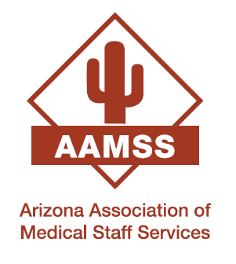 | Arizona Association of Medical Staff Services  2025 Fall Conference  November 14, 2025  Banner - University Medical Center Phoenix  Phoenix, AZ
AAMSS Needs Your Help - Calling on all hospital, CVO and managed care organizations!!!
The Arizona Association Medical Staff Services (AAMSS) is hosting an Educational Conference on November 14, 2025. The conference will be held at Banner – University Center Phoenix in Phoenix, AZ.
AAMSS consists of over 130 professionals who are responsible for credentialing, physician onboarding, managed care enrollment and regulatory compliance supporting hospitals, managed care organizations and physician offices. Our mission is to provide an opportunity for continuing education and improvement of professional knowledge and skill by uniting those involved in these processes throughout Arizona and surrounding states.
To support the educational needs of these individuals, AAMSS is reaching out to organizations directly related to our industry and the interests of our conference attendees. It is only through Sponsorship and Conference Exhibitors that AAMSS can continue to bring these educational opportunities to your employees and industry peers.
Our past conferences have been attended by over 150 credentialing specialists. There will be many opportunities for networking and promoting your organization or company and products. There are varying levels of Exhibitor and Sponsorship options available as noted on the attached documents.
For additional information please contact me or visit our website https://azamss.com/
If you are interested in being a Sponsor or Exhibitor for the upcoming AAMSS conference, please complete and return the attached Sponsorship Form.
Thank you for your consideration,
Arizona Association of Medical Staff Services
For additional information or questions, please contact:
Lisette Estala
AAMSS Education Committee
Lisette.Estala@outlook.com
(520) 260-5941

