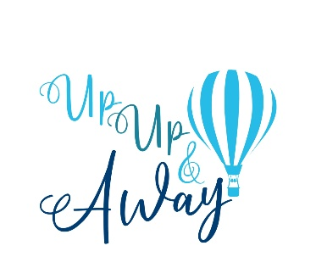

BOUNCE HOUSE RENTAL AGREEMENT & LIABILITY RELEASE

- The maximum number of jumpers allowed in the Bounce House at any one time are:

Maximum Individual Weight Limit | Maximum # of Jumpers
150 lbs | 8

- All jumpers must remove shoes, jewelry, badges, eyeglasses, and any sharp objects before entering the bounce house.
- Absolutely NO - confetti, gum, food, drinks, sprays, or other sticky substances are allowed in the bounce house. Failure to follow these guidelines will result in the imposing of an additional cleaning fee.
- No Piñata’s in the bounce house- risk of severe injury.
- No smoking on or around the inflatable.
- To avoid neck and back injuries - no wrestling, flipping, colliding or fighting.
- Do not bounce against the sides or near the doorway of the bounce house - serious injury may result.
- Anyone with head, back, neck or any muscular-skeletal injuries or disabilities, pregnant women, children under 3 years of age, and others who may be susceptible to injury from falls bumps or bouncing are not permitted in the unit at any time.
- Do NOT allow older children to jump with younger children - risk of severe injury.
- No hanging from the netting on the sides or from the roof of the bounce house. A repair fee will be imposed if the sides/roof is damaged.
- Keep unit away from heat and open flame at all times, material will burn or melt.
- If inflatable begins to lose air, make your way to the exit immediately.
- Bounce House MUST be staked to the ground securely at all times to prevent tipping or injury. Do not use if winds exceed 25mph - bounce house can flip over in high winds. If high winds exist, exit the bounce house immediately and turn off the blower.
- Keep children away from the blower unit - risk of electric shock and serious injury from moving parts of the blower.
- Do not operate the bounce house when raining or if ground is wet. Risk of serious injury due to slipping hazards and electric shock from the blower if wet conditions exist.
- Children’s safety depends on you. Your personal supervision is absolutely required. As the Lessee of the bounce house, the safety of all who come in contact with the bounce house or parts thereof is YOUR responsibility.

Weather Policy

We reserve the right to cancel any reservations due to severe or imminent deterioration of weather conditions.

Cancellation Policy

A 24 hr notification of cancellation is required (except due to weather conditions).

 LIABILITY RELEASE

- This rental equipment has been received in good condition and will be returned in the same condition (ordinary wear and tear accepted).
- Customer assumes all responsibility for injuries to persons or damages to property, and agrees to release and hold Up Up and Away LLC harmless for any and all claims, of whatsoever nature, arising out of use of the rental equipment while in his/her custody. In the event that the release and hold harmless as contained herein is held unenforceable for any reason, Customer herby agrees to a limit on any damages claimed by Customer to the total paid to Up Up and Away LLC for the rental.
- Customer agrees to company right to enter premises of customer at anytime to repossess said equipment.
- Customer agrees not to loan, sublet or otherwise depose of equipment or use it at any other location.
- Customer agrees to pay in full the replacement cost, including labor, for all damages to rental equipment.
- If the inflatable equipment is lost, stolen, or damaged beyond repair the renter agrees to pay $4000.00(four thousand dollars and 0 cents).
- THERE ARE NO WARRANTIES OF MERCHANTABILITY OR FITNESS EITHER EXPRESSED OR IMPLIED.

The person/s or organization renting this Equipment from Up Up and Away LLC will be held responsible and liable for any and all damage or injury occurring for any reason whatsoever. I have read the above agreement and fully understand and accept the conditions as above. I am aware that while in my care I am fully responsible for the inflatable and will pay for any loss or damages that may occur.

PERSON ASSUMING RESPONSIBILITY
Lessee:

Address:

Items Rented:

License #/ State:

Delivery Date/Time: | Pick Up Date/Time:
Rental Cost:
SIGNATURE: | Date/Time:

