Volume 6, Issue 8

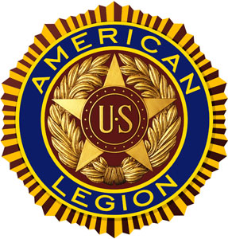

“For God And Country”

August 2020 POST 3 NEWSLETTER
Meeting Schedule for August - September 2020
Organization | Location | Time | August | September
Legion Post 3 | Elks Lodge, 5910 S 58th | 7 PM | None | 09/08/20
Auxiliary Unit 3 | Elks Lodge, 5910 S 58th | 7 PM | None | 09/08/20
SAL Squadron 3 | Elks lodge, 5910 S 58th | 7 PM | None | 09/17/20
ALR Chapter 3 | Denton Legion Club | 6 PM | 08/20/2020 | 09/17/20
40 & 8 Voiture 103 | Elks Lodge, 5910 S 58th | 7 PM | None | TBD
8 & 40 Salon 832 | Elks Lodge, 5910 S 58th | 7 PM | None | TBD
Pitch Tournament | Risky's, 4648 Leighton | 7 PM | None | TBD
Buddy Check | The Foundry, 211 N 14th | 7 PM | None | TBD
VA Coffeehaus | Antelope Park Bandshell | 10 AM | 08/21/20 | TBD

COMMANDER’S CALL
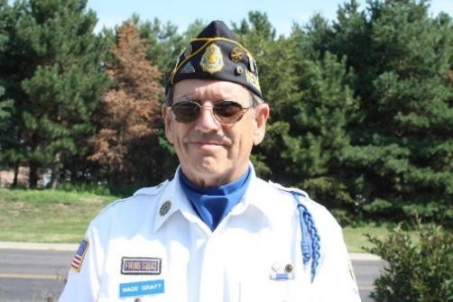

Legion Family All,

As your new Post 3 Commander I have been asked to introduce myself to the entire membership in this Newsletter. So, here goes:

I was born in Atlantic, Iowa and my father was a manager for J.C. Penney’s. We moved around the Midwest about every 2 years and ended up in Havelock where my father opened his own small retail store.

I attended elementary school in Havelock and University Place and then went on to Northeast High School. The University of Nebraska was next on my education journey (1958) and was drafted into the Army in 1962. I was sent to Fort Leonard Wood for Basic Training and then on to Fort Sill for AIT where I trained on how to fire 105mm howitzers.

After graduation from AIT, I was assigned to a Nike Missile Battery about 60 miles out of Fairbanks, Alaska. There I was a missile crewman-launch control operator and warhead team member. I was discharged in Fort Lewis in 1964 after driving the Alcan highway from Fairbanks to Fort Lewis in Washington.

I spent most of my civilian working career in sales and marketing.

The last 33 years I worked in wholesale paper distribution at Western Paper Co. and SCA Tissue ( a Swedish paper mfg. company located in Stockholm, Sweden).

I am married to Mary Graft (my much better half) and together we have 5 children and 6 grandchildren. I have been blessed way more than I deserve.

I have been a proud member of Post 3 here in Lincoln, NE for 31 continuous years. I have also served the Nebraska American Legion as District 15 Vice Commander, District 15 Commander, Area C Vice Commander, and I am very happy to say, recently elected as your Post 3 Commander.

Post 3 is fortunate to have several very experienced Legionnaires on our membership rolls and they are open to offering advice and leadership to me. My 1st Vice Commander is Gerry Wolf and 2nd Vice Commander is Bruce Gubser. They are experienced and knowledgeable leaders who will do us all proud.

Post 3 has been very active during this Covid-19 issue with weekly Leadership Zoom meetings to make sure we keep on track to be the best we can be. I will keep you all advised in following communications.

I hope to see you at the Sept.8th meeting.

Wade Graft
Post 3 Commander

ADJUTANT’S REPORT
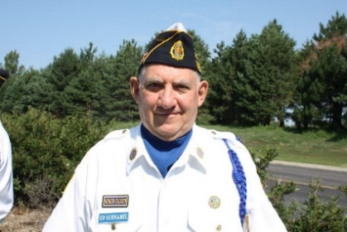

.

We are off to a good start on 2021 renewals, currently we stand at 787 members. This is just over 55 percent of our estimated goal for this year, 2021. Here is the breakdown: 529 paid renewals, 77 renewals online, 4 paid transfers, 92 Paid Up For Life (PUFL), 84 Nebraska Life Members and 1 new member.

For this past Legion year, 2020, we finished at about 96 percent with 1409 members. Thanks to a lot of help, we were able to contact some of our older members and get them renewed for this past year.

For those who have not sent in their 2021 renewals, please try and get them in by the end of August . National Headquarters will be sending out their second mailing the first week of September. To save on mailing cost they request we have our renewals to them before then.

For those who have renewed by mail, I will be depositing your checks the 3rd of August. After this first deposit, I will be depositing checks every Friday during the month of August.
If you happen to receive a second renewal mailing, and you know that you have paid your 2021 dues and received your 2021 Membership Card, just throw the renewal slip away.

If you have mailed a check and have not received your 2021 Membership, please call and let us know. Mail does get lost, going both ways. During the past weeks we have received mail addressed to others that are not in this building, or even in this part of Lincoln.

Again, thanks for the good start. Let’s keep it up and reach 100% for 2021.
Other News:

As we start the 2021 Legion Year, we have one of our youth programs that will be coming up very soon. That is Oratorical Contest. We will be needing judges, timers, etc. Keep watching for further news as we get closer to November.

Our office hours: Please call to be sure we are in the office. Normally there is someone here on Tuesday and Thursday mornings, 10:00 to noon.

LB 153, Taxation of Military Retirement Benefits, is currently pending final reading. Keep watching the news to see if the Legislature acts on it before this session ends in ten days.

Thanks for your service and thanks for being a member of Post 3

Ed Schnabel
Adjutant

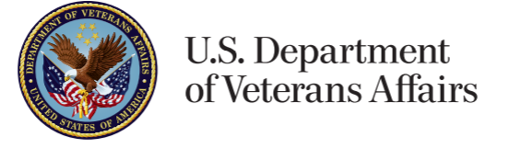
Lincoln VA Legion Report

While at the VA Community Based Outpatient Clinic, I was able to talk with the staff.
They are still looking for the New Clinic to be finished around the first part of December 2020.
They will then take about 90 days to outfit the building with equipment, etc. Thus, they are looking at sometime in March 2021 to move the clinic from the old hospital to the new Community Based Outpatient Clinic.
Until this pandemic is over the current clinic is closed to Walk-Ins. Here is the current guidance from the VA as to how to make use of the Lincoln Clinic.
NO WALK-INS are allowed in any departments.
DO NOT enter building more than 15 minutes before your scheduled appointment time.
If needed, you may be accompanied by ONE person. No visitors under age 18 allowed.
TO SCHEDULE AN APPOINTMENT PLEASE CALL 402-489-3802
(Choose Option 2 and Option 2 a second time)
All Services Require an Appointment – NO WALK INS
Some helpful notes:
If you need to talk with Eligibility, their hours are 0900 to 1500.
Do not try between 1200 noon and 1300, you will have to wait.
When you arrive at the VA and are asked if you have an appointment, tell them you wish to talk to Eligibility.
Remember this is now being done by way of a Zoom meeting.
For Eye Clinic – call 402-489-3802; Ext 6991
For Audiology – call 402-489-3802; Ext 7863
The Patriot Pride Shop is now closed. Joe is moving his business to the College View area, on the corner of 48th and Calvert. He will open on Monday the 17th of August 2020. Hours are M - F 10 to 4, and Saturday 9 to12. Stop by and tell him thank you for reopening his store.

Ed Schnabel
American Legion VA Representative

ALR COMMANDER’S REMARKS
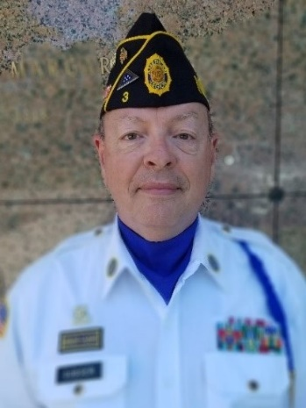
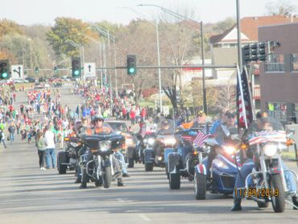

Lincoln Chapter 3 American Legion Riders met on 16 July at our usual venue. In an effort to enhance camaraderie, I will be leading a monthly Commander's Ride, weather permitting. Our first monthly ride in July will take us to Bailey's Local in Eagle.

The pandemic has pretty much decimated the many functions and parades in which we normally participate. Nevertheless, the Chapter will be sponsoring a Poker Run on Saturday, August 22nd, with stops at various Lancaster county veteran locations. We'll start at the DAV on north 70th, with stops at American Legion posts in Bennett, Hickman, Hallam, and ending at the Denton post.
Proceeds from the Poker Run will benefit Operation Comfort Warriors, an American Legion program that supports wounded, injured or ill military personnel with comfort items not usually supplied by the government.

Participants in the Poker Run do not need to be motorcyclists in order to take part. We gratefully accept anyone on two-, three- or four-wheels (or more) as participants. More details to follow. Until next time,
Ride (or Drive) Safe!

Bruce Gubser
ALR Commander

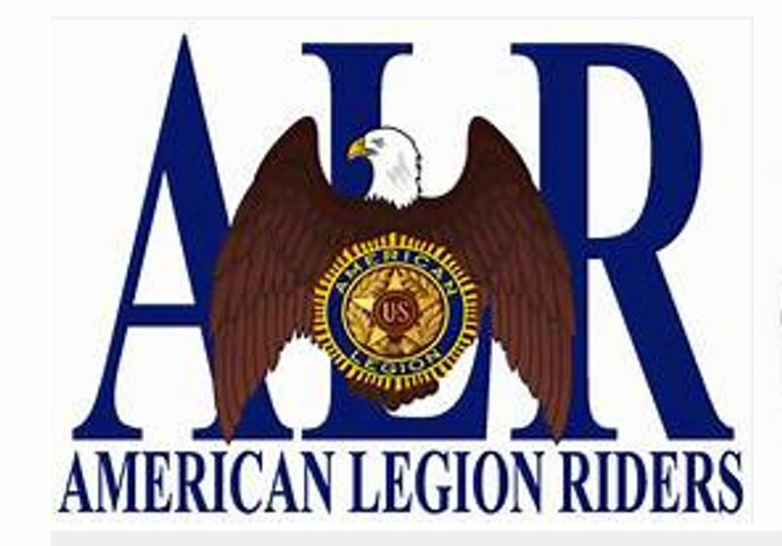

Legion Family upholds dedication to children and youth
By Daniel Wheeler, National Adjutant
JUL 07, 2020
FacebookTwitterMore

The American Legion has been a strong advocate for children and youth since its inception 101 years ago, making Children & Youth one of the four pillars. This steadfast dedication has never wavered. And it’s that dedication to our children and youth that Legion Family members have shown since COVID-19 impacted families in communities nationwide.
When Nebraska Boys and Girls State was canceled because of the pandemic, “American Legion Post 3 in Lincoln was looking at other opportunities to serve the community, since they would not be sponsoring high school youth to attend the programs” said Riders Chapter 3 Commander Bruce Gubser. A post member lived near Pyrtle Elementary School, which serves a number of lower income families, and had the idea of paying off the outstanding lunch account balances of students.
The post and Legion Riders chapter contacted the school district about their idea and the response was “we really appreciate that,” Gubser said. Together, Post 3 and the Legion Riders paid off the balance of nearly $600.
“This will allow these students to start the next school year with a zero balance,” Gubser said.
“We were just trying to do our part in making sure our community members’ needs were being met, even in some small way. It was only a few hundred bucks but to those particular families I think it was probably significant.”

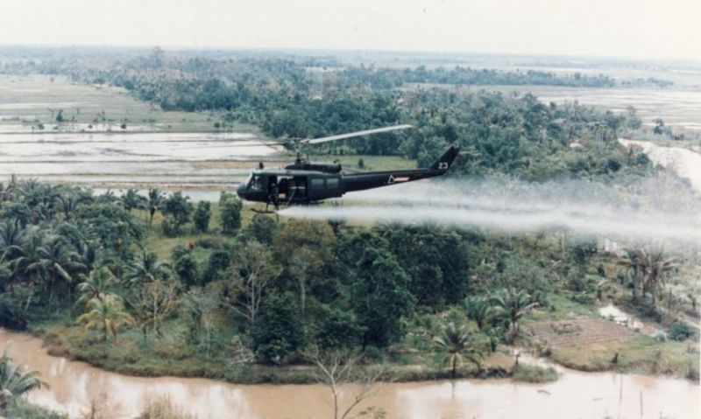

SENATE PASSES BILL TO COVER MORE AGENT ORANGE CONDITIONS

On July 22, the U.S. Senate voted 94-6 to pass a measure to be included in the National Defense Authorization Act (NDAA) to expand the Department of Veterans Affairs (VA) list of conditions presumptive of Agent Orange exposure.
The addition to the NDAA, introduced by Senate Veterans' Affairs Committee Ranking Member Jon Tester, adds bladder cancer, hypothyroidism and Parkinson's to the 14 illnesses already covered by VA for their links to the toxic herbicide. While not yet signed into law, the passage of this bill brings many veterans who’ve been impacted from exposure to the chemical defoliant a step closer to having their conditions covered by VA.
“This is a historic win for thousands of Vietnam veterans who have been suffering from illnesses after being exposed to Agent Orange, but who have been unjustly denied benefits for decades,” said Tester. “With the inclusion of my amendment in this must-pass defense bill, we are now one step closer to providing our Vietnam War heroes with the treatment and benefits they deserve from VA.”
The American Legion previously joined with 16 other VSO’s in issuing a joint letter to VA Secretary Robert Wilkie that urged VA to add these three additional conditions — as well as hypertension — to those covered by VA for exposure to Agent Orange.
“For too long, our Vietnam veterans have had to fight for and have been denied the critical health care they need to treat medical conditions resulting from exposure to Agent Orange," American Legion National Commander James W. “Bill” Oxford said. "We have made significant strides in ensuring that these veterans are given the care they deserve for their service and sacrifice to our nation. However, there is still more work to be done and these veterans continue to suffer the detrimental effects of their exposure each day. This amendment would provide a presumption of service-connection for Bladder Cancer, Hypothyroidism, and Parkinsonism for veterans exposed to certain herbicide agents while serving in Vietnam.”
"The American Legion is proud to support this amendment and believes the evidence overwhelmingly supports adding these diseases to the presumptive list.”

We are Veterans

We left home as teenagers for an unknown adventure.
We loved our country enough to defend it and protect it with our own lives.
We said goodbye to friends and family and everything we knew.
We learned the basics and then we scattered in the wind to the far corners of the Earth.
We found new friends and new family.
We became brothers and sisters regardless of color, race or creed.
We had plenty of good times, and plenty of bad times.
We didn’t get enough sleep.
We smoked and drank too much.
We picked up both good and bad habits.
We worked hard and played harder.
We didn’t earn a great wage.
We experienced the happiness of mail call and the sadness of missing important events.
We didn’t know when, or even if, we were ever going to see home again.
We grew up fast, and yet somehow, we never grew up at all.
We fought for our freedom, as well as the freedom of others.
Some of us saw actual combat, and some of us didn’t.
Some of us saw the world, and some of us didn’t.
Some of us dealt with physical warfare, most of us dealt with psychological warfare.
We have seen and experienced and dealt with things that we can’t fully describe or explain, as not all of our sacrifices were physical.
We participated in time honored ceremonies and rituals with each other, strengthening our bonds and camaraderie.
We counted on each other to get our job done and sometimes to survive it at all.
We have dealt with victory and tragedy.
We have celebrated and mourned.
We lost a few along the way.
When our adventure was over, some of us went back home, some of us started somewhere new and some of us never came home at all.
We have told amazing and hilarious stories of our exploits and adventures.
We share an unspoken bond with each other, that most people don’t experience, and few will understand.
We speak highly of our own branch of service, and poke fun at the other branches.
We know however, that, if needed, we will be there for our brothers and sisters and stand together as one, in a heartbeat.
Being a veteran is something that had to be earned, and it can never be taken away.
It has no monetary value, but at the same time it is a priceless gift.
People see a veteran and they thank them for their service.
When we see each other, we give that little upwards head nod, or a slight smile, knowing that we have shared and experienced things that most people have not.
So, from myself to the rest of the veterans out there, I commend and thank you for all that you have done and sacrificed for your country.
Try to remember the good times and forget the bad times.
Share your stories.
But most importantly, stand tall and proud, for you have earned the right to be called a Veteran.

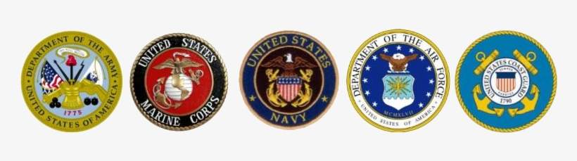

July 2020 Taps

Last Name | First Name | Era | Years | Reported
BARTH | ARVID | Korea | 46 | 7/13/2020
BAUSBACK | LEONARD | Korea | 52 | 7/27/2020
CHAMBERLAIN | LARRY | Vietnam | 40 | 7/22/2020
DIETRICK | SCOTT | Vietnam | 29 | 7/22/2020
DOUGHERTY | FRANK | Korea | 60 | 7/13/2020
EARL | HOWARD | Vietnam | 7 | 7/22/2020
OTTE | LEROY | Korea | 36 | 7/22/2020
PRIESS | LLOYD | Korea | 60 | 7/20/2020
BROWN | LARRY | Korea | 1 | 7/31/2020

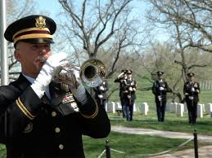

US Service Members Repatriated from South Korea
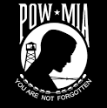

The remains of six US service members are on their way back to the United States after a repatriation ceremony at the Osan Air Base in South Korea.
The remains were contained in a single casket which was placed in a Boeing 747 that was chartered for the flight to the Joint Base Pearl Harbor-Hickam in Hawaii.
An honor guard consisting of service members from the US, the Philippines and Thailand carried the casket which was draped with a UN flag.
On the way to Hawaii, the flight made a stop in Japan where the UN flag was replaced with a US flag.
In Hawaii, the remains will be examined by the Defense POW\MIA Accounting Agency (DPAA) to be identified. Authorities are certain that the remains are of US service members due to the location where they were discovered being the sites of battles during the war and also due to artifacts found in the same location.
The remains were found by the South Korean Ministry of Defense Agency for KIA Recovery and Identification (MAKRI).
According to the DPAA, there are over 7,500 US personnel unaccounted for from the Korean War. Approximately 3,500 of those are believed to be in North Korea.
There is another repatriation ceremony planned for when the remains reach Hawaii. The ceremony will conclude a series of events which commemorate the beginning of the Korean War on June 25, 1950.
Korea was divided into two separate countries following World War II. Prior to the war, the Korean peninsula had been part of the Japanese empire.
After the war, the Soviets and the Americans had to come to terms with how to handle Japanese possessions. In August 1945, aides at the State Department divided the peninsula at the 38th parallel. The Soviets occupied the northern portion and the Americans occupied the southern part.
The Korean War began with 75,000 North Korean soldiers crossing the border between the Democratic People’s Republic of Korea in the north and the Republic of Korea in the south.
Within a month, US soldiers were deployed to defend South Korea. To the Americans, the war was a fight to prevent the spread of communism. President Harry Truman said that letting Korea down would encourage the Soviets to “keep right on going and swallow up one [place] after another.”
The two sides fought back and forth with no real gains for either side but a mounting loss of life on both sides.
In July 1953, the war ‘ended’ after the Americans aggressively sought an armistice to avoid what they saw as a bigger threat of the war spreading to Russia or China, or possibly turning into World War III.
Some refer to the war as the “Forgotten War” because it did not receive the same coverage in the US as the World Wars or the war in Vietnam. Approximately five million soldiers and civilians were killed in the conflict.
(From: TWS, July 6, 2020)

Space Force Selects Airmen To Join Newest Branch

WASHINGTON – The U.S. Space Force on Thursday announced it had approved more than 2,400 Air Force troops already serving in space specialties to move into the new branch of the military later this year.
The 2,410 space operations officers and enlisted space systems operations specialists approved to join the Space Force will transfer Sept 1. Airmen serving in 11 other specialties eligible for transfer into the Space Force are expected to do so in early 2021, and space-focused troops from the other military services could move in 2022 or 2023.
The transfers will dramatically grow the new service, which is charged with safeguarding U.S. space operations and has a key role in detecting potential threats, such as missiles targeting the homeland. The moves will expand the service to almost 2,500 troops. The Pentagon intends to grow Space Force to about 16,000 service members.
Officers will have to resign their Air Force commission and officially commission into the new service. Enlisted personnel will undergo a formal enlistment process, as well.
In all, the Space Force saw about 8,500 active-duty airmen request transfers into the new branch, which will operate as a separate military service within the Air Force Department, much as the Marine Corps operates within the Navy Department.
The service intends to select about 6,000 airmen for transfer by next year.
Air Force space operators who decided not to request a transfer should be informed of their options in the coming weeks. Choices include moving into another Air Force career field, applying to transition into the National Guard or Air Force Reserve, or applying to separate from the service or retire. For now, those airmen are likely to be assigned duties within the Space Force.
The remaining roughly 4,000 slots expected to be transferred into the Space Force beginning in February will come from Air Force officers and enlisted airmen now working in intelligence, cyberspace operations, developmental engineering, acquisition management, operations intelligence, geospatial intelligence, signals intelligence, fusion analysis, targeting analysis, cyberspace support and client systems.
They also want to know the service’s plans for Reserve forces. The Pentagon has yet to decide whether the Space Force will have its own Reserve component, such as a Space National Guard. Top leaders in the Army and Air Guard have lobbied for months for such a space-focused Guard force. Pentagon officials said they are still studying the issue.
Also yet to be decided are what members of the Space Force will be called, what the service’s rank titles will be and what their dress uniforms will look like.
dickstein.corey@stripes.com

Minutes of the July 14, 2020 Post 3 Meeting

These minutes need to be approved at the September meeting.

Regular Meeting of American Legion Post 3
Lincoln Elks Lodge #80
July 14, 2020
The colors being in place, Commander William Jackson opened the July 14, 2020 meeting of American Legion Post 3 at 7:00 PM at the Lincoln Elks Lodge #80 with 13 Legionnaires present.

The minutes of the June meeting (held virtually) were read and approved.

Ed Schnabel gave the finance report for the month ending June 30, 2020, reporting a balance on hand of $33, 188.56. He indicated that donations had been solicited and received to pay for 42 WWII and Korea members. The report was accepted and filed for review.

Wes Newton was introduced as attending his first meeting.

Membership for 2020 was reported at 1402. Adjutant Schnabel also indicated that 555 memberships for 2021 had already been processed.

Bruce Gubser reported for the Legion Riders. He announced that the Riders would meet at the Denton American Legion this Thursday. At least 1 Lincoln Rider attended the unveiling of the Medal of Honor Highway Sign in South Sioux City, and a poker run is being planned for later in the year.

Gerry Wolf reported for the Honor Guard. He indicated that they had been inactive for about 2 months, but funerals were now picking up again.

Fred Craigie report that the SAL was going to meet this Thursday, but that it would be somewhere other than at the Elks.

There was some discussion about the Voiture 103 plans to meet next week. Considering the rising number of virus cases in Lincoln currently --- and other factors ---- the consensus of voyageurs in attendance was that cancelling the gathering would be prudent.

District 15 Commander Ed Muggy was called to the podium for the purpose of installing new officers for 2020-2021. Installed were:

Commander --- Wade Graft
1st Vice Commander --- Gerry Wolf
2nd Vice Commander --- Bruce Gubser
Executive Committee (3-year term) --- Jack Sibert

Gerry Wolf presented a National Membership Retention Award to Adjutant Ed Schnabel on the post’s behalf.

Gerry Wolf presented Wade Graft with his certificate for having received the 2020 District Citizenship Award.

Jack Sibert recognized and thanked Dr. Jackson for completing his year of service as Post 3 Commander. He pointed out that Dr. Jackson was the first individual to have served 3 times as commander.

Ed Schnabel presented a proposed budget for the coming year. He pointed out that to be conservative, 92% of current membership is used as a basis for projecting income from dues. He also reported that the copy machine in the office was on its last leg.

Upon motion by Sibert and second by Jackson, $1000 was added to the budget for the purpose of purchasing a new copy machine. Following additional discussion and upon motion by Jackson, the post adopted the amended proposed budget with the understanding that an item would be added to track the funds in and out of the “Bunker Fund.”

Chaplain Jackson read taps, and the meeting was closed in proper form at 7:35 PM.

Steve Bartos
Recorder

E

Share Your Story
Top of Form
Bottom of Form

The University of Nebraska-Lincoln seeks to honor and celebrate veterans and military service members by creating a Veterans’ Tribute on Memorial Mall, near the Pershing Military and Naval Science Building. The design will feature glass panels depicting moments in a veteran or service member’s life, including training, deployment, family life, and humanitarian missions. There will be words engraved on the steps that reflect what it means to serve. Trees, seating, and landscaping will create a serene environment for reflection and remembrance.
The development of the Tribute has reached an important juncture, in which the design team is ready to begin collecting stories, memories, and experiences to be used as quotes on the glass panels. The Tribute will be representative of all veterans from every branch and area of Nebraska. We are asking for veterans, members of the military and families to assist us with potential content on the panels by answering a few questions. All quotes on the Tribute will remain anonymous although we do request that any submissions include the hometown, branch of service or family member of the veteran or member of the military.
We appreciate the sacrifices of all veterans, service members, and their families, and your willingness to share your experiences with the University of Nebraska-Lincoln. All content submitted will be reviewed and stored in a digital format, though not all content will be selected for the Tribute design. There is a 500 word limit on each question to ensure that all submissions will have the opportunity to be read and reviewed. Please feel free to answer the question or questions that best applies to you or your family member.
If you wish to submit your response in writing, please answer any or all of the questions and mail your response to:
Veterans' Tribute
201 Canfield Administration Building
Lincoln, NE 68588-0419
Whether electronic or written, all responses should be received by September 15th. For the submission form, go to:
https://veteranstribute.unl.edu/share-your-story?
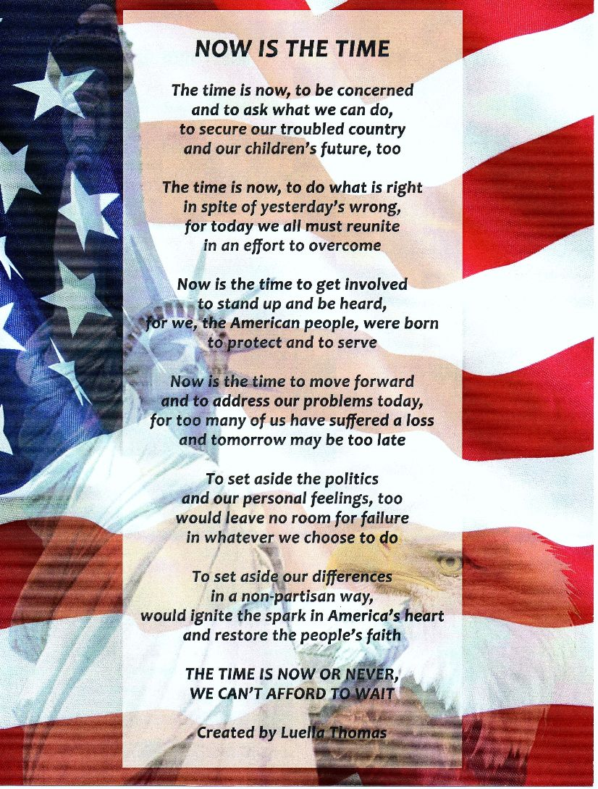
Become a Member of The American Legion
Do you want to help your community and fellow Veterans by becoming a member of the American Legion? Would you want to help recruit a new member? If you can certify that you served at least one day of active military duty since December 7, 1941 and were honorably discharged or are currently serving honorably, you are eligible. Complete the application below and send it with a check in the amount of $46.00 to:
American Legion Post 3
123 South 84th Street, Suite L
Lincoln, Ne 68510
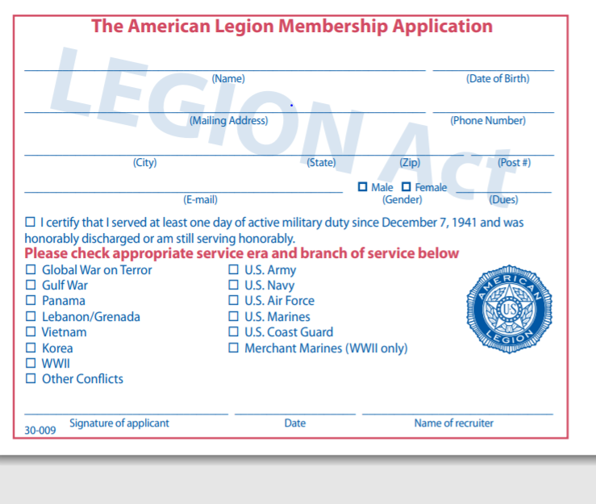

To transfer or renew, you only need to sign below and mail this and a check for $46 made out to “American Legion Post 3” to the address listed above. If you have already renewed for 2021, and want to transfer to Post 3, only sign below and return the bottom portion to us.
YES! Please transfer my membership to Lincoln American Legion Post 3

___________________________________________ Signature

___________________________________________ Membership Number

American Legion Post 3

123 South 84th St. Suite L

Lincoln, NE 68510
(402) 466-3958

Post3legionlincoln@gmail.com
https://lincolnpost3.org
2020 - 2021 Post 3 Officers
Commander - Wade Graft – Cell: 402-770-9126
First Vice Commander – Gerry Wolf – Cell: 402-417-8230
Second Vice Commander – Bruce Gubser – Cell: 402-470-1700
Adjutant – Ed Schnabel – Cell: 402-480-8542
Chaplain – William Jackson – Cell: 402-613-9774
Post Service Officer – Ed Schnabel – Cell 402-480-8542

Please submit any announcements or items for the monthly newsletter to the Adjutant for approval. All requests must be received two weeks before the monthly meeting.

