American Legion Post 3
Lincoln, Nebraska
Four Pillars of Service --- 2020

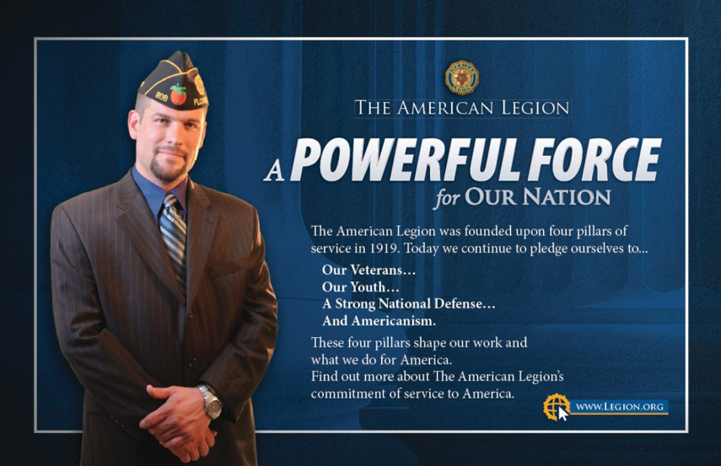

Following are some of the projects that reflect American Legion Post 3’s efforts to support our veterans and the Four Pillars of the American Legion. Some may support more than one Pillar.

1 --- Veterans Affairs & Rehabilitation
- Pay Final Respects and Provide Honor Guard for Military Honors --- 200+ per year
- Volunteer at VA Vet Centers
- Assist veterans seeking GI Bill Benefits
- Assist Homeless Veterans at Victory Apartments
- Present Retirement Home Programs to Honor Veterans
- Attend hearings and Support Legislative Bills at State and Federal Levels

2 --- National Security
- Support all of our troops and VA programs
- Volunteer at the Lincoln VA Clinic
- Provide funds to Veterans and their families Emergencies
- Provide Funds to support Operation Comfort Warriors
- Provide Funds to support the American Legion National Emergency Fund
- Provide Funds to support the American Legion Legacy Fund

3 --- Americanism
- Provide Flag Etiquette Education Programs
- Participate in Scheel’s Sporting Goods annual Flag Replacement Program.
- Conduct an annual Flag Disposal Program and Burial of Ashes
- Work with Boy Scouts of America / Honor Eagle Scouts
- Provide funds and participate in Wreaths Across American Program
- Provide School Talks
- Fund and support Lincoln Special Olympics
- Ring Bells for Salvation Army
- Provided funds to Call-a-Vet program
- Maintain a Post Web Site(https://lincolnpost3.org/)
- Publish Lincoln Legionnaire newspaper quarterly
- Distribute a monthly Post 3 newsletter
- Host Coffeehaus / Quilts of Valor events at the Lincoln VA Clinic
- Purchase Coffee for the VA Clinic
- Support VA Food Pantry
- Donate to Soldiers Christmas Fund
- Support the University of Nebraska – Lincoln ROTC program
- Sponsor and Support American Legion Auxiliary Unit 3
- Sponsor and Support Sons of the American Legion Squadron 3
- Sponsor and Support American Legion Riders Chapter 3
- Participate in Lincoln’s Veterans Parade
- Participate in Governor’s Welcome Home Picnic

4 --- Children and Youth
- Support and Sponsor delegates to American Legion Cornhusker Boys State
- Support and Fund American Legion Baseball
- Conduct District 15 American Legion Oratorical Contest annually
- Support and Sponsor participants to American Legion Jr. Law Cadet Program
- Support Boy Scouts / Eagle Scout Recognitions
- Provide up to 3 $500 Scholarships annually
- Honor Lincoln Public School teachers and Staff with 25 Years-of-Service certificates
- Honor High School JROTC Cadets with certificates and medals
- Provide funds and support for the VA Little Pride Program

