Volume 7, Issue 3
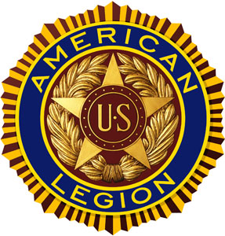

“For God And Country”
March 2021 POST 3 NEWSLETTER


Meeting Schedule For March 2021 – April 2021

Organization | Location | Time | March | April
Legion Post 3 | Elks Lodge, 5910 S 58th | 7 PM | 03/09/21 | 04/13/21
Auxiliary Unit 3 | Elks Lodge, 5910 S 58th | 7 PM | 03/09/21 | 04/13/21
SAL Squadron 3 | Post 3 Office, 123 South 84th | 7 PM | 03/18/21 | 04/15/21
ALR Chapter 3 | Denton Legion Club | 6 PM | 03/18/21 | 04/15/21
40 & 8 Voiture 103 | Elks Lodge, 5910 S 58th | 7 PM | 03/16/21 | 04/20/21
8 & 40 Salon 832 | Elks Lodge, 5910 S 58th | 7 PM | 03/16/21 | 04/20/21
Pitch Tournament | Risky's, 4648 Leighton | 7 PM | Cancelled | Cancelled
Buddy Check | The Foundry, 211 N 14th | 7 PM | 03/22/21 | 04/22/21
VA Coffeehaus | VA Clinic, 600 South 70th | 11 AM | Cancelled | TBA

Commander’s Call

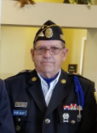

Legion Family All....

Post 3 had our February 9th Post meeting at the Elks Lodge in person and broadcast it live via Zoom for those who wanted to stay home and still participate. We are getting better at running a Zoom meeting and will be doing it again when we have the District 15 Convention on March 9th.
The District 15 Convention starts with a buffet at 5:30PM and the Convention starts at 6:30PM at the Lincoln Elks Lodge If you want to try the Zoom option, the link is https://bit.ly/2Y0MIYl. However, we hope that you feel comfortable enough to attend in person. We take special precautions to keep you safe and we have had several recent Post meetings using these recommended precautions - sanitizing all common touch areas, wearing masks and social distancing, with no issues. Either way, we want you to keep informed on what Post 3 is doing and planning to do. Your input is needed and appreciated.

Your Post 3 Leadership Team has kept very busy during the COVID-19 pandemic, frigid temperatures and snowstorms. We have Zoom meetings once a week to plan new Post 3 projects, evaluate current projects, keep up on office duties and promote veterans joining and renewing their membership in Post 3. We can be found on Tuesdays and Thursdays at the Post 3 business office (123 S 84th St.) between the hours of 10:00AM and Noon. Stop by and say Hello!
Here is another project that we are considering, designing a Post 3 Membership Kit. It will be small enough to carry in your pocket and have everything you need to feel comfortable about asking another veteran to join Post 3, including a membership application. If you have ideas on this, please contact me and we will get this accomplished together.
As always, ask a veteran friend or family member to join Post 3. Post Everlasting is gaining on us.

Respectfully,
Wade Graft
Post 3 Commander
402-770-9126
wamar4801@gmail.com

Adjutant’s Report

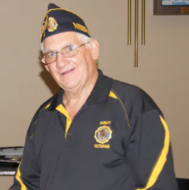

-

Welcome, Still in the grips of Winter.
Post 3 office is open on Tuesday and Thursday, 10:00 to noon. If you need anything in way of support from me, please text me at 402-480-8542 and I will be glad to help you.
We are still working hard on membership nearing 1270 paid for 2021. Over the past two months we have been working to reach out to our members who have yet to mail their 2021 renewals. We have mailed notes to 125 of these members in hopes they would want to renew with Post 3. We have also sent letters to those Post 500 members who might wish to join an active Post.
On the sad side, we have lost a few of our Post 3 members who have died during this pandemic. If your Veteran has died and you are still receiving these monthly newsletters, it means we have not received a notice of his/her death. It sure would help if you could drop us a note, as it saves the costs of mailing renewal notices, etc. If you have recently sent a note that a member has died, could you call the office, as we received a note of a death, but they did not include the veteran’s name.
One of the best ways would be to use Buddy Check. For those who are willing to help, I have a listing of these members who have not yet paid their 2021 dues. If you would like to help, you could make a few phone calls or send an email to those who we have a number or emails for. Give them a call for Buddy Check, just to say HI, ask if they are doing ok and if they need any help from the Legion. Then kindly remind them about renewing their membership with Post 3.
Another note for those who still have not paid their 2021 Legion Dues, you should be receiving a third notice in the mail. If you have paid your dues, please just throw the notices away. You do not need to write and tell me that you have your 2021 card, etc. Dues notices are sent out from the National Headquarters, with the covid-19 lock down, there are a few renewals that do not reach National in time for them to be processed before they send out the next renewal notice. If, by chance, you have paid and never received your 2021 membership card, then call the office. There have been a few mailings that have come back due to a bad address or that have been eaten by the postal machines to the point that I cannot tell who they were sent to. So do call if you are missing your 2021 membership card.
If you are receiving the monthly newsletter and know a member who does not get it, would you drop us a note so we can add them to our email list. If you do not want to receive the newsletter, drop us a note with your phone number and an email address and we would be glad to remove it from our mailings.
There are a few bills working through the current Nebraska Legislative session. The Nebraska office of Veterans Affairs web site has a list of bills that you might wish to keep track of. With this pandemic, in person testimony has been limited. The best way to let the members of the Legislature know of your support for these bills is to drop them a note.
The Veterans Affair web site has directions as to how best to do this. Two bills of interest are, 1) making military retirement pay tax free of Nebraska income tax, 2) property tax for those 100% disabled on one vehicle.
Thanks for your service.
Ed Schnabel
Adjutant
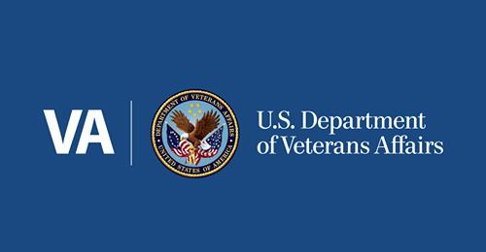
Lincoln CBOC / VA News
As you read this March newsletter, the Lincoln Community-Based Outpatient Clinic should be seeing veterans in the new clinic building. The moving date was set for the weekend of February 27-28, 2021.
I have not been in the new clinic, but looking at the floorplan, it should be a huge update from the old hospital building.
Main level
As you enter through the main entrance you will be in the general waiting area for Primary Care. Each Primary Care Team has its own clinic area. Staff will come out to the waiting area to escort the veteran to their appointment. To your right (east) is the Lab, Pharmacy, and Infusion clinic.
Upper Level
The specialty clinics are on the second or upper level. Mental Health, Respiratory, Eye, X-Ray, Dental, Physical Therapy, Audiology, and Whole Health. There is a general waiting area for all the clinics. Again, staff will come out and escort the veteran to their appointment.
The VA is still in a locked down mode, they ask you to not to come to the Clinic unless you have an appointment, and not to come more than a half hour before your appointment.
Covid-19 Shots are now being given in the Auditorium. If you have not been called, you need to call your primary care giver and request an appointment. You may enter using the North doors under the Auditorium.
NOTE: To receive a shot from the VA you must be enrolled in the VA Health Care System. Shots are only being given to the veteran and those who are enrolled as a Veteran Gare Giver with the VA. If you get care from the VA Health Care System, then you are enrolled. For those who do not currently used NWI (Nebraska Western Iowa) Health Care System, Omaha VA Hospital or the local CBOC’s, you can call 404-828-5257 to check if you are enrolled and enroll if you are not to receive VA Health services.
They request that you use the VA Facebook or the VA web site to request an appointment. The VA will call you back to make the appointment with you. They have brought more staff on hand to handle these covid-19 requests.
Baby Shower Volunteer Services will be holding a Baby Shower for our female veterans this spring. They are looking at March 13th for the Omaha VA Hospital, giving out baskets to those who request them.
Lincoln and Grand island will be hosting their own events, no date at this time. Volunteer Services will get a list of requested items later this spring. With lack of space in the new building, those wishing to donate for the Lincoln CBOC, it would be best to call Volunteer Services and ask if they have a specific need at this time.
Remember, the VA will only to be there for us if we use its services. If we do not use them, the government sees it as a service not needed here and will cut funding for the Lincoln CBOC. The government funds each CBOC / hospital based on the number of veterans signed up for services in its service area.
They, the veterans, do not need to be using the VA for their medical needs, just need to be enrolled in the VA Health Care System. Funding is based on foreseen needs, not current need, thus we need to talk with our fellow veterans to be sure they are enrolled in the VA system. There are many veterans who could receive medical service but have never signed up for this benefit of our service. Again, it is the old story, use them or lose them.
Thanks for your service.
Ed Schnabel
Lincoln VAG member (Veteran Advisory Group)
Lincoln VA American Legion Representative

Post 3 ALR Commander’s Remarks

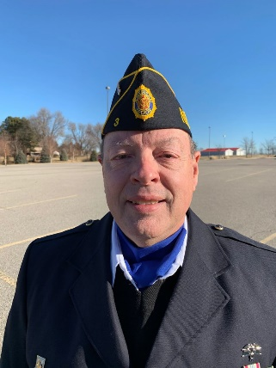
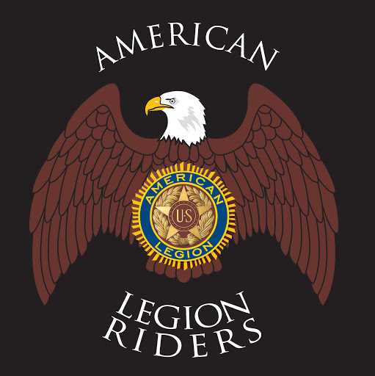

Greeting fellow Riders and Legionnaires,

March is nearly upon us, and I know what that means... Spring is about to arrive! Warmer weather will bring out the motorcycles (and their riders) from hibernation. We will once again be sharing the road with vehicles of all types.

To those on two wheels, remain ever-vigilant and keep your safety foremost in your mind. To those on four (or more) wheels, please be on the lookout. I remember back in the day, we had a game we played in the car called “slug-bug.” I’m sure many of you played the same game. Whenever we saw a VW Bug first, we’d (playfully... or not so playfully depending on the relationship) slug our brother or sister or cousin or whoever.

Especially as the weather gets warmer, consider modifying that game slightly to “slug-bike.” When you see a motorcyclist, whack whoever is in the car with you. Of course, I’m only kidding, but I do seriously ask everyone to be aware of their surroundings while driving and riding.

As mentioned last month, American Legion Riders are hosting a poker run as our fundraiser event on May 22nd. Any and all are invited to participate. Registration is at Frontier Harley-Davidson on West O Street from 10-noon. We are still finalizing our planned stops, but the run will end at the Denton Legion club where winners will be announced, and prizes awarded. We plan on having a silent auction on a few items and some door prizes in addition to a 50/50 drawing. I do hope that you can join us.

That’s all for now.

Until next time,
Ride (and drive) Safe!

Bruce Gubser
Post 3 ALR Commander

Message From The Chaplain

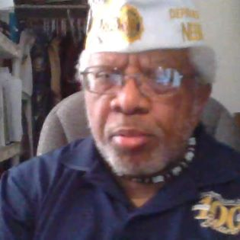

Here’s an idea. The world is flat. The oceans are crammed full of vicious sea monsters. Our lands are slowly sinking into the sea. Food supplies are dwindling. Fresh water is in short supply.
Sound unfathomable? Oh, by the way, the world and its cohorts—Satan and his anti-Christs— call this earth-shaking phenomenon “Global Warming.”
But what if it was all true? The Bible, God’s manuscript for the humanity, says He made, formed, and created humans in His image to live the abundant life through His provision and counsel (Genesis 1:27). Americans first applied this principle in our U.S. Constitution’s Declaration of Independence about “…life, liberty, and the pursuit of happiness…”
Those rights of “ liberty…” etc. enabled our U.S. Amendments, especially the initial “10 Bill of Rights,” highlighted by the First and Second Amendments regarding freedom of speech and the right to bear arms.
If you think there’s not a storm brewing with so-called “mother nature,” or that those in current power aren’t trying to pull a “superior than thou” routine, maybe you’ve been here too long. “superior than thou” routine, maybe you’ve been here too long.

Not that this not a rabble-rousing effort. For one thing, there is NO mother nature as His Word states clearly (Genesis 1:1). For another thing, we came together as Americans with the right of self-rule “…by, for, and of the people…”. That’s you and me, NOT your U.S. Senators or Congresspersons.
This is not a call for armed resistance or related issues to actually overcoming a corrupt government…unless…it’s gotten that far out of whack that anyone might consider such a tragic step. No, by God’s grace we have NOT come to that. I trust the Lord for His provision and counsel in the lives all Nebraska Legionnaires, and those here in ALP 3.
Just keep looking to God, not world and national leaders, to guide through the Coming Darkness(Proverbs 4:19), when Satan’s anti-Christs (1 John 4:3) try to overthrow our trust in Jesus to see us through. If any of you lack wisdom about how to handle this changing time in the Last Days of humanity (2 Timothy 3:1), let her or him go to the Lord (James 1:5). Prepare ye the way for your spiritual defense as a soldier of Christ (2 Timothy 2:3) through taking on God’s amour as depicted in Holy Scripture (Ephesians 6:10-18).

Rev. Dr. William Jackson
ALP 3 Chaplain

Post 3 Honor Guard

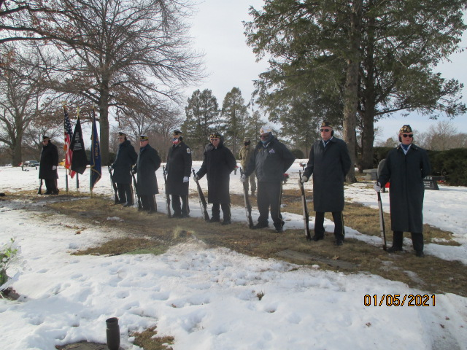
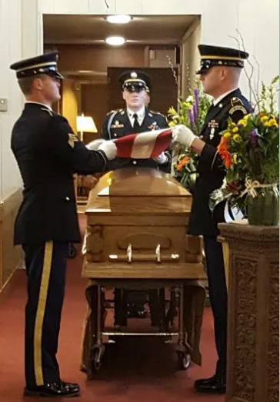

In the month of February, the Honor Guard rendered “Honors” at 3 Legion funerals and asked to assist at 6 VFW funerals.

February 2021 TAPS

LAST NAME | FIRST NAME | BRANCH | WAR ERA | YEARS
BALLENTINE | JAMES | NAVY | VIETNAM | 11
CARPER | CHARLES | ARMY | VIETNAM | 36
CLARK | THOMAS | NAVY | KOREA | 32
DIVOKY | RONALD | ARMY | VIETNAM | 50
IRWIN | ROBERT | USAF | KOREA | 51
MASTER | FRANKLIN | ARMY | VIETNAM | 18
MATHIS | DALE | ARMY | WWII | 49
MOTIS | ERNEST | ARMY | KOREA | 59
SNIDER | NAT | ARMY | WWII | 31

Minutes Of Post 3 Meeting, 02/09/2021

Regular Meeting of American Legion Post 3
Lincoln Elks Lodge #80 and also on ZOOM
February 9, 2021

Commander Wade Graft opened the February 9, 2021 meeting of American Legion Post 3 at 7:00 PM at the Lincoln Elks Lodge 80 with 11 Legionnaires present. An additional 3 members and one guest joined on ZOOM during the course of the meeting.

William Jackson offered prayer.

The minutes of the January meeting were read and approved.

Ed Schnabel gave the finance report for the month ending January 31, 2021, showing a balance on hand of $45,875.95. The report was accepted and filed for review.

Veterans of the various war eras were asked to stand and be recognized.

Membership Chairman Jackson made some comments about making videos of Post 3 activities and using Zoom, YouTube, and Facebook to spread the word about Post 3 activities and encourage veterans to join the American Legion.

Bruce Gubser reported for the Legion Riders. He said that the Riders have begun meeting regularly in-person and on Zoom at the Denton American Legion. He said that they have scheduled a poker run for May 22nd.

Steve Bartos reported that the Boys State selection process is under way and that the packets of applicants’ resumes have been distributed to donors.

Gerry Wolf reported for the Memorial Squad. He indicated that the crew participated in 11 Legion funerals in January and assisted the VFW with 8. So far during February, they have participated in 5.

Steve Bartos reported that he will begin working on the newspaper this week.

Wes Newton, POW/MIA liaison, was unable to attend tonight’s meeting, but Len Ostrowsky gave his report. Len read a list of names of servicemen whose remains had recently been identified.

Commander Graft reported on an idea he had about developing some “membership kits” which Legionnaires could carry with them and have handy when they come across a potential new member. He asked for volunteers to work on developing or acquiring some material that could be used for such a kit.

It was announced that the Nebraska State Patrol had cancelled the Junior Law Cadet program for this year.

Bruce Gubser reported on the birthday card initiative. He indicated that Yankee Hill Village had come on board.

Jerry Salber announced that Voiture 103 would meet next Tuesday at 7:00 PM, but that they were still not ready to be serving a meal.

Rev. Jackson read TAPS, and the meeting was closed in proper form at 7:30 PM.

Steve Bartos
Recorder
______________________________________________

MEMBER DATA UPDATE

If you haven’t already done so, Post 3 members are invited to share some basic information with us. It often proves very helpful when we get involved in assisting with claims, checking obituaries, or just keeping track of the demographics of our members.

If you are comfortable doing so, you can email any or all of the following information to us at post3legionlincoln@gmail.com and we will enter it into the national myLegion.org database. Or you can call the Post 3 business office on Tuesday or Thursday mornings from 10:00 to noon at 402-466-3958.

Date of Birth
Dates of Service (War Era)
Branch of Service
Phone Number
Email Address

Soldier Accounted For From Korean War

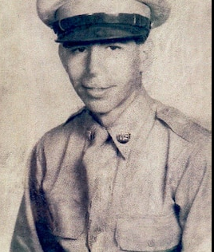

The Defense POW/MIA Accounting Agency (DPAA) announced today that Army Cpl. Paul W. Wilkins, 19, of Bellwood, Pennsylvania, killed during the Korean War, was accounted for Oct. 30, 2020.
In July 1950, Wilkins was a member of B Company, 1st Battalion, 21st Infantry Regiment, 24th Infantry Division. He was reported missing in action on July 11 when his unit was fighting enemy forces near Choch’iwan, South Korea. He was never found, nor were any remains recovered that could be identified as Wilkins. The Army declared a presumptive finding of death for Wilkins on Dec. 31, 1953, and he was declared non-recoverable on Jan. 16, 1956.
On Oct. 4, 1950, U.S. forces buried an unidentified set of remains, designated Unknown X-113 Taejon, in United Nations Military Cemetery Taejon. There was no record or information as to the recovery location or identity of these remains. After multiple attempts to identify X-113, the remains were deemed unidentifiable, and were sent to Hawaii where they were buried at the National Memorial Cemetery of the Pacific, known as the Punchbowl.
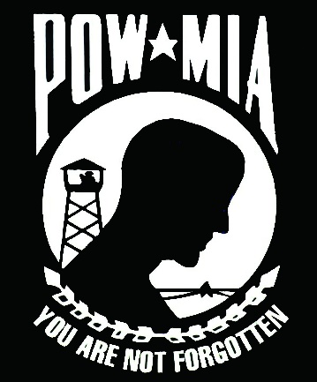

In July 2018, DPAA historians and anthropologists proposed a plan to disinter and identify the 652 Korean War unknown burials from the Punchbowl, including 53 recovered from the Taejon area. X-113 was disinterred July 1, 2019, as part of the Korean War Identification Project, and transferred to the DPAA Laboratory at Joint Base Pearl Harbor-Hickam, Hawaii.
To identify Wilkins’ remains, scientists from DPAA used dental and anthropological analysis, as well as chest radiograph comparison. Additionally, scientists from the Armed Forces Medical Examiner System used mitochondrial DNA (mtDNA) analysis.
Wilkins’ name is recorded on the Courts of the Missing at the Punchbowl, along with the others who are still missing from the Korean War. A rosette will be placed next to his name to indicate he has been accounted for.
Wilkins will be buried in his hometown. The date is yet to be determined.
Defense POW/MIA Accounting Agency

Green Baret Awarded The Medal Of Honor
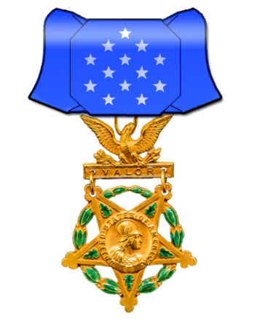

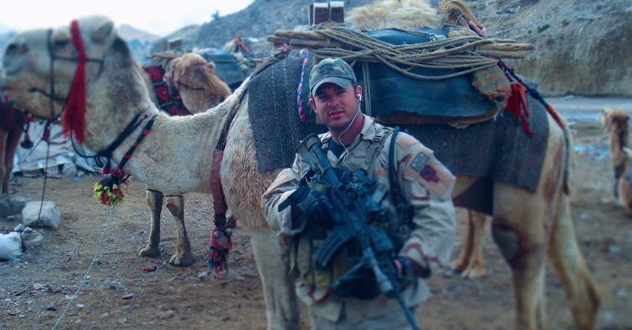

Master Sgt. Matthew Williams was with his team on a mission near the village of Hezeb Islami al Gulbadin in the Shok Valley of Nuristan Province, On April 6, 2008, then Sgt. Matthew Williams was a Green Beret with the Operational Detachment Alpha 3336, Special Afghanistan. They had been inserted by a riverbed in very steep, rocky terrain.
Soon after they arrived the silence around them exploded with machine gun and rocket propelled grenade (RPG) fire. Word came in that a couple of team members that were up higher, closer to the village, had been wounded. Williams and his unit found themselves in an intense battle with over 200 enemy combatants.
Williams climbed up the steep scree slope with another team member. They found that two of the men in that forward element had been wounded, one in the arm, the other with a serious wound to the hip. Williams went back down the mountain finding a new corridor to potentially move the wounded down and to get more commandos to move up to that level, then returned to where the wounded team members were.
While others transported the other wounded man, Williams was able to help the soldier who was ambulatory down the mountain to a small house located by the river bottom. That house would become the casualty point.
All of this was done under extremely intense enemy fire from multiple directions.
Williams would go up and down that steep slope several times during the battle continuing to help get the rest of the team back to the casualty point where they continued to take very heavy fire from the enemy.
Williams coordinated the medivac helicopters to come in for the wounded. The medivac helicopters had to come into a hot zone and were taking heavy fire from the enemy as they did. Williams had nothing but praise for those helicopter pilots who did not retreat but came in and stayed as long as was necessary to evacuate the wounded.
After six hours of intense fighting, engaged with over 200 enemy combatants, they were able to disengage. Not one U.S. soldier was killed.
Master Sgt. Matthew Williams was awarded the Silver Star for his actions that day. Last Sept. 14, 2018 he received a call from the President of the United States informing him that his Silver Star was going to be raised to the Medal of Honor at a White House ceremony on Oct. 30, 2019.

Army Nurse – First Woman Lost In Combat In WWII

· 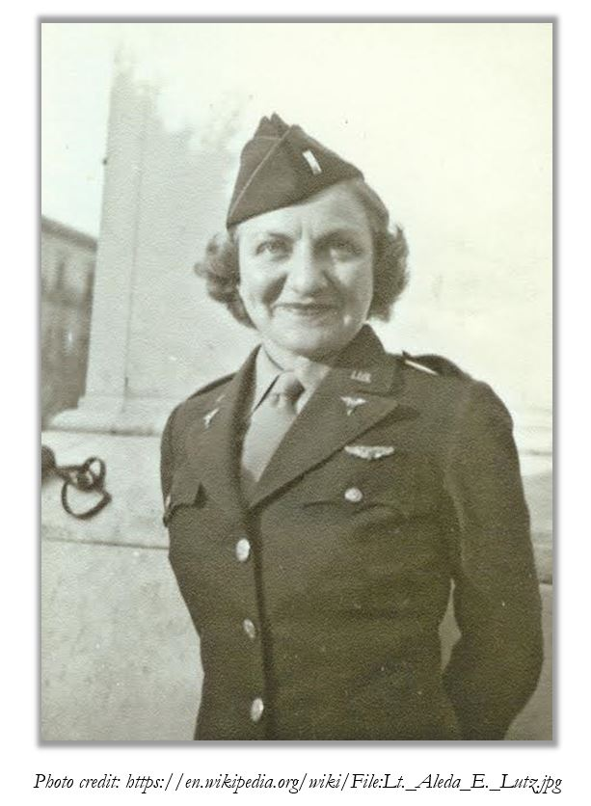
On this day in 1942, a daughter of German immigrants enlists in the Army Nurse Corps. Aleda Lutz would become one of a handful of World War II nurses qualified to fly aboard troop transport planes.
She is widely believed to be the first American woman lost in combat during the war, yet Lt. Lutz’s legacy endures: She remains one of the most highly decorated women in U.S. military history, with many facilities and military vessels also named in her honor.
Aleda Lutz was born in Michigan in 1915, and she was working as a nurse at a local hospital when the Japanese attacked Pearl Harbor. The young nurse was among those who jumped to serve. She volunteered for the Army Nurse Corps and was commissioned a second lieutenant on February 10, 1942.
Lutz served stateside at first, but that wouldn’t last too long. Nurses who could pass the pilot’s physical were encouraged to serve as flight nurses overseas, and Lutz was among only a handful who could pass the test.
By the end of 1942, Lutz found herself promoted to first lieutenant and assigned to the 802nd Medial Air Evacuation Squadron, Army 12th Air Force. Her life had been turned upside down over the course of a mere 12 months.
Lutz was immediately deployed overseas, and it seems likely that she received her training while on the job in a war zone.
Her service would span European, African, and Italian battlefields as she accompanied air combat missions and medical evacuations.
“The missions on which Lieutenant Lutz flew were made in all kinds of weather, and often from fields barely wrested from enemy forces,” one Army publication concluded in 1945. “She had flown into the beachhead at Anzio, Italy, when the enemy was still shelling the Anzio fight strip.”
Lutz’s letters home give further insight into her experiences. She was alternately excited at her new adventures, bored by periods of inactivity, or amused by American soldiers who gave her too much attention. (Many hadn’t seen an American girl in months!) Sometimes, she attended a memorial, and it left her feeling down. Always, she faced challenges from lack of equipment, and she was forced to drum up quick solutions with limited materials aboard aircraft.
Meanwhile, her friends were back at home in the States, getting married and having babies. She wondered “how I will ever fit in the picture if I ever get home, everything seems so changed.”
Unfortunately, she never had the chance to find out. Instead, the brave nurse was killed on November 1, 1944, as she attempted to help evacuate soldiers from Lyon, France, to a hospital in Italy. Her medevac flight crashed into the side of a mountain during poor weather. There were no survivors.
Before her passing, Lutz had served on 196 missions, and she had 814 flight hours under her belt. She’d helped to transport more than 3,500 patients to safety.
Perhaps unsurprisingly, Lt. Lutz would become the first Army nurse to receive the Distinguished Flying Cross, posthumously. The award cited her “superior professional skill and courage” as well as her “selfless devotion to duty and outstanding proficiency.”

Tara Ross

Nebraska Native Gains Fame in WWII

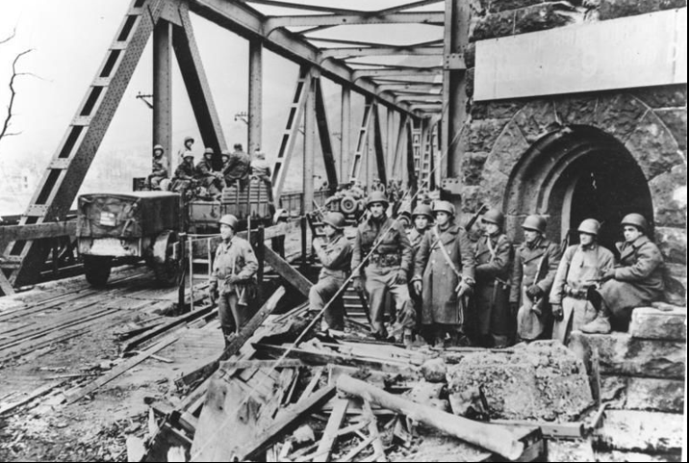
On a rainy German afternoon 75 years ago, 2nd Lt. Karl Timmermann stood on a hill and peered through wet haze at the bomb-battered railroad bridge he and his men had to find a way to cross.
This span at Remagen, alone among the Rhine River bridges in these last days of World War II, somehow had survived strafing by Allied bombers, and hadn’t been dynamited by retreating Nazi forces.
Timmermann and his soldiers knew the enemy must have wired it for demolition. German batteries had their guns trained on it.

Crossing the rickety bridge more than three football fields long, right under the enemy’s nose, was a fool’s errand, a virtual suicide mission.
But it had to be done. They had orders. Timmermann, a quiet, sturdy Nebraskan, knew his troops would follow him.
“What’s holding up the show?” he shouted, waving at his soldiers. “Get goin’, you guys, get goin’!”
So the men of Company A dashed across the bridge even as it was strafed by gunfire and rocked with explosions. They were the first invading soldiers to cross the Rhine since Napoleon.
“God was surely smiling on Karl Timmermann and his men that day,” wrote Ken Hechler, an Army historian and onetime speechwriter for President Harry Truman who chronicled the battle. He described it as “a brilliant stroke of military daring.”
Gen. Dwight Eisenhower said taking the Remagen bridge March 7, 1945, shortened the war in Europe by six months. The Nazis surrendered just two months later.
The Remagen miracle sparked worldwide headlines, bringing renown to Timmermann, 22, of West Point, Nebraska, in his home state and far beyond. He was one of several soldiers in his unit awarded the Distinguished Service Cross, the Army’s second-highest award for valor. His heroism was later celebrated in Hechler’s popular 1957 book, “The Bridge at Remagen,” and a 1969 Hollywood movie of the same name.
But back in West Point, Timmermann’s wartime achievements didn’t carry much weight. His neighbors had a hard time forgetting that he was German-born, part of a poor family from the wrong side of the tracks. Worst of all, his father, John, had deserted from the U.S. Army in Germany after World War I and returned home a few years later with a German bride.

(Remagen – Continued)
“A lot of people in town looked down on him,” said Robert Wostoupal, a Vietnam War veteran from the West Point area who served for years as Cuming County’s veteran services officer. “He was just kind of shunned for what his father did or didn’t do.”
Wostoupal worked with Hechler — who took part in the Rhine River campaign and interviewed Timmermann soon after — to bring attention to the soldier’s accomplishments. In 2004, Hechler published a second book, “Hero of the Rhine: The Karl Timmermann Story.”
In an interview that year, Hechler told The World-Herald that he was shocked to learn of Timmermann’s ill treatment.
“The whole story of his life is so fascinating to me,” said Hechler, who died in 2016 at age 102. “It’s stranger than fiction.”
The first invading officer to cross the Rhine had been taunted and called “Hitler” as a teenager because of his heritage.

A generation earlier, John Timmermann had worked at his own father’s feed store in Snyder, Nebraska, until enlisting in the Army in spring 1919. He was assigned to post-World War I occupation duty in Germany but was one of about 40 members of his unit who went absent without leave once they got there.
He married a German woman, Maria (Mary) Weisbecker in 1921. Karl, the oldest of the couple’s four children, was born the following

year. But the family couldn’t make a living in postwar Germany. They returned to Nebraska in 1924.
Four years later, John Timmermann turned himself in to the Army. He served no jail time but received an other-than-honorable discharge. That solved his legal problems but didn’t change his neighbors’ disdain. John Timmermann couldn’t find steady work, and Mary was subject to taunts at her job at a local cafe.
“We were looked at as second-class citizens,” Karl Timmermann’s sister, Mary Ellis of Omaha, told The World-Herald in 2004. “We knew what prejudice is. We knew it, we felt it.”
Karl Timmermann joined the Army within a month of graduating from high school in 1940 “to clean up the Timmermann name,” said Ellis, who died in 2012.
Karl served as an enlisted soldier for three years before being commissioned as an officer in 1943. While home on furlough, he met and married La Vera Meyer of West Point that May after a three-month courtship.
His unit, the 27th Armored Infantry Battalion of the 9th Armored Division, landed in France in August 1944, and engaged in months of heavy fighting. Timmermann was wounded by shrapnel during the Battle of the Bulge later that year. The night before the bridge engagement, he was named company commander despite his rank because senior officers had been wounded.
(Remagen – Continued)
Neither Timmermann nor his men were eager heroes. When one of his men asked what they should do if the Germans blew up the bridge while they were on it, he said, “Swim.”
Timmermann assembled three platoons to accomplish the task and put himself with the first one. As he gave instructions, a massive explosion nearby sent timbers and steel flying through the air.
German defenders on the other side had set off a charge in hopes of destroying the bridge. They blew a large hole in the road leading up to it, but the bridge remained standing.
Then it was Timmermann’s turn.
“Let’s go,” he said.
German machine guns opened fire, but Timmermann and his men kept going. One soldier, Sgt. Joseph Delisio of New York City, climbed a three-story tower at one end of the bridge and captured three German gunners who had some of the Americans pinned down. Delisio’s buddy, Sgt. Al Drabik, was the first across.
Karl Timmermann held the distinction of being the first officer across, only a few steps behind.
The men of Company A secured the bridge and fought off pockets of German resistance on the other side. Over the next 10 days, 25,000 American troops crossed it.

Then, finally, weakened by bomb damage and too much heavy traffic, the bridge collapsed into the Rhine. At least 20 soldiers were killed.
Timmermann was discharged in December 1945 and returned to West Point, in Hechler’s words, “a lone figure trudging into town with a barracks bag slung over his shoulder. His reception committee consisted of one little dog who snarled and snapped at his heels.”
He worked for a time as a salesman in Fremont but rejoined the Army in 1947, and later was assigned to Japan. He saw combat again when war broke out in Korea, taking part in the landing at Inchon in September 1950.
Within weeks, though, Timmermann was sent to a military hospital in Colorado after developing a painful lump in his groin. It turned out to be cancerous. He died in November 1951, at age 29.
A few in town argued that West Point’s hometown hero deserved a memorial. A former mayor told Hechler in the 1950s that “most people were tired of the war. Also, there were many deserving veterans who came home from World War II.”
Ed Baumann, a local department store owner and president of the War Dads during World War II, wrote to Hechler that “Karl was a real gentleman and a true-blue soldier. He was a hero. But the town belittled him.”

(Remagen – Continued)
He blamed John Timmermann’s braggadocio and religious prejudice, because Karl Timmermann was Catholic and had married La Vera, who was a Missouri Synod Lutheran.
Over time, some of the hard feelings softened. In 1965, the town named a park for him. And in 1995, Wostoupal organized a celebration in Timmermann’s honor, on the 50th anniversary of the bridge crossing. A monument was erected in his honor, too, calling him the “Hero of the Rhine.”
“I just took it upon myself to do it,” he said. Hechler spoke at the ceremony. So did then-Gov. Ben Nelson.

Wostoupal said he’s heard no mention of any events to honor Timmermann this year. His close family is all gone. His parents and three siblings have died. La Vera, who remarried in the 1950s, died in 2002. His daughter died in 2015.
But Wostoupal still thinks Timmermann’s story deserves to be told.
“He did not get the praise or glory he deserved,” Wostoupal said.

Early-warning system tells E-4s when First Sergeant is approaching

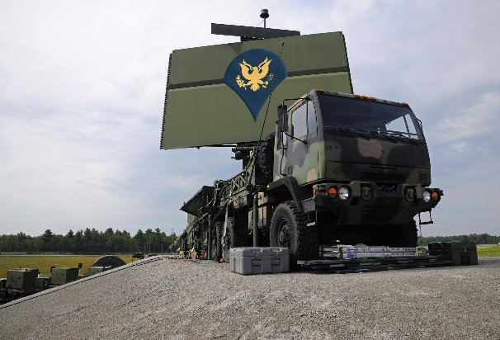

BENNING, Ga. — Specialists across the U.S. Army have begun testing a new early-warning system that lets them know when a senior noncommissioned officer is inbound to their position.

A trove of leaked hand-scribbled notes, as well as blueprints and photographs, have revealed the existence of the Specialist Hands-free Automated Mobile System for HIgh-ranking Enlisted Leader Detection, a repurposed mobile radar platform. It has been programmed to spot angry senior noncommissioned officers on approach before quickly sending out a notification, similar to an AMBER Alert, informing users of the bogey’s speed, location, and anger-level, according to experts who have reviewed the materials.

A barracks resident who had scribbled sharpie over his still plainly readable nametape showed reporters the current alert on his phone. He then told reporters that he had to “go to dental” and walked off before his first sergeant could spot him.
Further tests by barracks scientists show the SHAMSHIELD increases the average warning lead-time from 2.4 minutes to 3.8 minutes, allowing non-NCO E-4s more precious time to find cover and concealment or pretend to be busy with something else.
“Back in the day, we knew to quickly skedaddle or grab our shamming-clipboards because one of the guys would run past and tell us ‘First Sergeant is on his way, and he looks pissed!’” said Ben MacKall, a former soldier who left the service last year. “When smartphones came along, we used mass text-messaging. But based on what we’ve seen in the leaked report, it looks like they’ve perfected the process.

Development of the device comes as no surprise to NCOs between corporal and staff sergeant, according to Staff Sgt. Ignacio Vidal, a military policeman who discovered one of the SHAMSHIELD emitters mounted on an old military vehicle atop a concrete bunker during a routine patrol.

“As a young E-4, I was quite good at making myself scarce when I realized ‘Top’ would be paying us a visit shortly,” said Vidal. “But as I’ve climbed the ranks, I’ve become less adept at outsmarting the specialists under my supervision when they try to disappear before it comes time to pick up cigarette-butts or wait in a lengthy formation.

“Generation Z has managed to out-sham the Millennial Army, and we NCOs haven’t got a chance at stopping them.”
Meanwhile, senior Pentagon officials say senior NCOs appear to be clueless that they’re being outmaneuvered by their subordinates.

At press time, a spokesperson for the E-4 Mafia told reporters that once finalized, the SHAMSHIELD should collectively save Army specialists about 4.9 man-years by helping them dodge bullshit work-details.

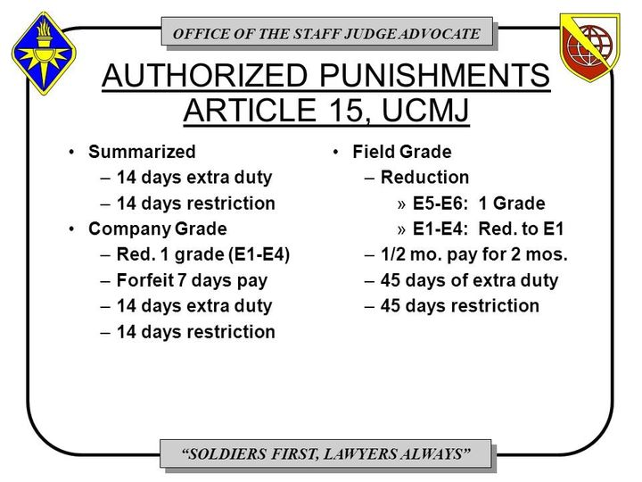
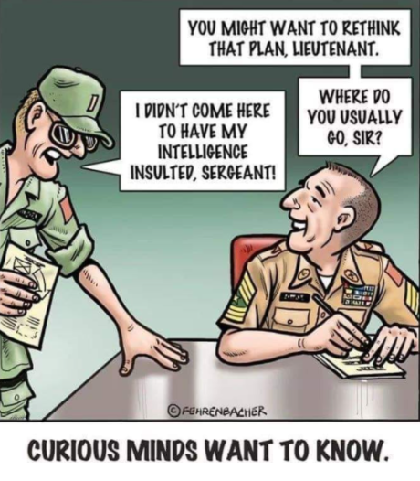
Become a Member of The American Legion
Do you want to help your community and fellow Veterans by becoming a member of the American Legion? Would you want to help recruit a new member? If you can certify that you served at least one day of active military duty since December 7, 1941 and were honorably discharged or are currently serving honorably, you are eligible. Complete the application below and send it with a check in the amount of $46.00 to:
American Legion Post 3
123 South 84th Street, Suite L
Lincoln, Ne 68510
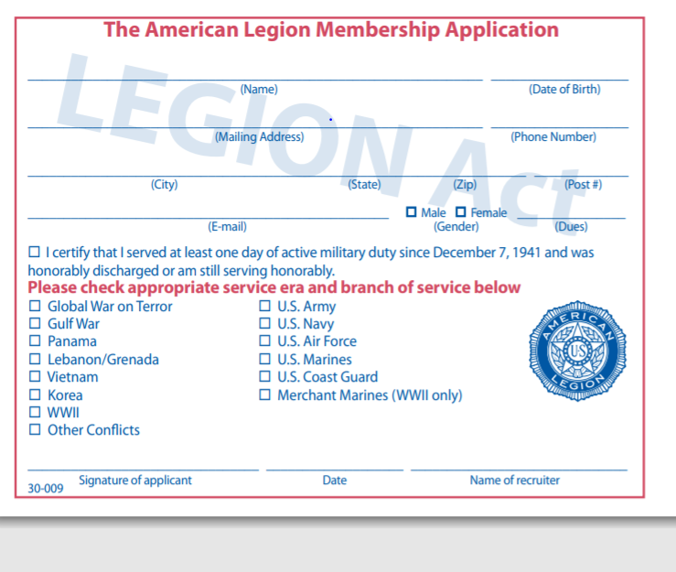
To renew or transfer to Post 3, you only need to sign below and mail this and a check for $46 made out to “American Legion Post 3” to the address listed above. If you have already renewed for 2021, and want to transfer to Post 3, only sign below and return the bottom portion to us.
YES! Please transfer my membership to Lincoln American Legion Post 3

___________________________________________ Signature

___________________________________________ Membership Number

American Legion Post 3
123 South 84th St. Suite L
Lincoln, NE 68510
(402) 466-3958

Post3legionlincoln@gmail.com
https://lincolnpost3.org
2020 - 2021 Post 3 Officers
Commander - Wade Graft – Cell: 402-770-9126
First Vice Commander – Gerry Wolf – Cell: 402-417-8230

Second Vice Commander – Bruce Gubser – Cell: 402-470-1700
Adjutant – Ed Schnabel – Cell: 402-480-8542
Chaplain – William Jackson – Cell: 402-613-9774
Post Service Officer – Ed Schnabel – Cell 402-480-8542

Please submit any announcements or items for the monthly newsletter to the Adjutant for approval. All requests must be received one week before the 1st of the month.

