Volume 7, Issue 6
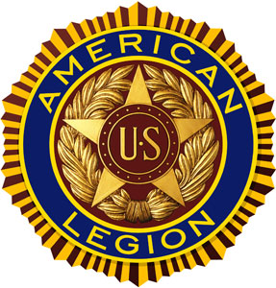

“For God And Country”
June 2021 POST 3 NEWSLETTER
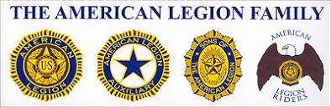

Meeting Schedule For June 2021 – July 2021

Organization | Location | Time | June | July
Legion Post 3 | Elks Lodge, 5910 S 58th | 7 PM | 06/08/21 | 07/13/21
Auxiliary Unit 3 | Elks Lodge, 5910 S 58th | 7 PM | 06/08/21 | No Meeting
SAL Squadron 3 | Post 3 Office, 123 South 84th | 7 PM | 06/17/21 | 07/15/21
ALR Chapter 3 | Denton Legion Club | 6 PM | 06/17/21 | 07/15/21
40 & 8 Voiture 103 | Elks Lodge, 5910 S 58th | 7 PM | 06/15/21 | 07/20/21
8 & 40 Salon 832 | Elks Lodge, 5910 S 58th | 7 PM | 06/15/21 | 07/20/21
Buddy Check | The Foundry, 211 N 14th | 7 PM | 06/22/21 | 07/22/21
VA Coffeehaus | Auld Pavilion Rec Center | 10 AM | TBD | TBD

Commander’s Call

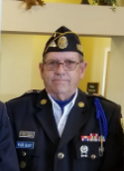
Legion Family All ........

The current Legion year is winding down. August 1st begins a new year with a new Post Commander and several other changes in Post 3 leadership. If you will attend the June 8th Post 3 Legion meeting you will be asked to vote on these changes. New people bring welcome new ideas and enthusiasm to move Post 3 forward. Serving as your Post Commander this past year has been a privilege and an honor for me. I learned a lot and hope that I had a positive influence on Post 3. I will still be active in Post 3 and remain on the Honor Guard. I know these changes will be a strong Stage 4 outcome.

Here's a short quiz to see how much you know about the American Legion and Post 3 Just for the fun of it. The answers immediately follow the questions.

1. Name the four Pillars that guide the American Legion in all our endeavors.

2. When did the U.S. Congress officially charter the American Legion?

3. How many members does the American Legion currently have in the U.S. and overseas?

4. How many members does the American Legion have in Nebraska?

5. How many Legionnaires belong to Lincoln Post 3?

6. How many current members of Post 3 have you personally recruited?

(1. Americanism--Children and Youth--National Security--Veteran Affairs & Rehabilitation)
(2. Sept. 16th, 1919)
(3. Approximately 2 million)
(4. Approximately 30 thousand)
(5. Approximately 1350)
(6. ?? This number is up to you to determine. I hope it's a big one and growing.

Respectfully,
Wade Graft
Post 3 Commander
402-770-9126

Adjutant’s Report

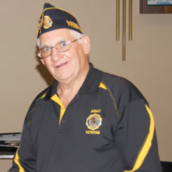

-

Welcome, Again, Time to pause and remember.
JUNE 1944 The Normandy Landing, “Operation Overlord”, D-Day, Largest seaborn invasion in history.
Last month we celebrated "Decoration Day" or as it’s now called “Memorial Day”. This month marks the 77th anniversary of the D Day landings on the beaches of Normandy. After three years of fighting, the war in Europe would be over in 11 months. Allied casualties were 10,000, with 4,414 killed. It was not the end but was the start of the end of WWII.

Where is your DD214 or Discharge Papers? And does your family know where to find it?
When the time comes, who can help your loved ones with your request for Military Honors by doing some simple things now.

First, if you desire Military Honors during your memorial service, you need to talk with your family, so they know your wishes.

Second, find your DD214 or discharge papers, again, tell your family their location, this is a key piece in requesting Military Honors that are provided by DOD personal.

Third, talk with your family as to where you would like to be interned. The local family plot or in a VA National Cemetery. You can find answers to many of your questions on the VA’s web site.

The VA’s site will help with requesting a VA grave head stone, how to request burial in a National Cemetery, etc.

Two pieces of legislation that will influence our military family. Legislative bills #387 and #64.

The Nebraska Legislature passed these two bills that deal with the taxation of Military Retirement pay and Social Security benefits.

For taxable years beginning or deemed to begin on or after January 1, 2022, 100% of benefit will be free from Nebraska state income tax.

Legislative Bill #64 begins a nine-year program to lower the Nebraska state income tax on Social Security benefits. 2021 – 5% will be tax free, building to 100% tax free in 2030. The way the bill was written, any further Nebraska Legislature could vote to stop or end the benefit, so we must keep an eye on them.

The Legion is still working on renewing those who have yet to pay their 2020-2021 dues.

Legion National HQ is processing 2021-2022 members cards currently. Notices will be mailed out at the end of June, only a month off. 2021-2022 Legion Year begins August first, 2021. At this time, I do not believe there will be any dues increase for 2021-2022.

Have a great summer and stay safe out there as you enjoy getting out of the house for a change.

Again, thanks to all those who have served.

Ed Schnabel
Adjutant

LINCOLN CBOC/VA NEWS
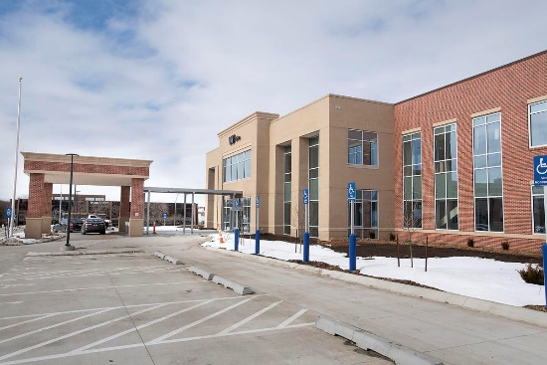

Take time to remember those who fell on D-Day, June 6, 1944. All Gave Some, Some Gave All.
The new Lincoln Community Based Outpatient Clinic, (CBOC), served it first patients on March 2, 2021. The coffee shop is now open. Located to the west (left) of the entrance as you enter the building. They will have a full line of coffee and drinks, and some food items.
The VA is still doing Covid-19 screening, I believe they are only given on Wednesdays currently. NOTE: To receive a shot from the VA you must be enrolled in the VA Health Care System.
The VA sent out a message on their VA Web Site that they are now giving shots to partners of veterans. If you get care from the VA Health Care System, then you are enrolled. For those who do not currently used NWI (Nebraska Western Iowa) Health Care System, Omaha VA Hospital or the local CBOC’s. You can call 404-828-5257 to check if you are enrolled and enroll if you are not currently enrolled to receive VA Health services.
They request that you use the VA Facebook or the VA web site to request an appointment. The VA will call you back to make the appointment with you. They have brought more staff on hand to handle these covid-19 requests.
Shots are only being given to the veteran and those who Are enrolled as a Veteran Gare Giver with the VA. Remember to bring your VA ID card. You are required to check in for your appointment on the Kiosk and you will need your VA ID card or your full Social Security Account number.
When checking in, it will print off your appointments, in small print it tells you which waiting area to wait in. Staff will come out to the waiting areas and escort you to your appointments.
There are five waiting areas, two on the main floor and three on the second floor. Look for West Waiting Area, South Waiting Area, or East Waiting Area. Remember, the main entrance faces SOUTH.
Come and see your new CBOC. It’s worth a visit.
Remember, the VA will only to be there for us if we use its services. If we do not use them, the government sees it as a service not needed here and will cut funding for the Lincoln CBOC. The government funds each CBOC / hospital based on the number of veterans signed up for services in its service area.
They, the veterans, do not need to be using the VA for their medical needs, just need to be enrolled in the VA Health Care System. Funding is based on foreseen needs, not current need, thus we need to talk with our fellow veterans to be sure they are enrolled in the VA system.
There are many veterans who could receive medical service but have never signed up for this benefit of our service. Again, it is the old story, use them or lose them.
Thanks for your service.
Ed Schnabel
Lincoln VAG member (Veteran Advisory Group) Lincoln VA American Legion Representative for Nebraska

Post 3 ALR Director’s Remarks

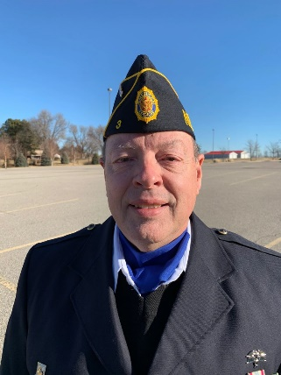
The weather is warming (and humidity is on the rise), the backroads are clear, and our bikes and trikes need some miles added to the odometers! We just held our Poker Run fundraiser on Sunday, May 22nd. Although we had far fewer participants this year, due to a number of other competing events in the area, we had good results in our fundraising efforts for our chosen charities, Pets for Vets and Guitars for Vets. Through the efforts of some 25 riders (plus passengers, in some cases), playing 49 poker hands, participating in a 50/50, a raffle, a couple of donations, and a silent auction, we were able to raise $792. We’ve already received another donation of $8 to make it an even $800 to be split between the charities. Well done, Riders and all!!!

A few of our Riders are also participating in another fundraiser for our Chapter, called the “Lack of ‘Cents’ Challenge.” In this challenge, riders solicit support by way of pledges per mile ridden on their bike or trike

between now and the end of October. Pledges can be in any amount, including fractions of cents. The charity, or charities, selected to receive the results of have not yet been selected, but the intent is to keep the donation local and in a way that benefits Veterans. Our local community and Veterans have endured so much during this past year, and now that we are making our way back to “normal,” many of our charities have continued to struggle. Our goal is to ride 10,000 miles as a group.

With COVID-related restrictions being lifted or relaxed, many communities who cancelled activities last year are on track with their celebrations this year, and we anticipate participating in several parades in the coming months. We very much enjoy representing The American Legion, our sponsoring Post, and our ALR Chapter in communities in the surrounding area. We currently have plans for, or at least are aware of, about a dozen parades in communities from Wymore in the south to Ashland in the north, and from Hebron in the west to Weeping Water in the east.

Until next time,
Ride (and Drive) Safe!!

Bruce Gubser
Director, Lincoln Chapter 3, American Legion Riders

**************************************************************************************************

Mark your calendars now for a ceremony taking place on Wednesday, June 2nd, 9am, at Hanger 948 at the Lincoln Air National Guard Base, near the Lincoln Airport.

From the Department of Nebraska, The American Legion:
"The Defense POW/MIA Accounting Agency (DPAA) will be holding a ceremony to honor a Sailor from the USS Oklahoma (sunk on December 7, 1941), whose remains were recently identified by the DPAA in their labs at Offutt Air Force Base. The Sailor is being returned to his hometown for proper and final burial.
The ceremony will be held on June 2nd, at Hanger 948 at the Nebraska Air National Guard Base in Lincoln at 9:00am and he will be loaded onto a plane at 10:30. No Legion Color Guard or other Legion ceremony requested, only the presence of Veterans to honor the service and sacrifice of this Sailor."

If you intend on attending the ceremony, just tell the security officials at the front gate that you are attending the ceremony at Hanger 948, and they should let you on the base with no issues.

Submitted by Bruce Gubser

Two Post 3 Members Receive Recognition

On Wednesday, May 12, two Post 3 members, Ray Mathis (PFC, US Army, Korea, deceased) and Dale Nurnberg (1LT, US Army, Vietnam) were recognized by the HONOR365 organization at a ceremony in the Veterans Memorial Garden at Antelope Park.
Dale Nurnberg and Marilyn Mathis (Ray’s Wife) were presented with a certificate and coin.

Lincoln was one of the stops on a nationwide tour of a 9/11 exhibit, sponsored by HONOR365. The exhibit was on display at Gateway Mall from May 11th-22nd. On May 12th, at an event hosted by HONOR365 and the Lincoln Convention and Visitors Bureau, Ray and Dale were recognized, along with other living and deceased heroes from the fire, law enforcement, and first responder communities.

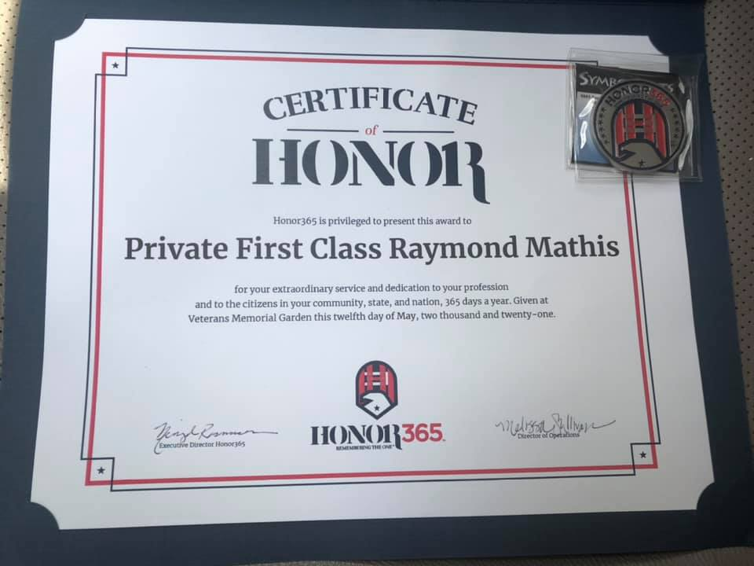

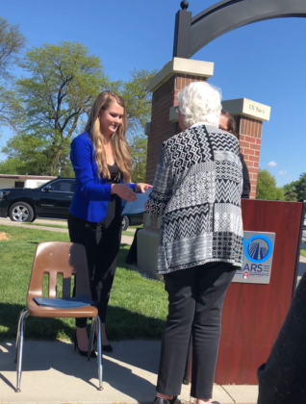

Each honoree received a certificate and token of appreciation. The event also featured speeches by Nebraska Governor Pete Ricketts and Lincoln Mayor Leirion Gaylor Baird, along with an Honor Walk led by the Lincoln Fire & Rescue Pipe & Drum, a shotgun salute by the Lincoln Police Department Honor Guard, and Taps played by a Lincoln Firefighter. Lincoln Chapter 3, American Legion Riders, stood in a flagline at the entrance to the Garden prior to the ceremony.

Submitted by Bruce Gubser

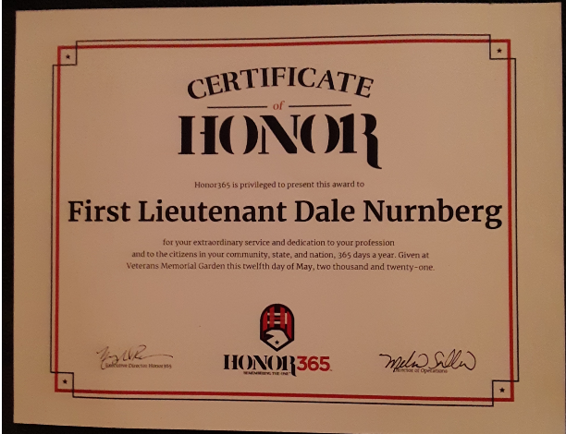

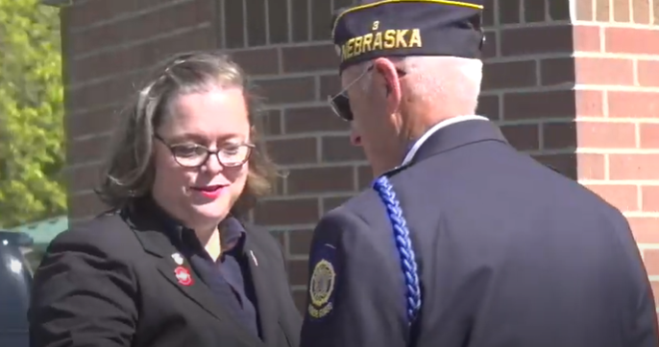

Message From The Chaplain
Heroic Stand

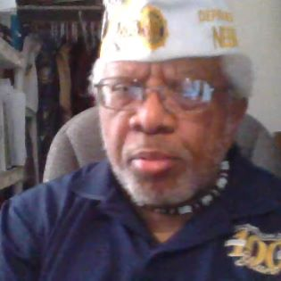

Rev. Dr. William Jackson
Lincoln ALP 3 Chaplain
There comes a time when every person needs to stand up, look into their mirror, and imagine…that a robust warrior is staring back at you, armed to the teeth, and raring to go to battle for a worthy cause.
And what cause is worthy enough for a person like you, you’re wondering? Come to think of it, what cause warrants ANYONE’S attention, beyond the daily grind and bustle of merely living, let alone managing to make something of one’s self? I imagine that the Lord might have something to say about overcoming adversity, like in the case of having a dear friend to aid one’s quest for significance and accomplishment (Proverbs 17:17).
What is it for you to stand in the Lord and finally realize what you’ve been put here for? Have you ever really wondered what it might be like to do and be the person God wants you to be, without rancor or subterfuge (Jeremiah 40:4)? Or how about fathoming what to do in your here-and-now to vastly improve your status among God’s elect (Matthew 24:24) in serving Him with no doubt or anxiety (1 Peter 5:7)?

It’s time. Time to prepare. Time to rehearse. Time to do all things that would make you ready for His return in full glory to take you home with Him. Wouldn’t that be worthwhile to know that you, and hopefully your family and friends, will be caught up with the Lord—the Persia, Greek for the Rapture (1 Thessalonians 4:17)? Imagine: you and the Lord…together…in Heaven….!?!?
Preparation is the key to comprehending what the Lord has for you to do…still. It starts with your accepting Him as your Lord and Saviour (Romans 10:10) to be saved from your rightful condemnation (Jude 1:4). Next is your willingness—for God would NEVER force you to obey Him—to serve Him through your love for Him and compassion for His greatest creation, your fellow women and men (Matthew 6:24). Another consideration for armouring up to fight on God’s team is to dress in appropriate gear (Ephesians 6:10-18), where your spiritual war garment covers your front, like any seasoned trooper, because you’re facing the enemy, not running away from him, Satan.
So…the battle is upon us. Who stands with the Lord, knowing victory over those little anti-Christs and Satan’s wiles because they CAN NOT HURT you—IF—you stand in the Lord’s wake (1 Corinthians 15:57)? We’re soldiers with varying skills and talents honed through our service with America’s Armed Forces, and our studies of His Word, the Holy Bible (2 Timothy 1:7). Let’s armour up, folks! You KNOW you can do it! This fight is spiritual, so never lose sight of your marching orders from God. Fulfill your destiny through God’s wisdom (James 1:5).

Nebraska Highway 20 Renamed

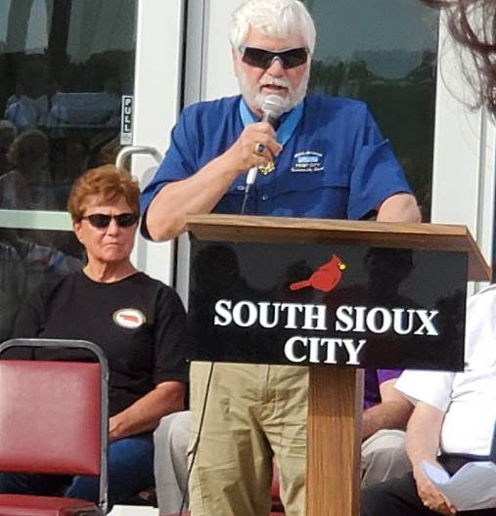
It was a bright, sunny, cheery day on 22 May 2021 when Nebraska’s Route 20 was renamed U.S. Medal of Honor Highway with a dedication at Siouxland Freedom Park in Sioux City, NE. Daryl Harrison and fellow walkers traveled 432 miles eastward from the Wyoming border to Sioux City as part of a national American road honoring Medal of Honor veterans.
Among the distinguished but humble persons at Freedom Park was James McClelland, a U.S. Army veteran, and Medal of Honor recipient, who also sang the U.S. National Anthem during opening ceremonies. He was joined by Daryl Harrison, American Legion Nebraska Area A Vice Commander, who helped McClelland smash a champaign bottle against a rock from the Berlin Wall signifying the official naming of former Nebraska Highway 20.
Iowa Department Commander James Kessler also came forward to take the next step of naming Iowa Highway 20 as Iowa Medal of Honor Highway.

In attendance were American Legion Nebraska Department Commander Gary Wooten, Sioux City Mayor Rod Koch, and American Legion Post 307 Commander Mike Newhouse, who served as program master of ceremonies. A Native American group from Sioux City American Legion Post 307 played drums in blessing the Nebraska highway project. The Medal of Honor Highway will cross this nation from Newport, Oregon to Boston, Massachusetts when the naming is completed.
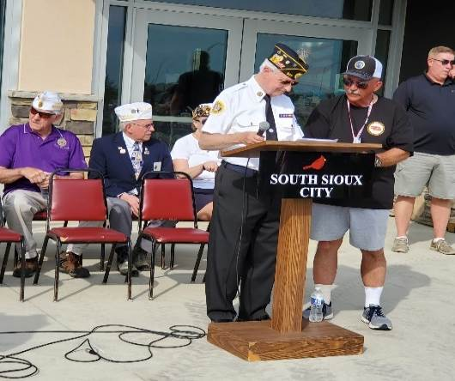

(Left, ALP 307 Commander Mike Newhouse &
AL NE Area A Commander Daryl Harrison)

Submitted by William Jackson

Post 3 Honor Guard

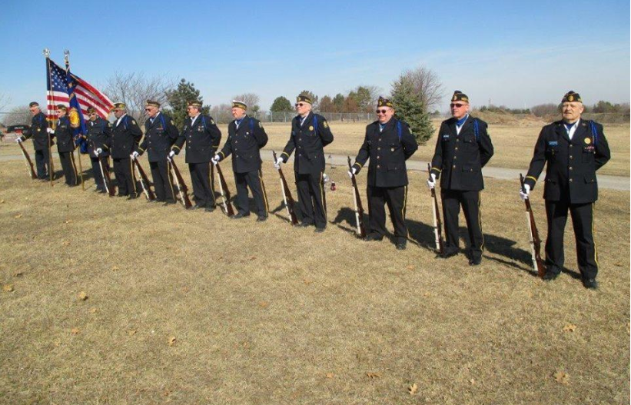
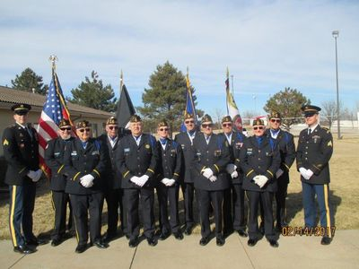

In the month of May, the Honor Guard rendered “Honors” at 10 Legion funerals and was asked to assist at 7 VFW funerals. They also appeared at 8 civic functions. In calendar year 2021, the Honor Guard rendered “Honors” at 70 combined funerals and appeared at 11 civic functions.
Make sure to fly your American Flag high and proudly on Monday, June 14, Flag Day.
The Honor Guard conducted Memorial Day ceremonies at 5 locations on Memorial Day.
Below are a couple of pictures of the Honor Guard performing an early Memorial Day ceremony at Pemberly Place, a senior housing and living center in Lincoln.

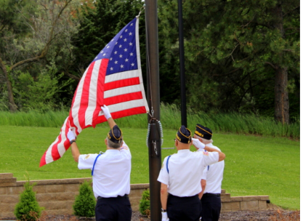

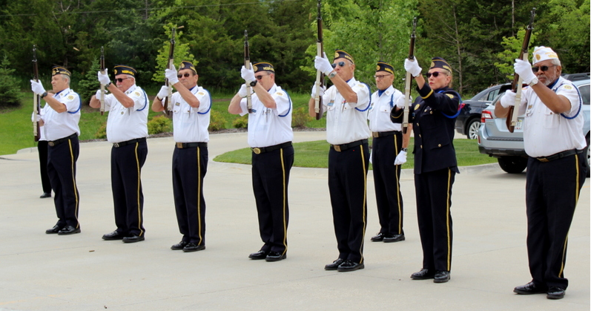

Submitted by Gerry Wolf

April 2021 TAPS



LEGIONNAIRE | WAR ERA | BRANCH | YEARS
Charles Hagemeister | Vietnam | Army | 53
Robert Huneke | Vietnam | USAF | 19
Charles Savidge | Korea | Army | 55
Pressley Williams | WWII | Unknown | 51

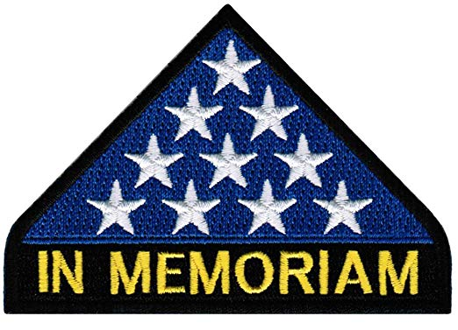

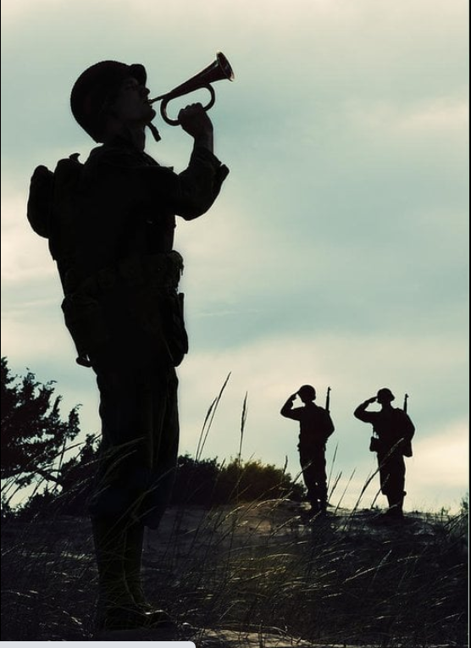

Minutes of the April 2021 Regular Monthly Meeting
Regular Meeting of American Legion Post 3
Lincoln Elks Lodge #80 and on ZOOM
May 11, 2021

Commander Wade Graft opened the May 11, 2021, meeting of American Legion Post 3 at 7:00 PM at the Lincoln Elks Lodge 80 with 22 Legionnaires and guests present. The meeting was being made available on Zoom.

Steve Bartos read the minutes of the April 13, 2021, meeting.

Ed Schnabel gave the financial report for the month showing a balance on hand of $40,095.00. Ed Muggy questioned the use of some money out of the Bunker Fund. The report was filed for review.

Several new members or guests were asked to introduce themselves, and they made a few remarks.

Veterans of the various war eras were asked to stand and be recognized.

As related to membership, Dr. Jackson gave a brief report on some of the things he had been working on with YouTube, Facebook, etc.

Bruce Gubser reported for the Legion Riders. The Riders will meet next Thursday (the 20th), and the Poker Run will be held on May 22nd.

Bruce also reported on the Honor 365 event to be held at 10:00 AM tomorrow at the Veterans Memorial Gardens. Ray Mathis (deceased) and Dale Nuernberger are going to be recognized. An Honor 365 display will be at Gateway through May 22nd.

Bruce also reported on the Birthday Card Project, and said cards were available for signing tonight.

Gerry Wolf reported on ROTC. He indicated that he and the commander had attended the Chancellor’s Review at UNL. He also indicated there had been a program for the JROTC unit at Lincoln Northeast High School.

Fred Chrastil reported for the Memorial Squad. He indicated that they had done 59 funerals and were preparing for the presentation of colors and a post everlasting ceremony at the Department Convention in June. They will also be participating at events on Memorial Day, at Brentwood Estates, and at Eagle Days.

Gerry Wolf made an appeal for help on the Memorial Squad.

Jerry Salber reported briefly on the 40/8. He invited anyone who is interested to contact him about becoming a member. Voiture 103 will meet next Tuesday at 7:00 PM.

In the way of Americanism, Brendan Moore reported on the 100th Anniversary of the Tomb of the Unknown Soldier.
District 15 Commander Ed Muggy reported on 3 resolutions being submitted to the Department Convention that are intended to clarify the order of succession of the Department officers. Each takes a slightly different approach to the subject. Steve Bartos pointed out that the post could vote to select one over the other two, but such action would only serve as a recommendation to the District 15 delegate appointed to serve on the Resolutions Committee at the Convention. The actual adoption or rejection of the resolutions will be made by Convention following convention procedures.

After much discussion, the body recommended that Steve Bartos be appointed to serve on the Resolutions Committee at the Convention.

Commander Graft called for nominations for Post 3 officers for the coming year. Nominations were as follows.

Commander --- Gerry Wolf by Jack Sibert
1st Vice Commander --- Bruce Gubser by Dave Timmerman
2nd Vice Commander --- Ronnie Hindmand by Gerry Wolf
3-Year Term on Post Executive Committee --- Fred Craigie by Jack Sibert.

Jack Sibert reported on activities with the web page.

Jack also reported on an ongoing project at Wyuka Cemetery to provide headstones for some of the unmarked graves in “Babyland.” The post may consider this as a project in the future.

Chaplain Jackson read TAPS and the meeting was closed at about 8:20 PM.

Steve Bartos, Recorder

Honoring Those Before Us

Remains of 2 Indiana brothers killed during Pearl Harbor attack identified.
La PORTE, Ind. — The remains of two Indiana brothers who were killed in the 1941 Japanese attack on Pearl Harbor have been identified by U.S. military scientists.
The Defense POW/MIA Accounting Agency said Monday it had identified the remains of Navy Fire Controlman 2nd Class Harold F. Trapp, 24, and Navy Electrician’s Mate 3rd Class William H. Trapp, 23.
The brothers from La Porte in northern Indiana were assigned to the battleship USS Oklahoma on Dec. 7, 1941, when it was attacked by Japanese aircraft while moored at Pearl Harbor.
The USS Oklahoma capsized after sustaining multiple torpedo hits and 429 crewmen were killed, including the Trapp brothers.
In 2015, the remains of unidentified USS Oklahoma servicemen were exhumed from the National Memorial Cemetery of the Pacific in Honolulu. The DPPA said military scientists identified the Trapp brothers’ remains last November after analyzing dental, anthropological and genetic evidence.
The Trapp brothers will be reburied in Honolulu on June 15, at National Memorial Cemetery of the Pacific, also known as the Punchbowl, nearly 80 years after their deaths in the surprise attack that launched the United States into World War II.
The brothers’ names are among the names recorded at the Courts of the Missing at the Punchbowl. A rosette will be placed next to their names to indicate they have been accounted for.
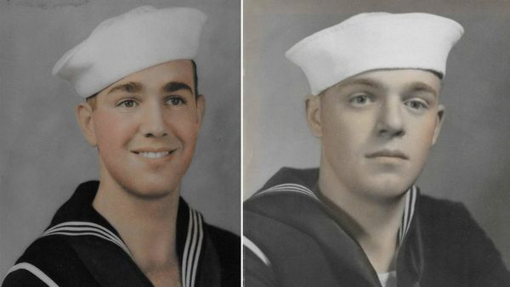

Medal Of Honor Recipient And Post 3 Member, Hagemeister Dies

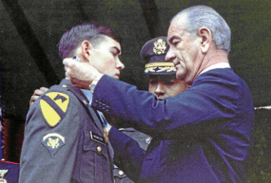
Charles C. Hagemeister, a Nebraska-born Army medic who was decorated with the Medal of Honor during the Vietnam War for dashing through enemy fire multiple times to save the lives of wounded soldiers, has died in Leavenworth, Kansas. He was 74.
Born in Lincoln in 1946, Hagemeister was the youngest of four children and graduated from Lincoln Southeast High School. He quit the University of Nebraska-Lincoln after a year of school and was working in a warehouse when he was drafted into the Army in 1966.
Hagemeister, then a specialist fourth class, served as a medic with the 1st Battalion, 5th Cavalry Regiment of the 1st Cavalry Division (Airmobile). The battalion was operating in Vietnam’s Binh Dinh province on March 20, 1967, when his platoon was surrounded on three sides in a graveyard and attacked by North Vietnamese troops, according to the Congressional Medal of Honor Society.
Two soldiers went down immediately. Hagemeister raced through heavy fire to treat them. He looked around and realized that he would have to lead because the platoon leader was dead and most of the rest were either killed or wounded. He was unable to call in air support because of the close quarters fighting, or evacuate the wounded. For hours, and under heavy fire, Hagemeister moved among the platoon’s defensive positions, treating soldiers, and rallying the survivors.
At nightfall, a sniper took aim at him and several other members of his unit. Medics typically don’t carry rifles, so Hagemeister grabbed one from a fallen soldier and shot the sniper. He also killed three other enemy soldiers who were silhouetted against a burning village as they tried to outflank him — and then took out a machine-gun nest, too. Still pinned down, Hagemeister again braved heavy fire and ran to get help from another platoon. He led the troops back, then worked to evacuate the wounded.
“Hagemeister’s repeated heroic and selfless actions at the risk of his life saved the lives of many of his comrades and inspired their actions in repelling the enemy assault,” his Medal of Honor citation said.
Hagemeister traveled to Washington to receive the medal — the nation’s highest award for military valor — from President Lyndon Johnson on May 14, 1968. According to the 2003 book “Medal of Honor,” by Nick Del Calzo and Peter Collier, Johnson asked Hagemeister during the ceremony how much longer he had left in the service. “About 72 hours, sir,” Hagemeister replied. Johnson turned to a senior officer standing nearby and said, “I want you to talk to this young man after we’re done here and change his mind.” The president’s gambit worked. Hagemeister reenlisted and made the Army a career. He later became an officer and retired as a lieutenant colonel in 1990.
A funeral service was be held 11 a.m. Wednesday, May 26, 2021, at Sacred Heart Catholic Church in Leavenworth, with burial at 1:30 p.m. at Leavenworth National Cemetery. Hagemeister’s death leaves 66 living Medal of Honor recipients, according to the Congressional Medal of Honor Society. Former Gov. and Sen. Bob Kerrey is the only one left from Nebraska.
STEVE LIEWER - Omaha World-Herald

The Tootsie Roll Marines
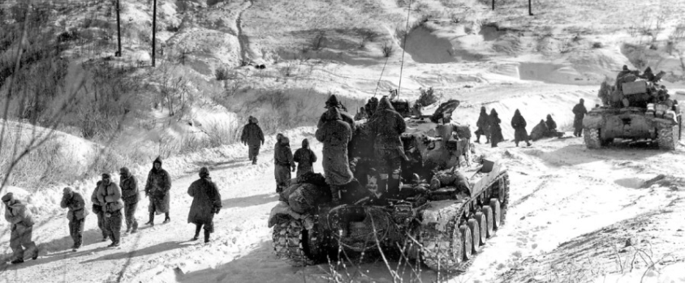

On November 26, 1950, 10,000 men of the First Marine Division, along with elements of two Army regimental combat teams, a detachment of British Royal Marine commandos and some South Korean policemen were completely surrounded by over ten divisions of Chinese troops in rugged mountains near the Chosin Reservoir. Chairman Mao himself had ordered the Marines annihilated, and Chinese General Song Shi-Lun gave it his best shot, throwing human waves of his 120,000 soldiers against the heavily outnumbered Allied forces.
A massive cold front blew in from Siberia, and with it, the coldest winter in recorded Korean history. For the encircled allies at the Chosin Reservoir, daytime temperatures averaged five degrees below zero, while nights plunged to minus 35 and lower.
Jeep batteries froze and split. C-rations ran dangerously low and the cans were frozen solid. Fuel could not be spared to thaw them. If truck engines stopped, their fuel lines froze. Automatic weapons wouldn't cycle. Morphine syrettes had to be thawed in a medical corpsman's mouth before they could be injected. Precious bottles of blood plasma were frozen and useless. Resupply could only come by air, and that was spotty and erratic because of the foul weather.
High Command virtually wrote them off, believing their situation was hopeless. Washington braced for imminent news of slaughter and defeat. Retreat was hardly an option; not through that wall of Chinese troops. If the Marines defended, they would be wiped out. Instead, they formed a 12-mile long column and attacked.
There were 78 miles of narrow, crumbling, steeply-angled road and 100,000 Chinese soldiers between the Marines and the sea at Hungnam. Both sides fought savagely for every inch of it. The march out became one monstrous, moving battle.
The Chinese used the ravines between ridges, protected from rifle fire, to marshal their forces between attacks. The Marines' 60-millimeter mortars, capable of delivering high, arcing fire over the ridgelines, breaking up those human waves, became perhaps the most valuable weapon the Marines had. But their supply of mortar rounds was quickly depleted. Emergency requests for resupply were sent by radio, using code words for specific items. The code for 60mm mortar ammo was "Tootsie Rolls" but the radio operator receiving that urgent request didn't have the Marines' code sheets. All he knew was that the request came from command authority, it was extremely urgent and there were tons of Tootsie Rolls at supply bases in Japan
Tootsie Rolls had been issued with other rations to U.S. troops since World War I, earning preferred status because they held up so well to heat, cold and rough handling compared to other candies.
Tearing through the clouds and fog, parachutes bearing pallet-loads of Tootsie Rolls descended on the Marines. After initial shocked reactions, the freezing, starving troops rejoiced. Frozen Tootsies were thawed in armpits, popped in mouths, and their sugar provided instant energy. For many, Tootsie Rolls were their only nourishment for days. The troops also learned they could use warmed Tootsie Rolls to plug bullet holes in fuel drums, gas tanks, cans, and radiators, where they would freeze solid again, sealing the leaks.
Over two weeks of unspeakable misery, movement, and murderous fighting, the 15,000-man column suffered 3,000 killed in action, 6,000 wounded and thousands of severe frostbite cases. But they reached the sea, demolishing several Chinese divisions in the process. Hundreds credited their very survival to Tootsie Rolls. Surviving Marines called themselves "The Chosin Few," and among themselves, another name:
The Tootsie Roll Marines.

Top of Form

A Brief History Of Flag Day



Flag Day is celebrated in America on June 14, commemorating the day the first flag resolution was passed.
On June 14, 1777, less than one year after Betsy Ross had received the order from General Washington to make the first flag, the Second Continental Congress passed a flag resolution stating:
Resolved, That the flag of the United States be thirteen stripes, alternate red and white; that the union be thirteen stars, white in a blue field, representing a new Constellation.
The first national observance of Flag Day was on June 14, 1877; 100 years after the flag resolution was adopted by the Continental Congress.
In the late 19th century, schoolteachers all over the United States began conducting patriotic ceremonies commemorating Flag Day as a way to teach children about history. One such schoolteacher, Bernard J. Cigrand, is often referred to as the “Father of Flag Day.” He lobbied Congress for many years for Flag Day to be officially observed.
Other patriotic groups, including the Colonial Dames and the Sons of the American Revolution, also spent years trying to convince Congress to make Flag Day official. In 1916, President Woodrow Wilson issued a proclamation stating that June 14 shall be National Flag Day, and in 1949, it was made official by an Act of Congress.
On June 14, 1891, the Betsy Ross House began publicly celebrating Flag Day, and has been celebrating Flag Day every year since 1911. Since 2008, the Betsy Ross House has revived the patriotic zeal of the earliest celebrations with Flag Fest – an all day, old-fashioned, family fun street fair with games, live entertainment, a patriotic pet contest, shopping and more, celebrated on the Saturday before Flag Day.

Monday, June 14, 2020

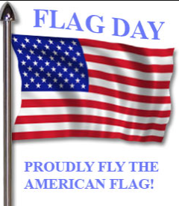

Become a Member of The American Legion
Do you want to help your community and fellow Veterans by becoming a member of the American Legion? Would you want to help recruit a new member? If you can certify that you served at least one day of active military duty since December 7, 1941, and were honorably discharged or are currently serving honorably, you are eligible. Complete the application below and send it with a check in the amount of $46.00 to:
American Legion Post 3
123 South 84th Street, Suite L
Lincoln, Ne 68510
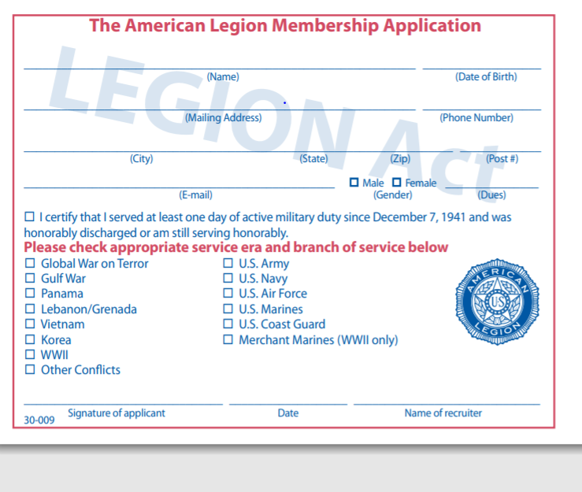
To renew or transfer to Post 3, you only need to sign below and mail this and a check for $46 made out to “American Legion Post 3” to the address listed above. If you have already renewed for 2021, and want to transfer to Post 3, only sign below and return the bottom portion to us.
YES! Please transfer my membership to Lincoln American Legion Post 3
____________________________________ Signature

___________________________________ Membership Number

American Legion Post 3
123 South 84th St. Suite L
Lincoln, NE 68510
(402) 466-3958

Post3legionlincoln@gmail.com
https://lincolnpost3.org
2020 - 2021 Post 3 Officers
Commander - Wade Graft – Cell: 402-770-9126
First Vice Commander – Gerry Wolf – Cell: 402-417-8230

Second Vice Commander – Bruce Gubser – Cell: 402-470-1700
Adjutant – Ed Schnabel – Cell: 402-480-8542
Chaplain – William Jackson – Cell: 402-613-9774
Post Service Officer – Ed Schnabel – Cell 402-480-8542

Please submit any announcements or items for the monthly newsletter to the Adjutant for approval. All requests must be received one week before the 1st of the month.

