Volume 6, Issue 9

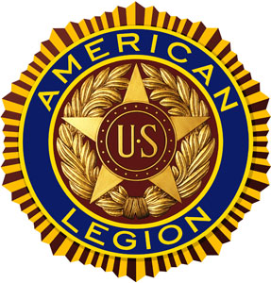

“For God And Country”
SEPTEMBER 2020 POST 3 NEWSLETTER

Meeting Schedule for September – October 2020
Organization | Location | Time | September | October
Legion Post 3 | Elks Lodge, 5910 S 58th | 7 PM | 09/08/20 | 10/13/15
Auxiliary Unit 3 | Elks Lodge, 5910 S 58th | 7 PM | 09/08/20 | 10/13/20
SAL Squadron 3 | Elks lodge, 5910 S 58th | 7 PM | 09/17/20 | 10/15/20
ALR Chapter 3 | Denton Legion Club | 6 PM | 09/17/20 | 10/15/20
40 & 8 Voiture 103 | Elks Lodge, 5910 S 58th | 7 PM | 09/15/20 | 10/20/20
8 & 40 Salon 832 | Elks Lodge, 5910 S 58th | 7 PM | 09/15/20 | 10/20/20
Pitch Tournament | Risky's, 4648 Leighton | 7 PM | NONE | TBD
Buddy Check | The Foundry, 211 N 14th | 7 PM | TBD | TBD
VA Coffeehaus | Antelope Park Bandshell | 10 AM | TBD | TBD

COMMANDER’S CALL

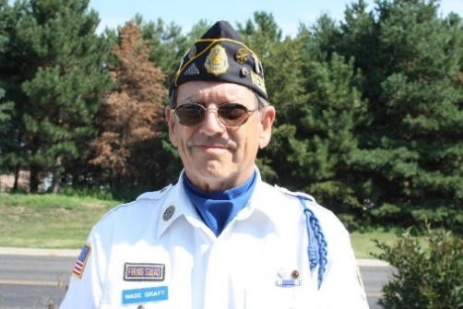

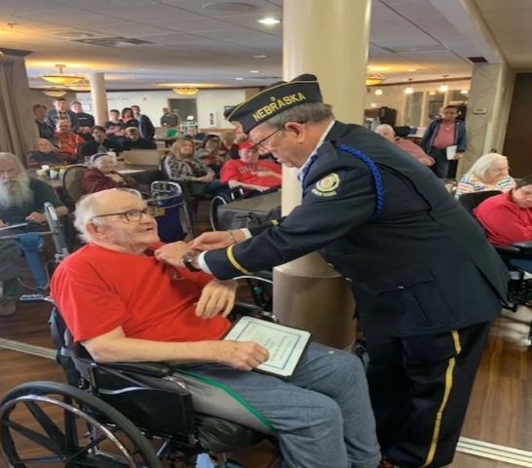

Legion Family All—
Well, we remain in the mist of the pandemic and looking for good news. There’s plenty of bad news: Wearing our masks to make a run to Walmart, the grocery store and church (if it’s open). I’m just not getting used to wearing that blasted mask. I’ll do it to protect others, but I don’t like it (sorry).
We all heard that the Big Ten has cancelled all fall sports for this year. Hard to imagine fall in Nebraska without Cornhusker Football. We hear so much conflicting information concerning the virus that it’s difficult to know for sure if we are gaining or losing ground. At this point, about all we can do is mask up and keep six feet of separation while awaiting the “all clear”.
On the plus side of things, The American Legion remains focused on doing what we do best – Helping veterans and their families. No changes or slowdown there.

The Post 3 leadership Team is working hard to keep positive from last year (2019-2020) rolling into the new year. We are currently working on processing membership applications. If you have a couple of hours on Tuesdays and/or Thursdays, we could use some help in the office (call me if interested).
At this time, we expect to have an in-person Post 3 meeting at the Elks Lodge on September 8th at 7:00 PM The hamburger buffet will start at 6:00 PM. Hopefully this meeting will get us back on track of an in-person fellowship and conducting our business face to face. Let’s make this meeting the best attended meeting we have had so far this year. Sure will be good to see you all.
Respectively,
Wade Graft
Post 3 Commander

ADJUTANT’S REPORT

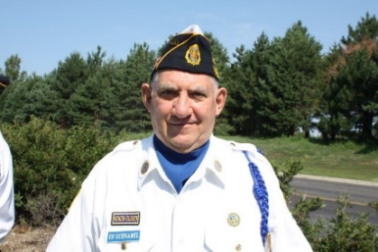
Things have been busy in the office during this pandemic. Renewals for 2021 have been good. As of today, we have 883 renewals, which is about 62% of our assigned goal.
The second mailing from National will be going out in the middle of September. If you receive a notice and you know you have paid your 2021 dues, just throw it away.
We will be holding Post3 / District 15th 2021 Oratorical Contest the first week of November. If you know of any Middle or Senior high students who might be interested in taking part, have them check out the Department web site for more information about the contest and rules.
We are in hopes of having an in person Post 3 meeting this month. Watch your email for updates.
Ed Schnabel
Adjutant

Lincoln VA Legion Report

Things are moving ahead with the new Lincoln Clinic; they hope to have the building ready by the end of the year. They installed the roof top mechanical this past week and the parking lots are being paved. Should be to the point where they can work inside when the weather turns cooler. They are still hoping the new clinic to be complete by the end of November or early December. Once the VA has control of the new building, they have 90 days to finish outfitting it before the clinic can open.

Onsite VA Coffeehaus is still on hold for the time being. We have done two outdoor events in Antelope Park that have been well attended. Looks as if we might be holding another one if the weather will cooperate. Coffeehaus is held the third Friday of the month, 10:00 to noon.
Let us know if there is anything the VAG can do to help the VA better meet your needs.
Ed Schnabel American Legion VA Representative

ALR COMMANDER’S REMARKS

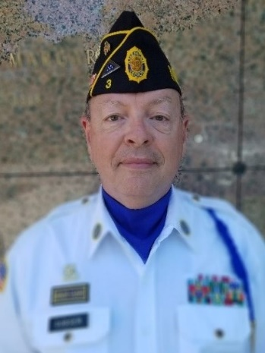

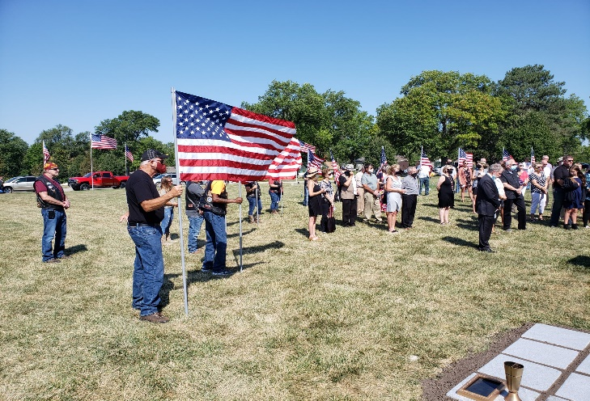

Your American Legion Riders concluded our annual fundraiser poker run. We had nearly 40 participants who played a total of 99 hands. Congrats to our High Hand winner ($75), Dave Lambrecht, who pulled three Queens. Our Second High Hand ($30) was Walt Dondlinger, with three Jacks. Low Hand ($20) went to William Smisek, who eeked out a 7-high hand. (7 of Diamonds, 6 of Clubs, 4 of Hearts, 3 of Diamonds, and a 2 of Spades). We also had a 50/50 winner that walked (well, rode) home with $87.
The BIG WINNER was The American Legion’s Operation Comfort Warriors program. Thanks to all riders and passengers, OCW will be receiving our donation of the balance of proceeds (after prizes) of $778. We are humbled by the generosity of so many. I am so very proud of our chapter, I appreciate the assistance of everyone involved, and I thank all who participated.

We had American Legion Riders, VFW Riders, HOG members, and riders with no specific affiliation. We had riders from Hebron, Fairbury, Beatrice, Cortland, Denton, Crete, Lincoln, Utica, Schuyler, Steinauer, David City, Roca, Ceresco, Firth, Odell, and Raymond. Most importantly, we had no accidents or injuries. I think everyone had a good time, and we received many great comments.
We have also been busy providing escorts and flag lines for a number of departed heroes. It is an honor to recognize the service and sacrifice of those who have gone before us. You can rest assured that we will continue to keep up these good works.

Until next time,
Ride Safe!
Bruce Gubser
Commander, Lincoln Chapter 3 ALR

Chaplain’s Comments
The Future

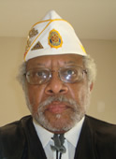
Is there such a thing…the future? If you know Jesus Christ, our Lord and Saviour, you know that He has two natures as the Theanthropos, Greek for “the God-man.” That means He prophesies about future events, but only knows what the Father allows him to know. He doesn’t know when He’ll return for the Parousia, Greek for the “rapture” (Matthew 24:35-

By Jesus’ Hypostatic Union (i.e., the coming together of two natures as the God-man noted in Philippians: 2:5-8), He is aware of what’s to come from His timeless standpoint. On the one hand, Jesus acknowledges future events, like the Church’s rise to recognition, But He doesn’t know when the Judgment will be. That means He’s trustworthy and worth believing for us to be holy (i.e., living by God’s 10 Commandments, grace, and mercy) in contrast to the world’s evil as run by the “prince of the power of the air,” Satan, our fiercest adversary (1 Peter 5:8).

So, if you and I don’t know when or how the culmination of these Last Days will be, in accordance with Eschatology (i.e., end time studies), who does? Jesus knows enough to preach these things to His disciples, then called them to apostleship, giving them specifics of what was still to come (Acts 2:17).

The problem with all this rigmarole about Jesus, the last days, and end times may cause some of us to try running and hiding, as will those under judgment when He returns

(Luke 13:28). But I’ve got a little secret for you. You don’t have to hide or engage in some other pointless ventures in lieu of meeting your Lord and Saviour. Really!

Just embrace His will for you. He wants you to be among the countless many to gain their reward of being with Him for eternity. For a quick introspection, or self-examination, do a “check up from the neck up.” Ask yourself: Who are you? How did you get to where you are now? When did you learn about yourself? Where are you going from here?”

After your self-examination, have you let God take over, especially when you weren’t able to complete those introspections on your own? What’s holding you back from being an active part of the kingdom of God here and now (James 2:5)? If you’ve invited Jesus into your (i.a.w. Romans 10:9,10)? Then you know that His kingdom is the Ecclesia, Greek for the church, where those who heed Jesus’ call become a part of His fellowship of like-minded believers, called disciples of Christ, or Christ-ins (i.e., Christians), as noted in Matthew 16:18.

The future is available to those who have experienced the repentance, forgiveness, and mercy of Jesus to be counted among His Church as the called out, or the Ecclesia of today. Prophesy is one of the operations of the Holy Spirit (1 Corinthians 14:22) that allows you to know what’s going on in the spirit world by way of both future events and current exhortation.

If you’re standing with the Church, then you’re ready to accept that this world is undergoing acts of God (e.g., Covid-19, fires, hurricanes, urban violence, global warning). God is reaching out to us in a way we can’t possibly ignore…or can we…???

Rev. Dr. William Jackson
ALP 3 Chaplain

Post 3 Honor Guard

Since the first of the year, the Honor Guard has rendered Honors at 30 Legion funerals and 39 VFW funerals. We have also appeared at various community activities 11 times. However, we need help. We are looking for a “Few Good Men” to help us. Our ranks are getting older and we are looking for some younger blood. We presently have 17 members on our Honor Guard roster. The average age of these members is 77.

Of the 17, 5 are available only occasionally because of health problems, weather-related issues, , or other committments. To equip a proper Honor Guard, we should have a minimum of 7 riflemen and a Commander. The Honor Guard is a personal commitment, but If you are interested, contact the Post 3 Legion office at 402-466-3958 or email at: post3legionlincoln@gmail.com
Gerry Wolf Post 3 Honor Guard

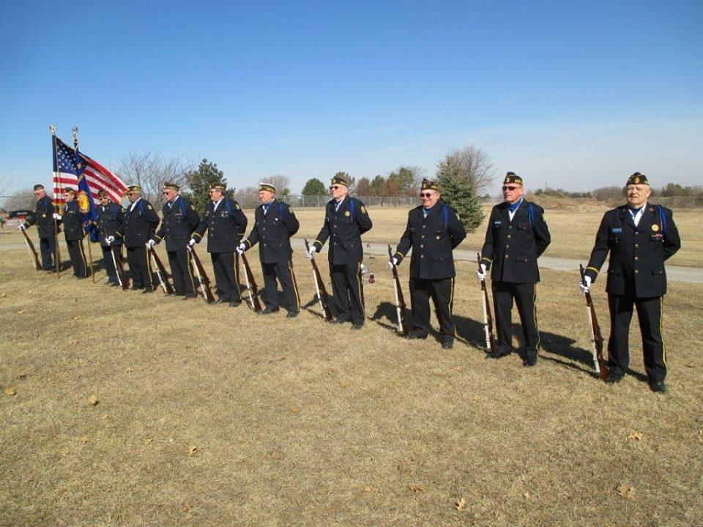
August 2020 Taps
LAST NAME | FIRST NAME | WAR ERA | BRANCH
BESCHEINEN | CALVIN | WWII | UNKNOWN
BUCHMAN | ROBERT | VIETNAM | ARMY
EITEL | THOMAS | VIETNAM | USMC
GREENWALT | DWAYNE | KOREA | USAF
HARMS | LARRY | VIETNAM | NAVY
MARSHALL | ERVIN | WWII | USAAC

Missing Marine from WWII Returning Home

The Defense POW/MIA Accounting Agency (DPAA) has announced that the remains of Marine Sgt. George R. Reeser have been identified and are being returned to his home for burial this fall. He is scheduled to be buried on September 26 in Deer Creek, Illinois.

He was 25 years old in November 1943 when he landed on the island of Betio in the Tarawa Atoll in what is now known as the Republic of Kiribati.
No recovered remains could be associated with Reeser, and, in October 1949, a Board of Review declared him “non-recoverable.”
He was serving with, 2nd Marine Division, as they faced strong resistance from the occupying Japanese forces. Approximately 1,000 US Marines were killed during the several days of fighting.

Reeser lost his life on November 22 – the third day of fighting. His remains were not positively identified at the time. It was reported that his body was buried in a cemetery on the island.
In 1946, US military officials began consolidating remains from the cemetery in order to return them home for burial.
At that time, around half of the known casualties could not be located. Reeser was one of those that were missing.
History Flight, Inc. – a non-profit organization – found what appeared to be the actual resting place of Reeser and around thirty other Marines who had been buried in a trench near where they had been killed.
The remains from that site were transferred to the Defense POW/MIA Accounting Agency Laboratory in Hawaii. Scientists at the lab have been working for the last decade to identify all the recovered remains. Reeser’s remains were identified using dental records, anthropological analysis, and other material and circumstantial evidence.

In the aftermath of the fighting in 1943, the surviving Marines were tasked with burying the dead. By the time they had secured their location and could turn their attention to the unpleasant task, the smell had become intense.
Three trenches were dug and filled with the bodies of the dead soldiers. They were marked as best as they could be given there was no material available to make a more permanent marker.
The trenches were labeled Rows A-C. A fourth row, which may have served as a “tank trap” during the fighting, was set apart from the first three rows and labeled Row D. Nothing remained of the markers that had been placed there.
Eventually they found Row B and, with some searching, were able to locate Rows A and C as well. Row D remained lost along with the 33 soldiers buried there.
War History Online – Craig Bowman

Coins left on Military Headstones

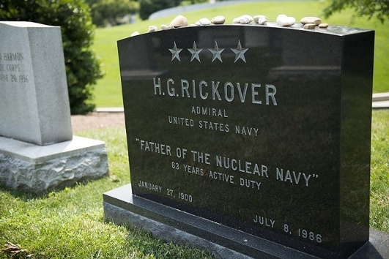

Coins have long been used to honor fallen warriors. In ancient Greece, it was customary to leave coins either on the eyes or in the mouths of the fallen. It was said that the spirits of the deceased would use these coins to pay Charon the Ferryman to carry their soul across the River Styx and into the afterlife. Today, many people still leave a coin on the headstone of the dearly departed.
There's an often-shared chain email that suggests each denomination of coin left on a headstone has a different meaning — a sort of hidden message left to be interpreted by other veterans who visit the grave. A penny is used to simply honor the dead, a nickel means you went to boot camp or basic training with the fallen, a dime means you served with them in some capacity, and a quarter means you were there when they died.
You will often find nickels, dimes, and quarters on gravestones from World War I and earlier — which just doesn't make physical sense. Still, this idea has been spread around enough that it carries at least some degree of significance.
When too many coins pile up at a gravesite, a caretaker collects the money and puts it in a separate fund to help pay for cemetery upkeep. The coins are put towards things like washing graves, mowing the lawn, and killing pesky weeds if the state or local government doesn't already allocate funds for such things.
The same fund also contributes toward the burial of an indigent veteran who cannot otherwise pay for the process.
In nearly every case, caretakers will remove these tokens to keep the area in pristine condition. Rocks are also commonly used, but they will more likely be removed and placed nearby, for another visitor to "happen upon." Military challenge coins, however, are often left on the stone for years.
Eric Milzarski – “We are the Mighty”

Japanese Surrender Ceremony to be held on Oahu

HONOLULU (Tribune News Service) — With a Japanese helicopter destroyer, the battleship Missouri and USS Arizona Memorial behind them, officials announced Wednesday that 52 World War II veterans plan to attend events on Oahu marking the 75th anniversary of the end of the deadliest conflict in human history.
The news conference was a scene that pulled together the upcoming Rim of the Pacific exercise with the presence of the Japanese ship, the start and end of World War II represented by the Arizona and Missouri, and the many challenges to both RIMPAC and the 75th anniversary event due to a surging COVID-19.
The update was provided on the back lawn of the Arizona Memorial visitor center. Both RIMPAC and the Aug. 29 to Sept. 2 end-of-World War II commemoration have been reduced in scope and scale due to the coronavirus, but both are moving forward.
Planners of the end-of-war events described the passion behind the decision by veterans who are in their mid-90s and up to come to Hawaii — COVID-19 notwithstanding — and the importance of honoring the actual Sept. 2, 1945, official surrender date by Japan.

Fourteen of the veterans were either on the Missouri, in aircraft overflying the battleship or on a ship nearby for the ceremony in Tokyo Bay. Of the 52 total, 44 are from outside of Hawaii.
“The greatest motivator is if you talk to these veterans or their children or their grandchildren and their desire, their passion, their commitment, their resolve, to want to be a part of this,” said Tony Vericella, executive director of the 75th World War II Commemoration Committee in Hawaii.
He added that the veterans “are making the choice — they want to be here.”
Committee co-chair Steve Colon, a retired Navy captain, noted that the coronavirus “situation is changing on a daily basis,” but that Sept. 2 is the day that the surrender ceremony took place on the Missouri.
“Seventy-five years from Sept. 2 (1945) regardless of whether all of the World War II veterans who can and want to make it here, can, for whatever reason, or whether none of them can, we will do some sort of ceremony on the fantail of the Missouri,” Colon said. “That date is too important for us to just let that go.”
©2020 The Honolulu Star-Advertise

Army Guard Begins to Reorganize

WASHINGTON — The Army National Guard will move most of its brigades under the command of its eight division headquarters as it reorganizes its fighting formations to give the force more combat power and some soldiers new career opportunities, officials said.
The Guard move will mark a substantial increase in the number of fully manned divisions that the Army can deploy, as only the service's 10 active-duty divisions are now filled out with subordinate units, said Lt. Gen. Daniel Hokanson, the director of the Army National Guard. The increase to 18 complete Army divisions comes at a time when service officials believe a major conflict with a near-peer rival — namely Russia or China — would require the employment of full divisions, he said.
For the last two decades, the Army has focused on its smaller brigade combat teams as its primary fighting elements for counterterrorism operations and deployments focused on assisting the forces of other nations.
The National Defense Strategy, crafted by former Defense Secretary Jim Mattis, guides the Pentagon on future planning, placing the potential for major conflict with rivals China and Russia as the nation's primary national security threat. For the two decades prior, the military had focused almost exclusively on fighting transnational terrorist organizations, which the strategy defined as a lesser threat than those posed by nation-state competitors.
But Hokanson said the new alignment will have no impact on the governors’ and state adjutant generals' control of the forces assigned to their home states. He also said the National Guard has not asked Congress to provide additional funding for the changes.
The new alignment, the general said, will actually provide new opportunities for soldiers serving in units such as the 1-200th, where states have no higher headquarters in a combat unit. Under the reorganization, a battalion commander or a battalion sergeant major who performed well would have an opportunity for promotions to serve in higher commands within the new division — potentially even becoming a brigade commander or division commander of a unit based in another state.
Like the bigger Army, Hokanson pointed out the National Guard has been heavily used during the last 20 years, at home — where Guard soldiers have responded to myriad natural disasters, civil unrest and the recent coronavirus pandemic — and abroad, where they have regularly deployed to the Middle East and Afghanistan. He wants those units to be well-prepared for the next kind of fight they could encounter with a major military power.
If that fight does come, he wants the Army Guard soldiers ready to deploy as a full division that has spent time working together, instead of having to piece together a division at the last minute.
dickstein.corey@stripes.com

Troop Presence in Afghanistan less than 5,000 by November

Defense Secretary Mark Esper said in an interview broadcast late Saturday that no more than 5,000 U.S. troops would remain in Afghanistan by the end of November as the Trump administration looks to move forward with a reduction of forces in the region.
"We’re going down to a number less than 5,000 by the end of November. We need to brief Congress [about] what that looks like," Esper said on Fox News's "Justice with Judge Jeanine."
Esper cautioned that the troop reduction would be "conditions-based" and carried out as long as the Pentagon felt it could proceed with missions in the region with fewer troops.
"Right now, we think that we can do all the core missions, first and foremost being ensured the United States is not threatened by terrorists coming out of Afghanistan," he said. "We can do those at a lower level."
"In the meantime, we see the Afghan peace process — it's not perfect, but it’s moving forward, slowly," he added. "You know, it’s a windy road. It’s a rough road."
The Trump administration and the Taliban earlier this year signed a historic
deal with the ultimate goal of ending the U.S. presence in Afghanistan. The deal called for the U.S. to withdraw troops in the region in exchange for a commitment from the Taliban that it will not engage in terrorism against the U.S.
The U.S. is expected to withdraw completely from Afghanistan according to the deal, which also includes intra-Afghan negotiations and commitments on counterterrorism. But those negotiations have faced setbacks due to continued attacks by the Taliban. The Pentagon has also said that the Taliban has yet to break its ties with al Qaeda.
In July, the Pentagon announced that the U.S. had withdrawn from five military bases in the country and that its troop level remained in "the mid-8,000s."
Trump said in an interview with Axios last week that he expected that figure to be below 5,000 by the 2020 presidential election, though he did not offer any specific timeline.
“We’re going down to 4,000. We’re negotiating right now,” Trump said. “I don’t want to tell you [when]. But I’ve always said we will get largely out.”

BY JUSTIN WISE – The Hill

30,000 Troops Quaranteed Ahead of Training & Deployment

“Today we have over 30,000 members of the military in a quarantine environment, because they're getting ready to deploy, they're getting ready to go on a ship, they're getting ready to go into basic training,” said Air Force Gen. John Hyten, the vice chairman of the Joint Chiefs of Staff. “They're getting ready to go into an environment where, in order to stay safe and make sure we don't infect large numbers, we put them in quarantine.”
His remarks were the first time a senior military official has quantified the personnel impact of the Pentagon’s effort to keep the force safe from the coronavirus ahead of training or deployment. He did not discuss how many people are in quarantine because of a positive test result for the virus.
“That’s like an entire Army Corps in quarantine for two weeks. That’s huge,” Hyten said.
Each service has instituted quarantine for recruits attending basic training and advanced schooling. The Army is also requiring coronavirus testing and self-quarantine for soldiers and their families before overseas travel. Over 1,000 U.S. Marines in Darwin, Australia, have gone through two weeks of quarantine ahead of their training mission in the country, with the last group of Marines finishing this week.
The Navy has a policy to establish a clean “bubble” around a ship while it operates at
sea, forcing sailors to quarantine and receive a negative test before being allowed to board their ship.
The Navy has had sailors assigned to ships in port become infected, and two serious outbreaks occurred on ships while they were at sea, including the USS Theodore Roosevelt, which had over 1,100 sailors infected.
The additional weeks for quarantine are more of a strain on the families of the service members, according to Hyten.
“If you're deploying, you're going to be gone for six months, nine months, 12 months. Well then you add two weeks on the front of that and maybe two weeks on the back of that, that adds again to those capabilities,” he said.
Hyten added that while there is stress on the force, the morale “is still positive.”
As of Wednesday, the military has had 32,299 cases of the coronavirus, 520 hospitalizations and four deaths, according to the Pentagon’s cumulative total case chart. The Army has had 11,140 cases, the highest of any service. The Navy has had 7,568 cases and the Air Force has had 5,073 cases as of Wednesday. The National Guard, which is assisting states with pandemic response, has had 4,223 cases, and the Marine Corps has had 3,991.
kenney.caitlin@stripes.com

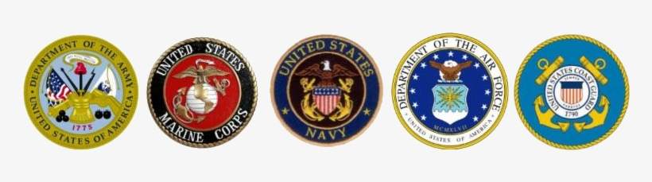
O
Oooo
OATH OF ENLISTMENT

Oath
O

Become a Member of The American Legion
Do you want to help your community and fellow Veterans by becoming a member of the American Legion? Would you want to help recruit a new member? If you can certify that you served at least one day of active military duty since December 7, 1941 and were honorably discharged or are currently serving honorably, you are eligible. Complete the application below and send it with a check in the amount of $46.00 to:
American Legion Post 3
123 South 84th Street, Suite L
Lincoln, Ne 68510
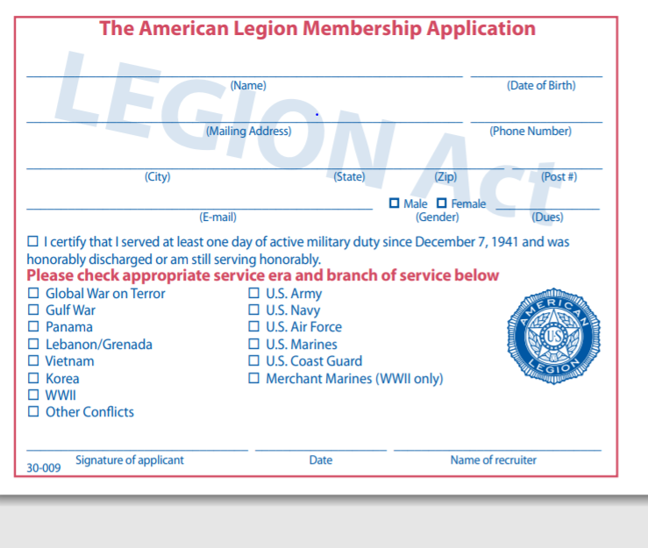
To renew or transfer to Post 3, you only need to sign below and mail this and a check for $46 made out to “American Legion Post 3” to the address listed above. If you have already renewed for 2021, and want to transfer to Post 3, only sign below and return the bottom portion to us.
YES! Please transfer my membership to Lincoln American Legion Post 3

___________________________________________ Signature

___________________________________________ Membership Number

American Legion Post 3

123 South 84th St. Suite L

Lincoln, NE 68510
(402) 466-3958

Post3legionlincoln@gmail.com
https://lincolnpost3.org
2020 - 2021 Post 3 Officers
Commander - Wade Graft – Cell: 402-770-9126
First Vice Commander – Gerry Wolf – Cell: 402-417-8230
Second Vice Commander – Bruce Gubser – Cell: 402-470-1700
Adjutant – Ed Schnabel – Cell: 402-480-8542
Chaplain – William Jackson – Cell: 402-613-9774
Post Service Officer – Ed Schnabel – Cell 402-480-8542

Please submit any announcements or items for the monthly newsletter to the Adjutant for approval. All requests must be received two weeks before the monthly meeting.

