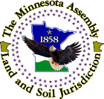
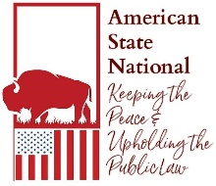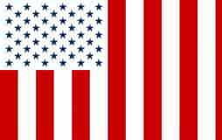
Did You Know?
● Did you know your birth certificate is a bond?
● Did you know your birth certificate is sold to the Pope who pays your birth weight in gold for it?
● Do you know the difference between JOHN JAY DOE vs John Jay Doe©™?
● Did you know the government has a life insurance policy on you & they collect when you die?
● Do you know what a “License” is?
● Do you know why you have to “register” everything you own?
● Did you know by registering anything you are giving away your owners rights?
● Did you know the Federal Reserve is privately owned and not a government agency?
● Did you know the IRS is a collection agency for the Federal Reserve, not a government agency?
● Did you know that the IRS was headquartered in Puerto Rico & has now moved to the Mariana Islands?
● Did you know income tax you pay to the IRS is voluntary unless your paycheck comes directly from the Federal or State Government?
● Do you know why the name on all your bills are in ALL CAPITAL LETTERS?
● Did you know that all Mortgages are Fraud?
● Did you know that you are borrowing your own money & not the banks?
● Did you know there is a difference between an American and a U. S. Citizen?

For answers to these questions and more information visit:
The American States Assemblies:https://tasa.americanstatenationals.org/
The States of the American States Assemblies:https://states.americanstatenationals.org/
Educational Information:https://states.americanstatenationals.org/educational-information-2/#top

All 50 states have Lawfully assembled. The Minnesota Assembly is in session and is working to help bring people/People back Home to the Land & Soil Jurisdiction, and take back their stolen identities. Please join us. Check us out @ https://minnesotaassembly.net

Contact The Assembly on Minnesota and find how to declare your political status by emailing:
minnesota-coordinator@mail.americanstatenationals.us

