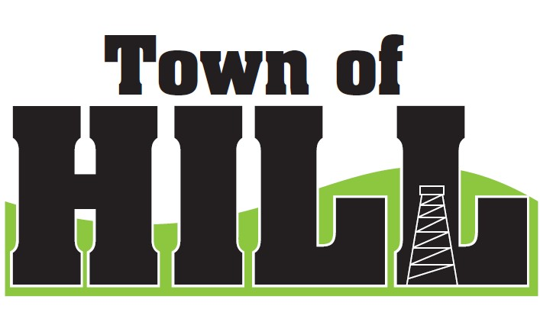
AGENDA - TOWN OF HILL TOWN BOARD MEETING

DATE: February 16, 2026
LOCATION: TOWN OF HILL TOWN HALL
TIME: 7:00 PM
1. CALL TO ORDER
2. PLEDGE OF ALLEGIENCE
3. MINUTES FROM JANUARY 19, 2025
4. TREASURERS REPORT
5. REVIEW & PAY BILLS
6. OLD BUSINESS:
- RESP updates – check received 2/11/26 ($22,908.00)
- Hill of Beans update from Jeff Ulrich
- 2026 WTA District Meeting update from Jeff U & Kristin T
7. NEW BUSINESS:
- Meeting with Josh Carlson – Rural Insurance new rep
- Price County Bridge & Culvert Aid
- Deputy Clerk Questions for operations
  - Job Descriptions, roles & responsibilities, Org chart
- Roads Supervisor insurance benefits conversation
- Snowmobile Ordinance update conversation
- (LSSIP) Local Small Structures Improvement Program
program
8. ZONING UPDATE/FOREST CROP UPDATES
9. AMBULANCE, FIRE MEETING & WTA REPORTS
1. John Underwood reports on recent meetings
10. ROAD REPORT
11. FUTURE MEETINGS:
- March 16, 2026 7:00 PM Town Board Meeting
- April 7, 2026 7:00am – 8:00pm SPRING ELECTION
- April 21, 2026 6:00pm - ANNUAL MEETING
- April 21, 2026 7:00pm Town Board Meeting
- April 29, 2026 6:00 – 8:00pm OPEN BOOK 2026
- May 6, 2026 6:00 – 8:00pm BOARD OF REVIEW 2026
12. AGENDA ITEMS for NEXT Meeting
13. ADJOURN

