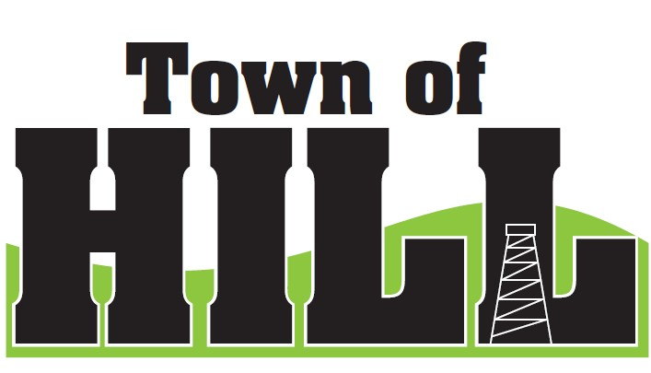
AGENDA - TOWN OF HILL TOWN BOARD MEETING
DATE: July 20, 2026 TIME: 7:00 PM
LOCATION: TOWN OF HILL TOWN HALL
- CALL TO ORDER
- MINUTES FROM June 15, 2026
- TREASURERS REPORT
- REVIEW & PAY BILLS
- OLD BUSINESS:
  - Price County Bridge & Culvert Aid updates
  - (LSSIP 620) Local Small Structures Improvement updates
  - Interim Assessment for 2027 – schedule conversation
    - See contract from Elk River (Cindy Chase)
  - Municipal Retail License Report (AT-827) COMPLETED
    - Hill of Beans is set with their Class B & C license
- NEW BUSINESS:
  - Clerk Updates:
    - Travel October 4-14, Payroll coverage figured out. Will issue payroll for Scott K on Friday October 2nd which will be dated for Monday October 5th.
    - Town of Hill Website updates
  - County Updates from Jeff Ulrich
- AMBULANCE, FIRE MEETING & WTA REPORTS
  - Supervisor Underwood Updates
- FOREST CROP UPDATES
  - Chairman Wiitala Updates
- ZONING UPDATE/ ROAD REPORT
  - Zoning/Roads Supervisor Updates
- FUTURE MEETINGS:
- August 11, 2026 – PARTISAN PRIMARY ELECTION
- August 17, 2026 – 7:00pm Town Board Meeting
- September 21., 2025 – 7:00pm Town Board Meeting
- October 19, 2026 – 7:00pm Town Board Meeting
- AGENDA ITEMS for NEXT Meeting
- ADJOURN

