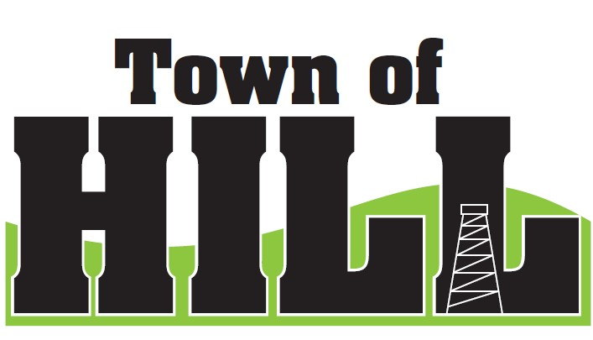

AGENDA
TOWN OF HILL TOWN BOARD MEETING

DATE: November 17, 2025
LOCATION: TOWN OF HILL TOWN HALL
TIME: FOLLOWING BUDGET HEARING AT 6:30PM
1. CALL TO ORDER
2. PLEDGE OF ALLEGIENCE
3. MINUTES FROM October 20, 2025
4. TREASURER’S REPORT
5. REVIEW & PAY BILLS
6. OLD BUSINESS:
- RESP - Kristin assisting with Grant updates and vendor needs.
  - Kristin working on Thunder Hill Electric (Complete) and Jeff Ulrich is working on Chuck.
- LRIP – Local Road Improvement Program update
- Town of Hill hosting the WTA Meeting January 2026 UPDATE on Speaker
- Deputy Clerk Training Update – State Required (20) vs. Town in person
- Non-Compliance Advisory – Received the official notice from DOR
- Contract for Extended Warrantee for Grader discussion about payment
7. NEW BUSINESS:
1. Discuss and action on renewal of $50,000 Line from Forward Bank which will mature December 18, 2025
8. ZONING UPDATE/FOREST CROP UPDATES:
9: AMBULANCE, FIRE MEETING & WTA REPORTS
- Review of Ogema Fire District meeting minutes by John Underwood
10: FUTURE MEETINGS:
    - December 15, 2025 7:00pm Town Board Meeting
    - January 19, 2026 7:00pm Town Board Meeting
    - February 16, 2026 7:00pm Town Board Meeting
11. ROAD REPORT
12. AGENDA ITEMS for December Meeting
1. Renewal of Forward Note for $50,000
13. ADJOURN

