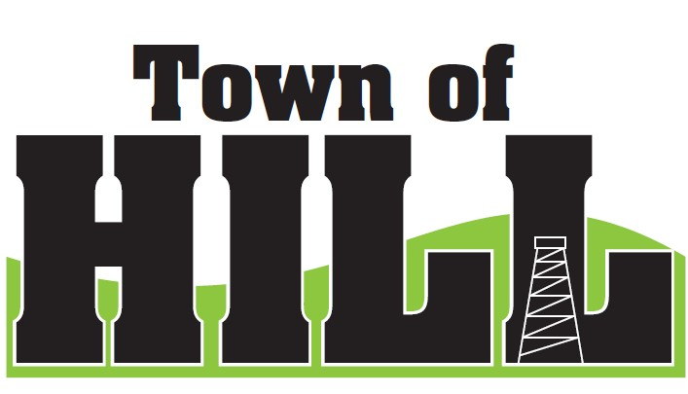
AGENDA - TOWN OF HILL TOWN BOARD MEETING
DATE: May 18, 2026 TIME: 7:00 PM
LOCATION: TOWN OF HILL TOWN HALL
- CALL TO ORDER
- MINUTES FROM APRIL 21, 2026
- TREASURERS REPORT
- REVIEW & PAY BILLS
- OLD BUSINESS:
  - Price County Bridge & Culvert Aid updates
  - (LSSIP 620) Local Small Structures Improvement due 5/1/26
  - Roads Supervisor insurance benefits updates
    - Nothing comparable is currently available for under $1500 per month
    - If willing to convert to America First Healthcare would lose access to many specialists and current doctors
    - Recommend we consider adjusting the amount of
  - LRIP 2026 updates – bid information mailed out 4/22/26
  - $45K moved to Equipment Fund on 4/22/26
  - Monthly Meeting Schedule updates
  - New Cemetery employee Grayson Swan onboarded 5/14/26
  - Clerk training on Alcohol licenses complete and assets available to share with other board members.
  - Maintenance of Effort Report has been submitted 5/6/26
- NEW BUSINESS:
  - County Updates from Jeff Ulrich
  - Interim Assessment for 2027 – schedule conversation
  - Municipal Retail License Report (AT-827) due July 15
    - Hill of Beans license – wants to retain license
    - Kiri will work with Kathleen to get everything handled
- ZONING UPDATE/FOREST CROP UPDATES
- AMBULANCE, FIRE MEETING & WTA REPORTS
- ROAD REPORT
- FUTURE MEETINGS:
- June 15, 2026 – 7:00pm Town Board Meeting
- July 20, 2026 – 7:00pm Town Board Meeting
- August 11, 2026 – PARTISAN PRIMARY ELECTION
- August 17, 2026 – 7:00pm Town Board Meeting
- September 21, 2026 – 7:00pm Town Board Meeting
- October 19, 2026 – 7:00pm Town Board Meeting
- November 3, 2026 – GENERAL ELECTION
- AGENDA ITEMS for NEXT Meeting
- ADJOURN

