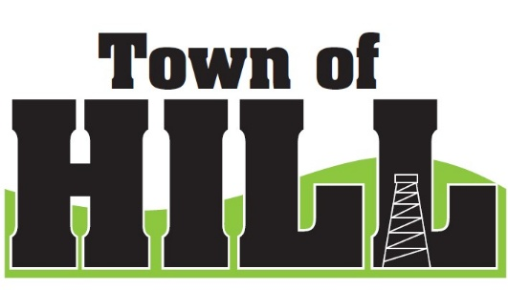
THE ANNUAL MEETING FOR THE TOWN OF HILL WILL BE HELD ON
TUESDAY APRIL 20, 2026
AT 6:30 P.M. AT THE TOWN OF HILL TOWN HALL

2026 BOARD MEMBERS & TOWN EMPLOYEES
CHAIRMAN | RON WIITALA | 715-499-4928 | chairman@tn.hill.wi.gov
TREASURER | ALLAN NIEMI | 715-965-4257 | treasurer@tn.hill.wi.gov
SUPERVISOR | JEFF ULRICH | 715-767-5960 | supervisor1@tn.hill.wi.gov
SUPERVISOR | JOHN UNDERWOOD | 715-767--5251 | supervisor2@tn.hill.wi.gov
CLERK | KRISTIN TORGLER | 715-657-0389 | clerk@tn.hill.wi.gov
ZONING/PERMITS | SCOTT KOMAREK | 715-922-0233 | zoning@tn.hill.wi.gov
ASSESSOR | CINDY CHASE | 715-339-4539 | elk.river@live.com

2026 CALENDAR OF EVENTS
JANUARY 19, 2026 | 7:00 PM | TOWN BOARD MEETING
FEBRUARY 16, 2026 | 7:00 PM | TOWN BOARD MEETING
MARCH 18, 2026 | 7:00 PM | TOWN BOARD MEETING
APRIL 7, 2026 | 7:00 AM – 8:00 PM | SPRING ELECTION
APRIL 21, 2026 | 6:30 PM | ANNUAL MEETING
APRIL 21, 2026 | 7:00 PM | TOWN BOARD MEETING
APRIL 29, 2026 | 1:00 PM – 3:00 PM | OPEN BOOK 2026
MAY 6, 2026 | 6:00 PM – 8:00 PM | BOARD OF REVIEW
MAY 18, 2026 | 7:00 PM | TOWN BOARD MEETING
JUNE 15, 2026 | 7:00 PM | TOWN BOARD MEETING
JULY 20, 2026 | 7:00 PM | TOWN BOARD MEETING
AUGUST 11, 2026 | 7:00 AM – 8:00 PM | PRIMARY ELECTION
AUGUST 17, 2026 | 7:00 PM | TOWN BOARD MEETING
SEPTEMBER 21, 2026 | 7:00 PM | TOWN BOARD MEETING
OCTOBER 19, 2026 | 7:00 PM | TOWN BOARD MEETING
NOVEMBER 3, 2026 | 7:00 AM – 8:00 PM | GENERAL ELECTION
NOVEMBER 16, 2026 | 7:00 PM | TOWN BOARD MEETING
DECEMBER 21, 2026 | 7:00 PM | TOWN BOARD MEETING
JANUARY 18, 2027 | 6:30 PM | CAUCUS
JANUARY 18, 2027 | POST CAUCUS | TOWN BOARD MEETING
FEBRUARY 15, 2027 | 7:00 PM | TOWN BOARD MEETING
MARCH 15, 2027 | 7:00 PM | TOWN BOARD MEETING

ALL DATES AND TIMES ARE SUBJECT TO CHANGE
NOTICES WILL BE POSTED FOR ALL MEETINGS AT THE TOWN HALL
AND IN “THE PRICE COUNTY REVIEW”
THE WEEK PRIOR TO THE MEETING
WHEN TIME ALLOWS.

