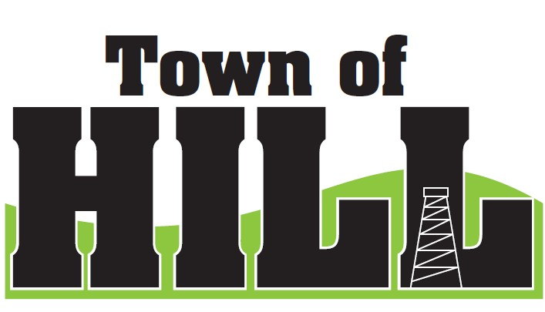
AGENDA - TOWN OF HILL TOWN BOARD MEETING
DATE: August 17, 2026 TIME: 7:00 PM
LOCATION: TOWN OF HILL TOWN HALL
- CALL TO ORDER
- MINUTES FROM July 20, 2026
- TREASURERS REPORT
  - Shared Revenue July Distribution Received ($8720.63 on 7/27)
  - First Dollar Credit - 2026 Payment to County ($19,566.82)
  - School Levy Tax Credit July 2026 Payment to County ($63,536.84)
- REVIEW & PAY BILLS
- OLD BUSINESS:
  - Price County Bridge & Culvert Aid updates
  - (LSSIP 620) Local Small Structures Improvement updates
  - LRIP Updates
- NEW BUSINESS:
  - County Updates from Jeff Ulrich
    - HWY & TRANSPORATION COMMITTEE Updates
- AMBULANCE, FIRE MEETING & WTA REPORTS
  - Supervisor Updates
- FOREST CROP UPDATES
  - Chairman Updates
- ZONING UPDATE/ ROAD REPORT
  - Zoning/Roads Supervisor Updates
- FUTURE MEETINGS:
- September 21, 2025 – 7:00pm Town Board Meeting
- October 19, 2026 – 7:00pm Town Board Meeting
- November 3, 2026 – 7:00sm – 8:00pm – General Election
- November 16, 2026 - 7:00pm Budget Meeting
- November 16, 2026 - 7:00pm Town Board Meeting
- December 21, 2026 - 7:00pm Town Board Meeting
- AGENDA ITEMS for NEXT Meeting
- ADJOURN

