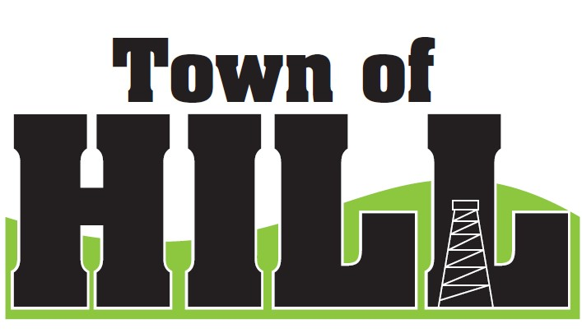
AGENDA - TOWN OF HILL TOWN BOARD MEETING

DATE: January 19, 2026
LOCATION: TOWN OF HILL TOWN HALL
TIME: 7:00 PM
1. CALL TO ORDER
2. PLEDGE OF ALLEGIENCE
3. MINUTES FROM DECEMBER 15, 2025
4. TREASURERS REPORT
5. REVIEW & PAY BILLS
6. OLD BUSINESS:
- Hill of Beans Liquor License – next steps
- Updated for 2026 - Emergency Election Procedures
- Election Committee Oath of Office Updates
- WTA Meeting Recap & Discussion
- RESP Updates
7. NEW BUSINESS:
- Review Rate Sheet for 2026
- Rural Insurance Sam Scott retirement
8. ZONING UPDATE/FOREST CROP UPDATES
9: AMBULANCE, FIRE MEETING & WTA REPORTS
10: FUTURE MEETINGS:
- February 16, 2026 7:00 PM Town Board Meeting
- March 16, 2026 7:00 PM Town Board Meeting
- April 7, 2026 – SPRING ELECTION
- April 20, 2026 7:00 PM Town Board Meeting
- April 29, 2026 6:00 – 8:00 PM OPEN BOOK 2026
11. ROAD REPORT
12. AGENDA ITEMS for NEXT Meeting
13. ADJOURN

