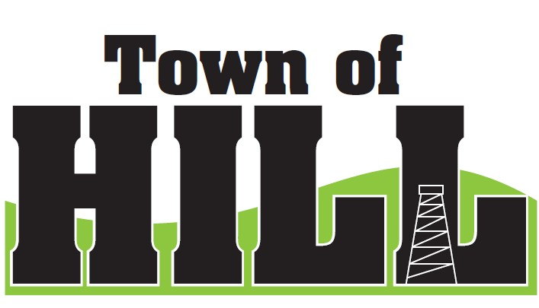
AGENDA - TOWN OF HILL TOWN BOARD MEETING
DATE: June 15, 2026 TIME: 7:00 PM
LOCATION: TOWN OF HILL TOWN HALL
- CALL TO ORDER
- MINUTES FROM May 18, 2026
- TREASURERS REPORT
- REVIEW & PAY BILLS
- OLD BUSINESS:
  - Price County Bridge & Culvert Aid updates
  - (LSSIP 620) Local Small Structures Improvement updates
  - LRIP 2026 updates – Project Number received
    - Chairman Wiitala Updates
  - Interim Assessment for 2027 – schedule conversation
    - See email from Elk River (Cindy Chase)
  - Municipal Retail License Report (AT-827) due July 15
    - Hill of Beans wants to retain Class B & C license
    - Once license renewal is approved, Clerk will handle final signatures and registration
- NEW BUSINESS:
  - Jeff Peterson Westboro Chairman to speak on new project
  - Ogema’s Gradall is going up for sale – discussion.
  - County Updates from Jeff Ulrich
- AMBULANCE, FIRE MEETING & WTA REPORTS
  - Supervisor Underwood Updates
- FOREST CROP UPDATES
  - Chairman Wiitala Updates
- ZONING UPDATE/ ROAD REPORT
  - Zoning/Roads Supervisor Updates
- FUTURE MEETINGS:
- July 20, 2026 – 7:00pm Town Board Meeting
- August 11, 2026 – PARTISAN PRIMARY ELECTION
- August 17, 2026 – 7:00pm Town Board Meeting
- AGENDA ITEMS for NEXT Meeting
- ADJOURN

