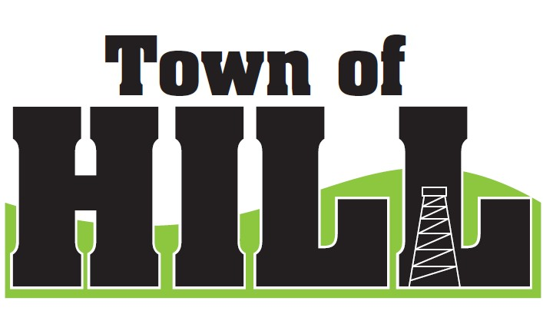
AGENDA - TOWN OF HILL TOWN BOARD MEETING
DATE: April 21, 2026 TIME: 7:00 PM
LOCATION: TOWN OF HILL TOWN HALL
- CALL TO ORDER
- MINUTES FROM MARCH 18, 2026
- TREASURERS REPORT
- REVIEW & PAY BILLS
- OLD BUSINESS:
  - Price County Bridge & Culvert Aid
  - (LSSIP 620) Local Small Structures Improvement due 5/1/26
  - Roads Supervisor insurance benefits conversation
  - Robert Kirkley – check to Aspirus has cleared 3/31/26
  - SourceWell account updates
  - Election overview
- NEW BUSINESS:
  - LRIP 2026 – 2 bids received
  - Move monies into Equipment Fund?
  - Discussion regarding monthly meeting schedule
    - Jeff Ulrich new county position
  - Cemetery Team Updates
    - Grayson Swan and wife
  - Clerk Pay Confirmation
  - Clerk Training on Alcohol Licenses ($20) 4/30/26
    - The first day will be taught by legal counsel from the Wisconsin Towns Association and the League of Wi Municipalities and focused on the administration of local municipal/town ordinances with 2 hours of instruction by legal counsel, and 45 minutes Q&A.
  - EMS – Maintenance of Effort Report 2026 Discussion
    - Prentice Ambulance verification received
    - Ogema Fire District – NEEDED
    - REPORT DATA DUE 6/1/26
    - REPORT FILING DUE 7/1/26
  - Timely depositing of Town of Hill issued checks. Please deposit or speak with clerk if needed.
- ZONING UPDATE/FOREST CROP UPDATES
- AMBULANCE, FIRE MEETING & WTA REPORTS
- ROAD REPORT
- FUTURE MEETINGS:
- April 29, 2026 1:00 – 3:00pm OPEN BOOK 2026
- May 6, 2026 6:00 – 8:00pm BOARD OF REVIEW 2026
- May 18, 2026 – 7:00pm Town Board Meeting
- June 15, 2026 – 7:00pm Town Board Meeting
- July 20, 2026 – 7:00pm Town Board Meeting
- AGENDA ITEMS for NEXT Meeting
- ADJOURN

