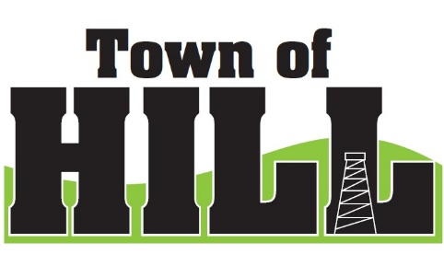
AGENDA - TOWN OF HILL TOWN BOARD MEETING
DATE: December 15, 2025
LOCATION: TOWN OF HILL TOWN HALL
TIME: 7:00 PM
1. CALL TO ORDER
2. PLEDGE OF ALLEGIENCE
3. MINUTES FROM November 17, 2025
4. TREASURERS REPORT
5. REVIEW & PAY BILLS
6. OLD BUSINESS:
- Hultman Lake Road Community Feedback
  - Chuck Lukes
  - Dan Price
- Forward Line of Credit final approval for 12/18/2025.
- RESP - Grant updates and next steps review.
- LRIP – Local Road Improvement Program update
- WTA Meeting 1/14/2026
  - UPDATE on Speakers
    - Sherrif Brian Schmidt
    - Dylan Scheller – Drug Investigator
    - (BACKUP) – TJ Podmolik - AI
  - Meeting Room has been confirmed/ reserved on 12/10/25
  - Catering for meeting dinner $7.25 per person
    - Includes: 2-piece chicken, mashed potatoes, gravy, green beans, dinner roll, lemonade, brownie
- Update Extended Warrantee for Grader – Payment sent
7. NEW BUSINESS:
- Appointing Election Board Members 2026-2027
  - Nancy Lukes – Chief Inspector
  - Barb Ramirez – Poll Worker
  - Lynn Granberg – Poll Worker
  - Sandra Behling
  - Kristin Torgler
- Roads Superintendent Assistant Discussion
- DNR Managed Forest Amendments
  - KN Forestry – additional 80 acres to move into forest
- Hill of Beans closing discussion.

8. ZONING UPDATE/FOREST CROP UPDATES:
9: AMBULANCE, FIRE MEETING & WTA REPORTS
10: FUTURE MEETINGS:
- January 14, 2026 – 6:00pm (Phillips) WTA Meeting
- January19, 2026 7:00 PM Town Board Meeting
- February 16, 2026 7:00 PM Town Board Meeting
- March 16, 2026 7:00 PM Town Board Meeting
11. ROAD REPORT
12. AGENDA ITEMS for NEXT Meeting
13. ADJOURN

