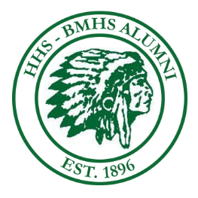

Howe High/Billerica Memorial High School 2020 Awards

 | NAME OF AWARD | AMOUNT | Number of scholarships | RESTRICTIONS
 | The Ann O'Neill Baraldi Memorial Award | $500.00 | 1 | Parent, Grandparent or Great-Grand Parent Alumni
 | The Robert and Heather Brown Family  Memorial Award | $500.00 | 1 | Parent, Grandparent or Great-Grand Parent Alumni and/or Athlete
 | The Mary-Jo O’Mahony Colburn Memorial Award | $500.00 | 1 | Teacher
 | The Sheila Russell Memorial Award | $500.00 | 1 | Athlete/ volleyball / track
 | The Grant H. and Roseanne Whiteway Memorial Award | $500.00 | 1 | Lacrosse or Athlete
 | The Billerica Memorial High School Award | $500.00 | 1 | None
 | The Howe High School Award | $500.00 | 1 | Parent, Grandparent or Great Grand Parent Alumni
 | Class of 1959 Scholarship Award | $500.00 | 1 | None
 | Karyn (Hansis) Marmiani Memorial Award | $500.00 | 1 | None
 | Ralph Brigham Memorial Award | $500.00 | 1 | None
 | BMHS In honor of the 50 year class 1970 | $500.00 | 1 | None
 | The Doug Dooley Award | $500.00 | # TBA | None

