Application Form

Please complete and return with a copy of their birth certificate to Little Acorns Pre-School, 140 Sidegate Lane, Ipswich IP4 4JD.

Our admissions policy is available on our website www.littleacorns-ipswich.org.uk

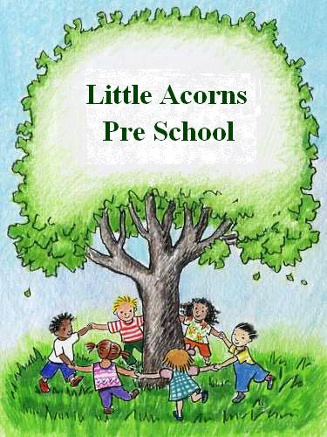

Child’s full name_________________________________ Date of Birth _____/_____/_______

Parent/Carers name______________________________ Relationship to child ______________________
Address____________________________________________

____________________________________________________

____________________________________________________

Home telephone __________________________

Mobile telephone _________________________

E-mail _____________________________________

You may be eligible for funding. Please refer to the information at www.childcare choices.gov.uk.

If your child has had their 2nd birthday and you believe they will be eligible for educational funding as a two year old please visit www.suffolk.gov.uk/two and apply now.

My reference number is AF________________

Alternatively please provide us with a copy of their ‘Golden Ticket’

If you child is currently 3 or 4 and you are eligible for the extended entitlement, please apply and provide us with your eligibility code from www.childcarechoices.gov.uk

My eligibility code is _________________________

Please indicate if any of these apply to your child:
Looked after Child  Adopted from Care  Special Guardianship or Residence Order 

When would you like your child to start at Little Acorns …………………………………………………
This can be any time after the child’s second birthday. If you are not eligible for funding you can pay for the sessions, however priority is given to funded children.

Privacy Notice

At little Acorns we take your privacy seriously and will only use the personal information on this form for the purpose of allocating a space for your child. Please tick the box to confirm you have read and
understood the above statement and agree to the privacy terms. 

A confirmation letter or E-mail is sent to confirm receipt of application, please allow six weeks before chasing.

By signing this form you understand that when it is a matter of safeguarding a child or vulnerable adult we may share information without your consent.

Parent/Guardian Signature_______________________ Date_________________________

Parents/Guardian Signature ______________________________________ Date _________________

To be completed by the Pre-School

Date application received ________________________________Confirmation sent__________________________

