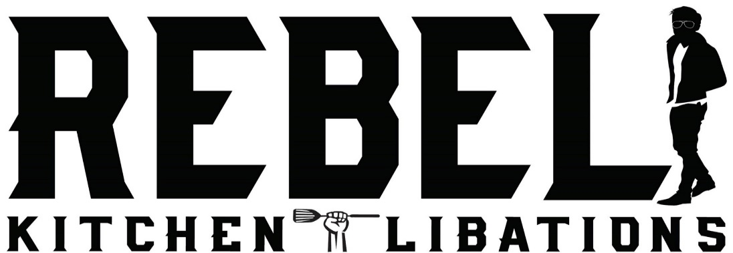

COCKTAIL AND WINE LIST
NETFLIX AND PILLOW TALK
Burnettes gin, apple brandy, lemon juice, house made vanilla simple syrup, egg white, lavender bitters 12

VIEUX CARRE
Rittenhouse rye whiskey, cognac, Carpano Antica, Benedictine liqueur, Peychaud bitters, Angostura bitters 12

BACON MAPLE OLD FASHIONED
Dickel bourbon, Proof bacon infused maple syrup, bitters 12

REBEL KNIGHT
Amaro Nonino, Aperol, Chivas Regal, lemon juice, rhubarb bitters 12

SURF AND TURF BLOODY MARY
Our own take on a bloody mary, topped with bacon, an angus slider, and jumbo black tiger prawn(takes about 10 min for your juicy
cooked slider) 14

MOJALISCO
Luna Azul 100% agave tequila, velvet falernum, cynar, fresh lime juice, ginger beer 12

WOODENVILLE RYE MANHATTAN
Woodenville 100% Rye Whiskey, Carpano Antica, angostura bitters, brandied cherry 12

YOU CAN’T HANDLE THE CHAR-TRUTH
Green Chartreuse, fresh lime juice, pistachio simply syrup, egg whites, dash of absinthe, garnished with lime wheel and candied pistachios 12

MANDARIN COSMOPOLITAN
Absolut Mandarin Vodka, triple sec, fresh squeezed lime juice, cranberry 12

KENTUCKY ROULETTE OLD FASHIONED
Bulliet Bourbon, simply syrup, angostura bitters 12

PEGU CLUB
Hendricks gin , Cointreau, lime juice, angostura bitters 12

WE CAN’T THINK OF A NAME YET
Pisco, St Germain, house made lychee simple syrup, fresh squeezed orange juice, garnished with lychee fruit 12

Wine List
Wente Southern Hills Cabernet Sauvignon $11 gls $38 btl
Folinari Chianti $9 gls $32 btl
Concannon Merlot $9 gls $33 btl
Wente Riva Ranch Chardonnay $12 gls $41 btl
Concannon Sauvignon Blanc $9 gls $33 btl
Cape Mentelle Rose, Austrailia $10 gls $37 btl
J Roget Brut Sparkling $8 gls $26 btl

