**Go to the MEVRS auction website**

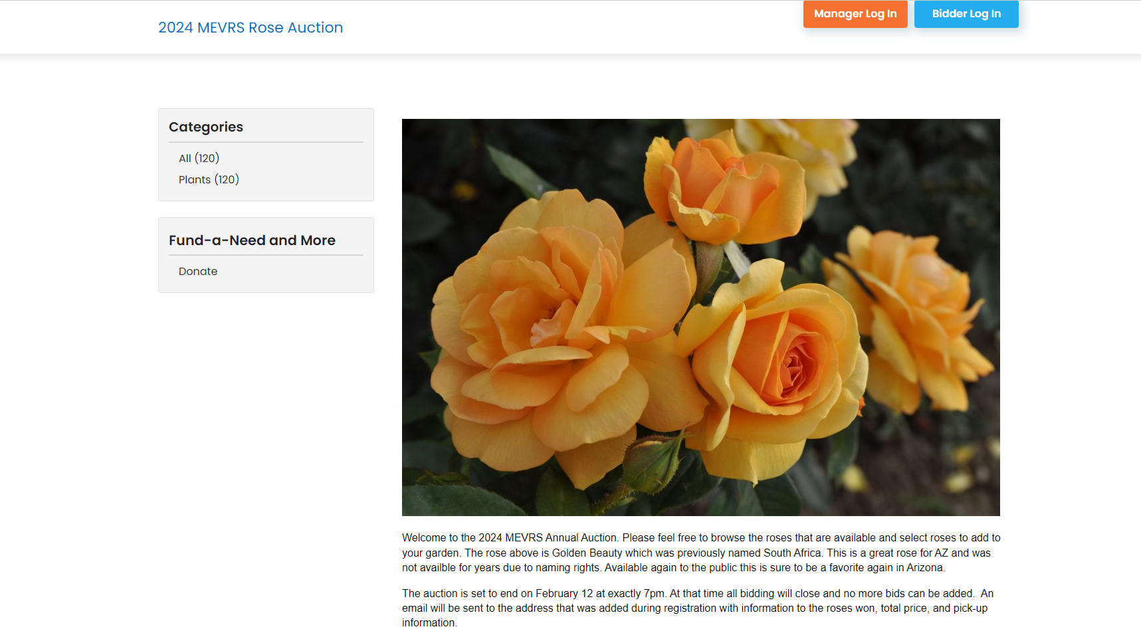

**Enter your email**

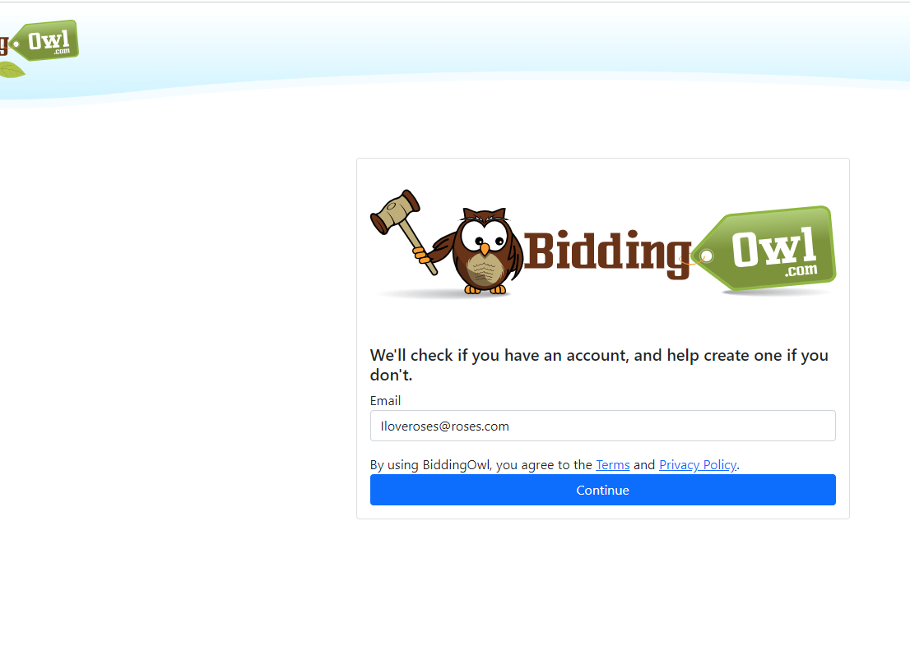

**Enter/ Create a Password**

* **If you were in the 2024 auction no further action is required**
* **New bidders please complete the following steps**

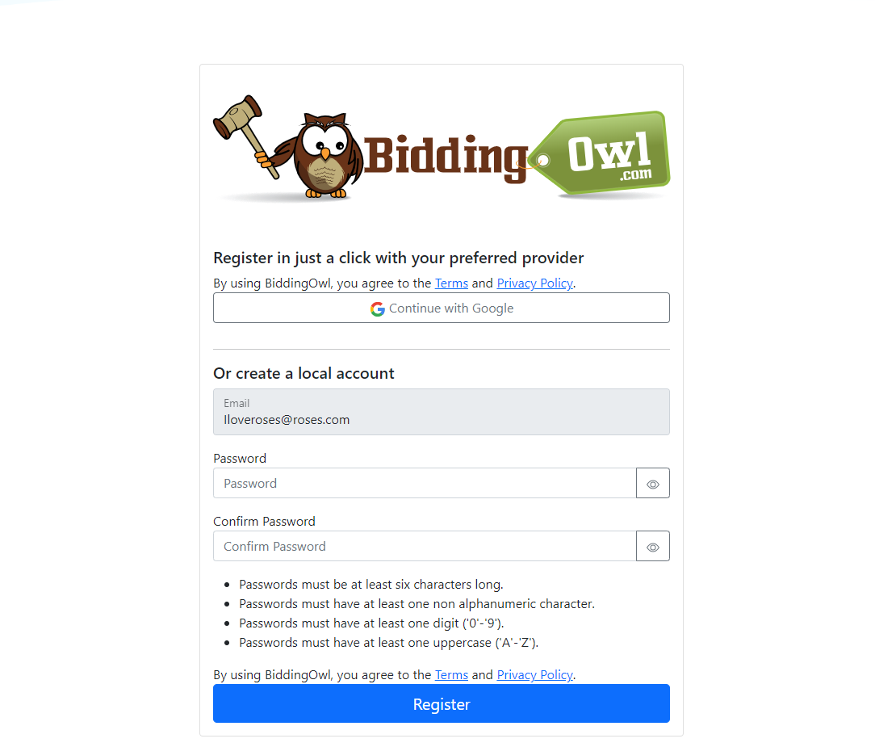

**Check your email and enter the code**

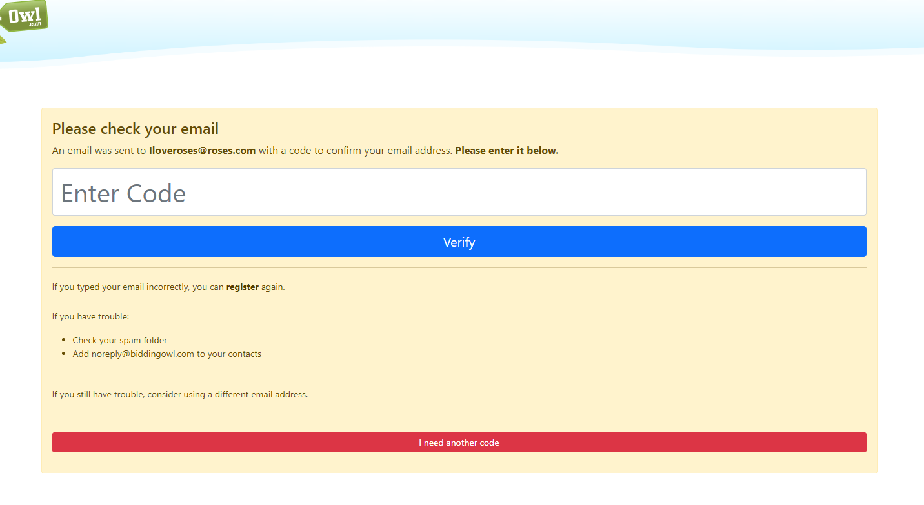

**Select Profile in the top corner to complete the contact information. This is necessary to complete the auction**

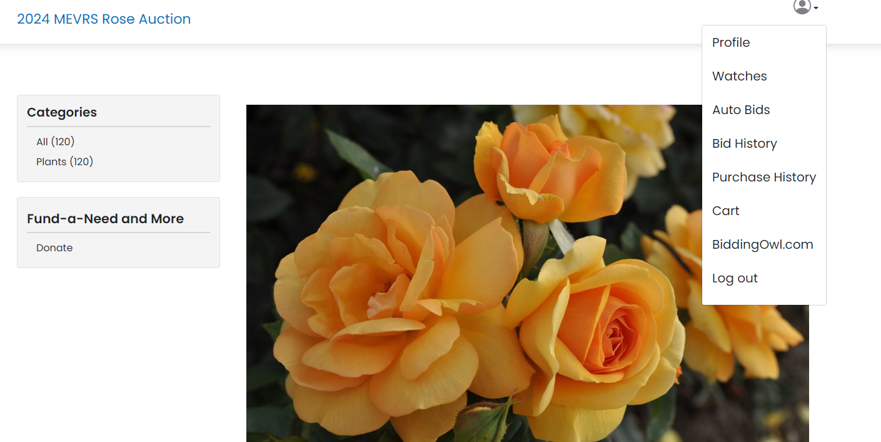

**Enter your information including your phone number so I can contact you at the end of the auction.**

