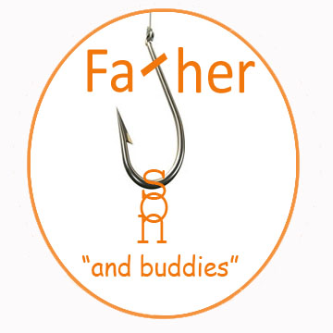
15TH Annual Shootout
Sunday May 5, 2024 10:00 AM
9:00 am Registration
Birds Landing Sporting Clays, 2099 Collinsville Rd, Birds Landing Ca
ADULTS $ 85.00 Juniors (17 & under) $45.00
Entry fee includes: 100 rounds of Sporting Clays, Lunch and drinks after the shoot. You must provide your own ammo, eye and ear protection
THERE WILL BE A RAFFLE WITH LOTS OF GREAT PRIZES
NAME _________________________________________________
ADDRESS_______________________________________________
PHONE_______________________________
EMAIL ________________________________________
Please Squad Me With ____________________ _________________________
____________________ _________________________
Adult ____ 85. OR Junior ___ $45. Checks payable to : Father Son & Buddies
I recognize that by voluntarily participating in this event, I will assume certain risks and that it is impractical and unfair for Father Son and Buddies Inc a California non- profit corporation or its officers , directors, members or agents to be financially responsible for any personal injury or property damage I may incur in connection with my participation. Therefore in consideration for permitting me to participate in this event I hereby release Father Son and Buddies Inc., its officers , directors, members, or agents of and from any and all claims , actions or causes of actions arising under the laws of the United States, or any state thereof ,which I or my heirs or assigns may hereafter have reason of any injury or damage I may suffer, directly or indirectly, whether by reason of negligence or otherwise, during my participation in this event. I further assume all risks which may be involved from my participation in this event.
SIGNATURE _____________________________________________
PARENT OR GUARDIAN for JUNIORS _________________________________
MAIL ENTRIES TO:
Father Son &Buddies, PO BOX 43 Dixon CA 95620

