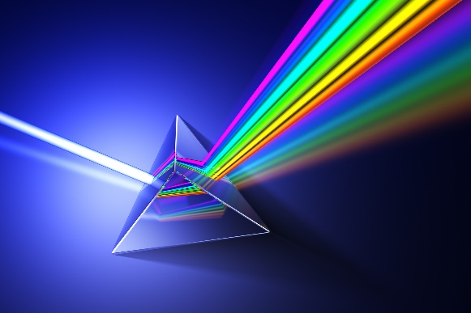
Advanced Aesthetic Laser Training

2000 Plymouth Road

Minnetonka, MN 55305
Phone: 952-248-0248 (Barb)

Class dates are scheduled as needed.

Class hours vary: Training is a total of 4 weeks MINIMUM-first week Didactics, last 4 hands on
Thurs-Sat 9am-3pm NCLC Certification – 4 weeks

Topics to be covered:

LASER PHYSICS, SKIN/LASER INTERACTIONS, LASER SAFETY,
LASER HAIR REMOVAL, LASER RESURFACING - ABLATIVE & NON ABLATIVE, RF MICRONEEDLING SKIN TIGHTENING, MICRO NEEDLING, RF RESURFACING, TATTOO REMOVAL, IPL PHOTO REJUVENATION, LASER HAIR REMOVAL & MORE!

Class space is limited to 6 people max*. Must have registration in 2 weeks prior to class start date.

$500. Non-refundable deposit at registration to be used towards $6000 tuition.

Payment Methods:

Option #1: Full balance due 1 week prior to class start date.
Option #2: Make Monthly payments interest Free to pay in full PRIOR to Start of Class.

*YOU MUST PAY $500.00 DEPOSIT IN ORDER TO GUARANTEE YOUR SPOT IN CLASS.

Educator:
Barbara Baruth, CLT, LCM, LCI, CLSO
Licensed Cosmetologist (30+ years experience)
Certified Laser Safety Officer (20+ years experience)

