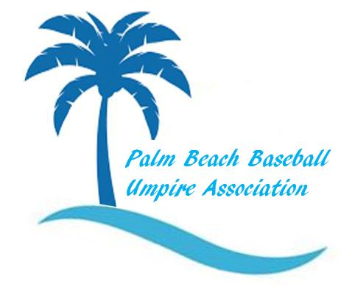
OFFICIAL’S NAME PLATE OR BASE REPORT FILLED OUT BY
ARBITER GAME # OR DATE & LOCATION OF GAME

SCALE: 1=Good 2=Average 3=Needs Improvement N/A=Not applicable

PROFESSIONALISM | GAME CONTROL | JUDGMENT | TIMING | MECHANICS

APPEARANCE | ATTITUDE | RULES  KNOWLEDGE | STRIKE ZONE | HUSTLE

NOTES

