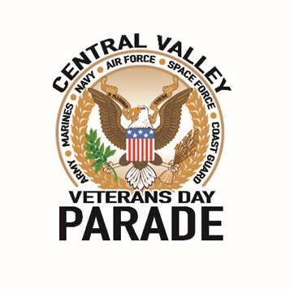

103rd CENTRAL VALLEY VETERANS DAY PARADE

WEDNESDAY, NOVEMBER 11, 2022

*NAME Of Organization________________________________________

*NAME OF POINT OF CONTACT:______________________________________ ______________________________________
Print Signature
Your signature signifies that you and all persons participating under your entry that you enter this parade at your own risk and hold the Central Valley Veterans Day Parade AKA Fresno Veterans Day Parade Committee, Inc, and the City of Fresno, California free of any responsibility or liability.

*PHONE:__________________________________________

* E-MAIL:___________________________________________________________________ Branch of service _________________________
ENTRY CLASSIFICATION (CIRCLE ONE)
VETERANS ORGANIZATION GOVERNMENT
MILITARY, ACTIVE OR RESERVE NATIVE AMERICAN
LOCAL BUSINESS EQUESTRIAN (Scoopers MUST BE PROVIDED)
MARCHING BAND: COLLEGE HIGH SCHOOL MIDDLE SCHOOL (CIRCLE ONE) MOTORCYCLE/CAR CLUB
JROTC ROTC (CIRCLE ONE) FRATERNAL

PEOPLE : ________________________ VEHICLES:_______________________ HORSES: _____________________

*NARRATIVE: Please write a short description of your group or unit to be read by the Master of Ceremonies and for the television and news media. Please keep it short (75 words)
*PLEASE SUBMIT PROOF OF INSURANCE FOR ALL VEHICLES IN THE PARADE OR YOUR ORGANIZATION’S “BLANKET INSURANCE” CARD
*Due to the high cost of operation, please submit a non-refundable donation of $100 per entry.
****Make checks payable to Fresno Veterans Day Parade. To be more inclusive, The Fresno Veterans Day Parade is doing business as Central Valley Veterans Day Parade
*All school entries (ROTC/Marching bands/single vehicles) suggested donation of $50 minimum.
ALL INFORMATION MUST BE SUBMITTED ALL TOGETHER (ENTRY FORM, NARRATIVE, DONATION, AND PROOF OF INSURANCE) Via email, mail, or in person. You will receive a confirmation email when your application is received.
PO Box 1685
Clovis, CA 93613
centralvalleyvdp@cvvdp.com
*Deadline October 14th for all completed applications
PLEASE READ CAREFULLY AND INITIAL EACH STATEMENT:
Please Initial to Show Understanding of Parade Rules
1. NO THROWING OF CANDY OR ANY OTHER ITEMS ALONG PARADE ROUTE.__________
2. ARRIVE IN YOUR STAGING AREA AT THE PRESCRIBED TIME.__________
3. STICK TO THE NUMBER OF CARS/PEOPLE. UPDATE PARADE WITH ANY CHANGES.__________
4. FOLLOW YOUR PACERS SO THERE ARE NO GAPS.__________
5. NO REVVING OF CARS OR MOTORCYCLES in front of Grandstands.__________
6. NO PEELING OUT OR SCREECHING TIRES (burning rubber) throughout parade route.______________
7. MUST ATTEND REQUIRED MEETING, ( 6PM AT THE CVMD). MUST PICK UP YOUR CVVDP PACKET AT THE LAST REQUIRED MEETING OR MAKE ARRANGEMENTS WITH PARADE OFFICIAL. NO PACKETS WILL BE HANDED OUT THE DAY OF THE PARADE UNLESS YOU ARE COMING FROM OUT OF TOWN AND MAKE ARRANGEMENTS.__________
8. IF YOU ARE AN INDIVIDUAL THAT WOULD LIKE TO ENTER INDIVIDUALLY, YOU MUST SUBMIT A LETTER FROM YOUR ORGANIZATION, WITH APPROVAL, IF USING ORGANIZATION LOGO._________

