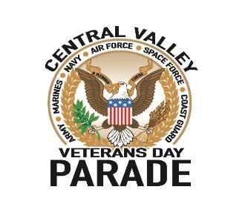
SPONSORSHIP LEVELS
Official Sponsor
- Name and logo are added on to all Parade correspondence along with the words “Official Sponsor”.
- Logo will be printed on the parade banner behind the announcers.
- The Official Sponsor will be granted the right to use the words “Official Sponsor of the
Central Valley Veterans Day Parade on their marketing material.
- Your logo will be displayed on all of our marketing material including, website and Facebook.
- Name and logo are added on to all Parade correspondence along with the words “Official Sponsor”.
- The name and the logo of the Official Sponsor will be added to the 1,000+ parade posters and direct mail flyers,
- Official Sponsor will be mentioned numerous times throughout the course of the parade at various times by the announcers.
- Provided 8 seats on the Grandstand with the dignitaries and will be announced during the opening ceremonies and will be given a brief interview by the televised parade announcers.
- Parade entry fee waived, and entry will be given priority to be in Division 1.
- Logo will be displayed on all division signs.
- Acknowledgement at the parade meetings, radio / TV interviews, and meetings with city officials.
- Commemorative gift will be presented.
Diamond Patriot Sponsorship Level - $10,000
- Name and logo are added on to all Parade correspondence along with the words “Major Sponsor”.
- Logo will be printed on the parade banner behind the announcers.
- Provided 5 seats on the Grandstand with the dignitaries, will be announced during the opening ceremonies and will be given a brief interview by the televised parade announcers.
- Parade entry fee waived, and entry will be given priority to be in leading Divisions .
- Acknowledgement at the parade meetings.
- Commemorative gift will be presented.
Platinum Patriot Sponsorship level - $5,000
- Platinum/Corporate Sponsors name/logo will be printed on the parade banner.
- Platinum/Corporate Sponsors will be mentioned throughout the course of the parade at various times by the announcers.
- Provided 3 seats on the Grandstand with the dignitaries and will be announced during the opening ceremonies.
- Parade entry will be given priority to be one of the leading Divisions .
- Acknowledgement at the parade meetings.
- Commemorative gift will be presented.

Gold Patriot Sponsorship Level - $3,000
- Sponsor’s logo will be printed on the parade banner.
- Gold Sponsors will be mentioned throughout the course of the parade at various times by the announcers.
- Provided 2 seats on the Grandstand with the dignitaries and will be announced during the opening ceremonies.
- Acknowledgement at the parade meetings.
- Commemorative gift will be presented.
Silver Patriot Sponsorship Level - $1,000
- Sponsor’s logo will be printed along the bottom on the parade banner.
- Silver Sponsors will be thanked by the announcers during the parade.
- Acknowledgement at the parade meetings.
- Commemorative gift will be presented.
Bronze Patriot Sponsorship Level - $500
- Acknowledgement at the parade meetings
- Bronze Sponsors will be thanked by the announcers during the parade.
- Commemorative gift will be presented.

