Wyomissing Hills Swimming Assoc.
March 2021
Welcome Back!

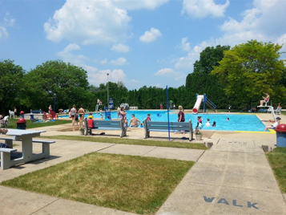
- Welcome back Wyomissing Hills Swimming Association members and we thank you for a safe and fun 2020 summer last season! We look forward to seeing our current members real soon and can’t wait to welcome our new ones, so think summer!
- As with last summer, any updated COVID guidelines, if needed, will be communicated as soon as we receive them.

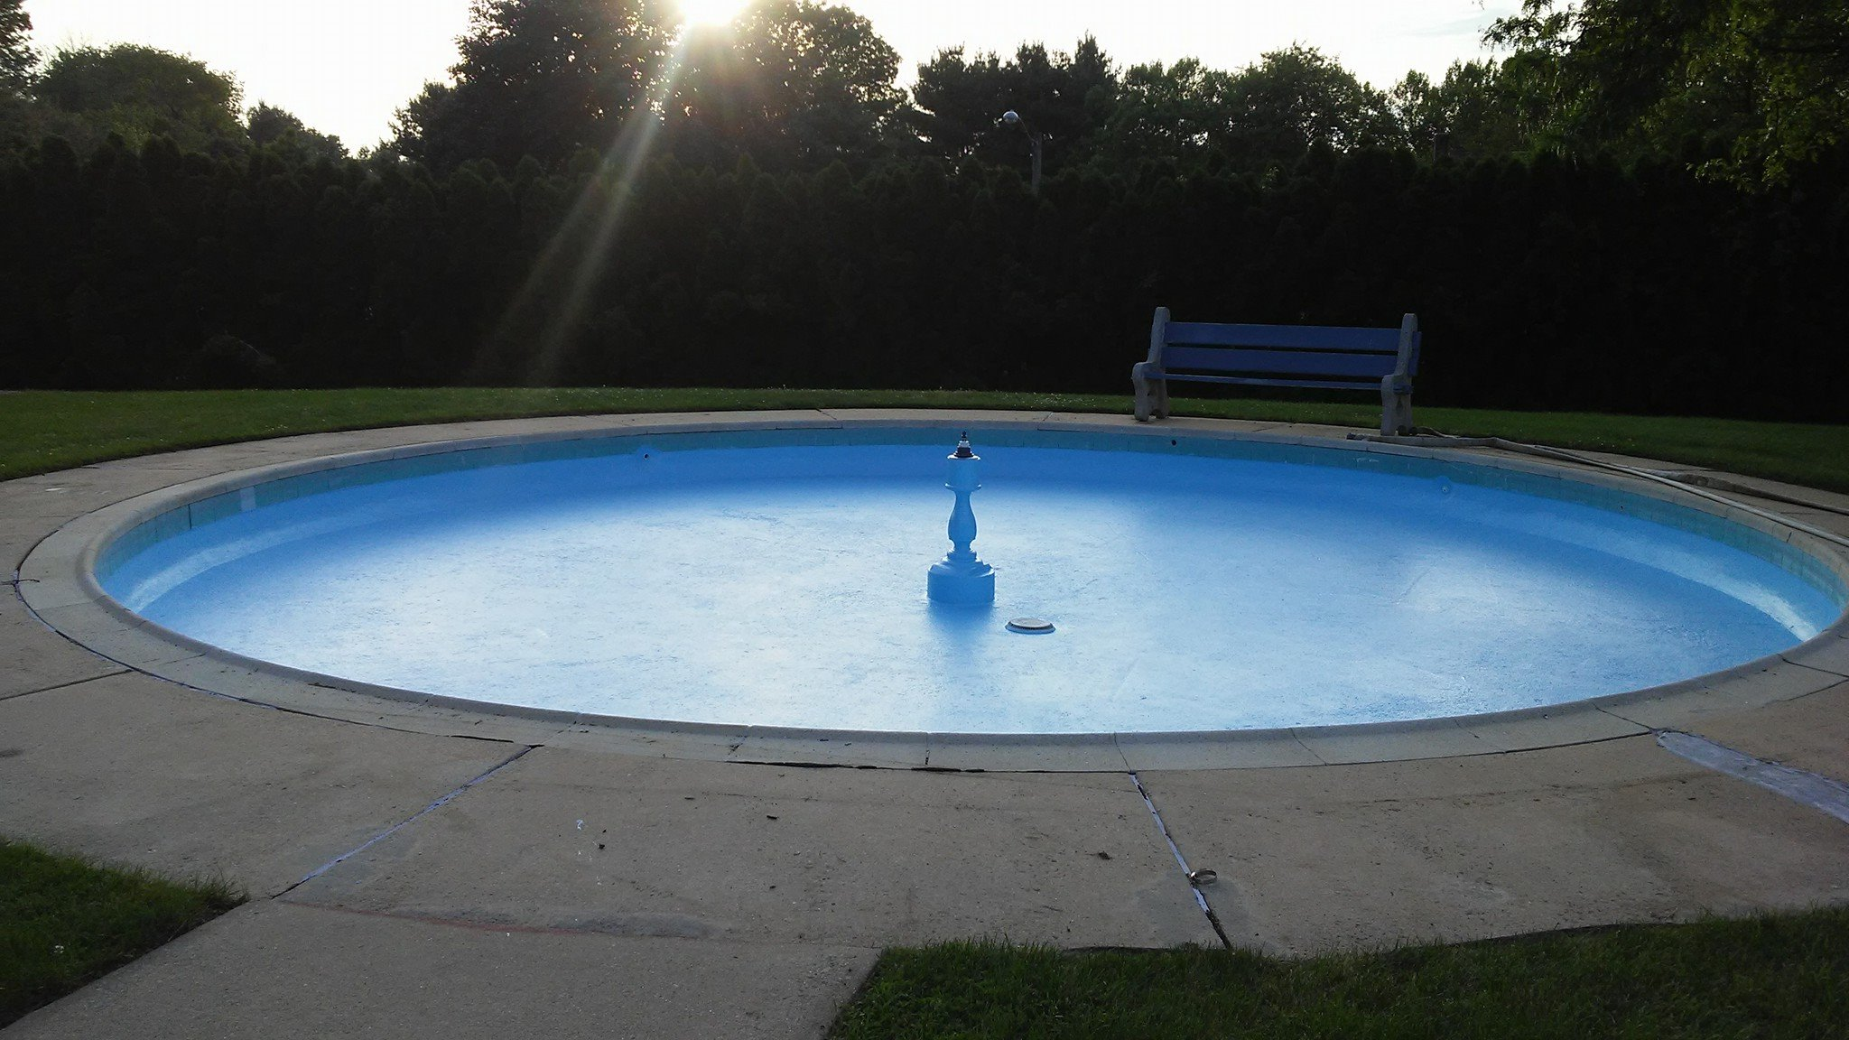
Help Wanted!
- We are currently hiring lifeguards! Please send an email to info@wyomissinghillspool.com for more information.
- Guest Reminder: guests can only visit the pool 5 times per season before becoming a member. Please remember you must be present when your guests arrive and they must sit with you while at the pool.
Half Price Stock Options are back!
- Now through April 30th there will be a half- price stock sale for new members! Tell your neighbors and friends who aren't members to join the fun at the Wyomissing Hills Pool!!! Contact Bev Cummings at Bev@kpsnet.com or Nancee Wenzel, wenzel2014@comcast.net, for more details.
- Due to an increase in memberships in 2020, new memberships are available however they are limited, so contact us soon!
- Looking for a fun and affordable way to have a birthday party or family picnic this summer? Rent the pavilion for your pool party. Details and rental forms are available at the pool office.
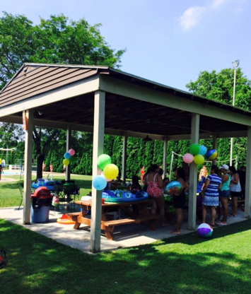

Wyomissing Hills Swim Team

- Coach Nancee and assistant coach Rylee are excited to coach another fun and promising season for the Wyomissing Hills Swim Team! Details will be announced after the Spring BCSA meeting. We will also once again be offering swim lessons for our new swimmers this summer. Details regarding Swim Team and lessons will be posted on the board in the breezeway beginning opening day.

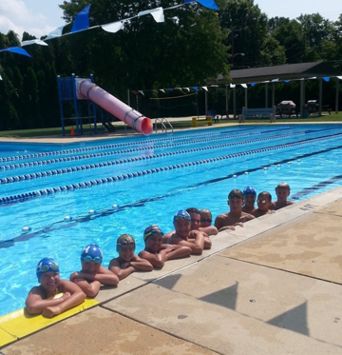
Pool Service Days & Support
- The Wyomissing Hills Swimming Association needs your help to get our pool in “mid-summer form” for the start of the swim season. On Sunday, April 11th and April 18th at 9:00 a.m. we will be cleaning up and pressure washing the pool to prepare to put on a fresh coat of surface paint. Please come dressed to work and bring any extra push brooms, lawn tools to use, and any cleaning supplies and/or paper products you’d like to donate for our starter supply. Dates and times for maintenance days for all of our events will be posted on Facebook. If you are on Facebook please email us at info@wyomissinghillspool.com for future updates.

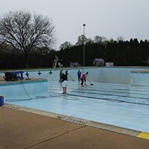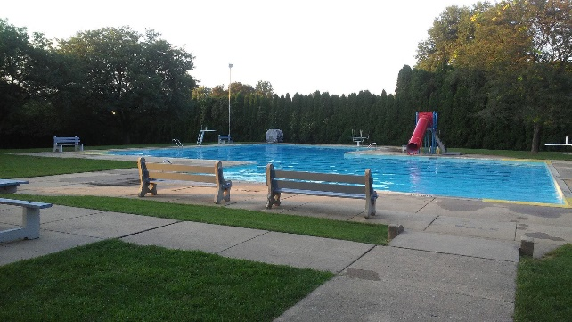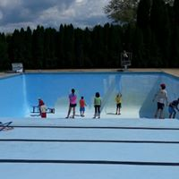
Reminder to all stock holders
- Just a reminder of the Wyomissing Hills Swimming Association’s bylaws regarding your stock: As per article IV, a membership is suspended if dues are not paid 30 days prior to the opening of the pool. If a stockholder notifies the Board of Directors 90 days prior to the opening of the pool of his/her intention not to be a member that year, the Board of Directors may allow the shareholder to retain his/her stock, provided that in no event shall any one stockholder be allowed to do the same for more than one (1) out of five (5) years. A $25 maintenance fee will be charged to all members. This fee can be refunded if you spend 4 hours helping to get the pool ready to open or help with projects throughout the season or refer a new member. Please contact Bev Cummings at bev@kpsnet.com with any questions about this policy.

- Stay up to date with your Wyomissing Hills news by following or subscribing to our media outlets:
  - Follow us on at ww.facebook.com/Wyomissing-Hills-Pool
  - Stop by to visit our website at: https://wyomissinghillspool.com/
  - For up to the minute weather closures and special announcements text the word Hillspool to 84483. This is a FREE text service we use through RainedOut to get information out fast!

- We look forward to and welcome spending another fun-filled summer with you and your families. Think Summer!!
The Wyomissing Hills Pool Directors

