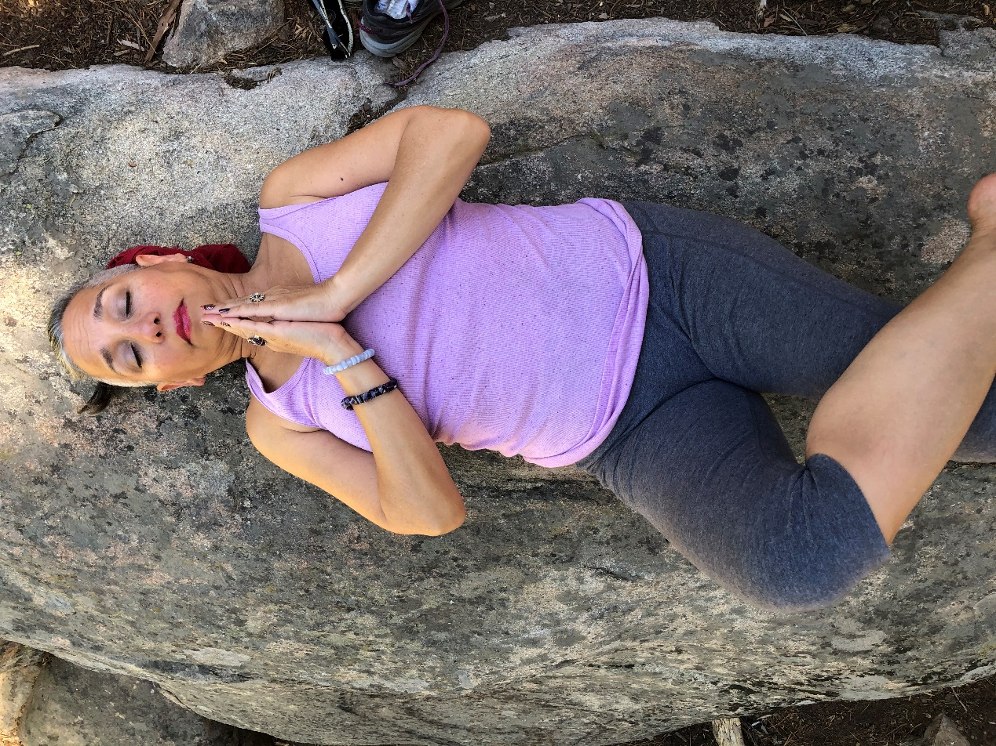

Sequoia National Park, CA 2020

Get into a comfortable position. Preferably outdoors, on grass or sand. NO SHOES to ground yourself. If you prefer to lie down, support your arms with pillows and cushions if desired  
  
Hold each position for 2-20 minutes. Breathe 4 breathes in every position to achieve 36 breaths. See 36 Breathes document.

In this exercise, the right hand will remain on top of the head until the last hold when it moves to the coccyx (dot not shown in picture).

**R1 - Place Right Hand/Fingers on Top of Head**

Maintain this position until you reach L7.

**L1 - Place Left Fingers between Eyebrows**

The Vital Force of Total Being. Revitalizes the deep energy circulation, improves memory, dissipates senility, harmonizes the pituitary gland and the pineal gland, controls blood pressure.  
  
**L2 - Place Left Fingers on Tip of Nose**

Revitalizes superficial body energy circulation, releases tension in the pelvic girdle and reproductive organs.  
  
**L3 - Place Left Fingers on bottom of throat**

Revitalizes Thyroid and Parathyroid; helps with facial muscular problems, helps prevent heart attacks, strokes, etc. Regulates metabolism and maintains mental balance. Helps us adapt to our surroundings and situations.  
  
**L4 - Place Left Fingers between Breasts on Sternum**

Revitalizes the immune system for the prevention of cancer, AIDS, etc. Assists in child growth and mental development. Governs reproduction, generative and regenerative functions. Relieves nausea and anxiety. Assists with breathing.  
  
**L5 - Place Left Fingers at Base of Sternum**

The Controller of Human Destiny. Revitalizes the energy path of the spleen and the adrenals, assists in the secretion of digestive juices and hormones. Gateway to the solar energy system revitalizing the nervous system. Prevents diabetes.  
  
**L6 - Place Left Fingers about an Inch above the Belly Button**

Revitalizes abdominal muscle tone and intestinal function.  
  
**L7 – Place Left Fingers on Pubic Bone**

Revitalizes the descending energy (down the front). Helps strengthen the spine. (**Continue to hold L7 when moving to R2, below**).  
  
**R2 - Right Hand moves to Base of Spine (Coccyx).** Revitalizes the ascending energy (up the back), helps circulation in the legs and feet, helps cold and clammy hands and feet. Alleviates menstrual cramps. (Hold R2 with L7). Dot not shown in picture.