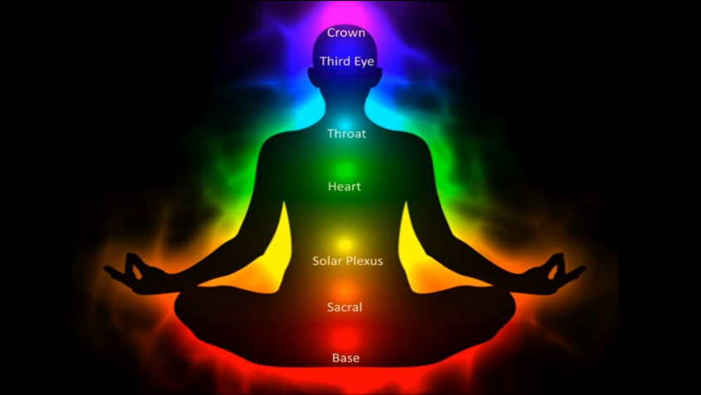
In Sanskrit, “chakra” means wheel of light. Chakras act like energy transformers, either stepping up or stepping down energy. They exist in the aura or Auric Dimension.
There are seven main chakras. They are located on the top of the head (7), middle of the forehead (6), throat (5), heart (4), solar plexus (3), lower belly (2) and between the legs (1). These chakras open up from points along a central energy current that runs along the spine, both on the back and front of the body. There are also numerous smaller chakras located all over the body including individual chakras in the joints, organs, hands and bottoms of the feet.
Chakras are shaped like a wheel, vortex or funnel. When functioning optimally, they spin clockwise and when less than optimal, they might spin counter clockwise or not at all. Each of the major chakras is associated with an endocrine gland. They also hold an emotional and physiological aspect of health.
The chakra’s job is to receive energy from the Universal Energy Field (the energy all around us) and nourish a particular area of the body. Each chakra holds and is activated by a frequency. The highest frequencies are found in the 7th, 6th and 5th chakras. These chakras are associated with spirituality. The lowest frequencies can be found in the 1st, 2nd, and 3rd chakras which are associated with our physical being. The heart, located at the 4th, chakra serves as the bridge between the spiritual or higher chakras and the physical or lower chakras. A particular color and sound (frequency) is also associated with each major chakra.

