HSV Citizens Police Academy Alumni Assn

9th Annual National Police Week

Golf Scramble Fundraiser

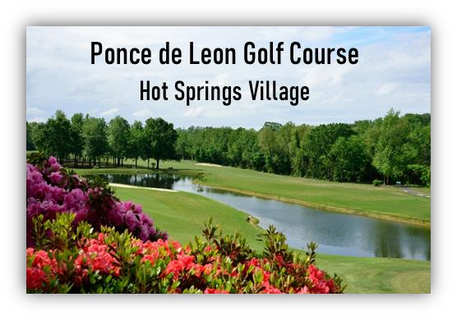
Monday – May 11, 2026

9:00 AM: Check In
10:30 AM: Shotgun Start
3:30 PM: Mulligan’s At Ponce
Awards & Dinner
Live Auction @Dinner (check, credit cards, cash)
Split the Pot 50 / 25-15- 10 (cash only)

$135.00 Per Person Package Pay for Play
- Team Awards for Each Flight Winner
- Win a $500 Cash Hole-In One Contest Chiefs Advantage: Move Up On Hole #17 ($20/Team)
- Win a Motorcycle Hole-In-One Contest Additional String ($5.00/ea.-sold throughout the event)
- Win a Golf Cart Hole-In-One Contest Additional Mulligans ($5.00/ea.-sold throughout the event)
- Tournament Gift
- Lunch & Dinner (Mulligan’s At Ponce

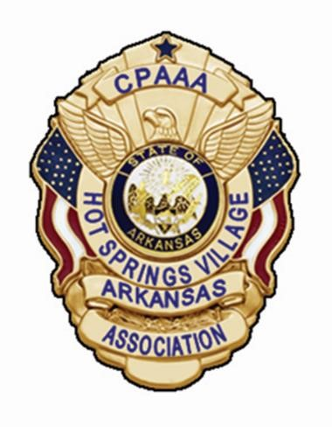

Supporting Law Enforcement
Download Registration Form at www.HSVCPAAA.com
Questions? Call Jim (708) 728-5172 or Mike (501) 282-4176
No Refunds or Rain Date

