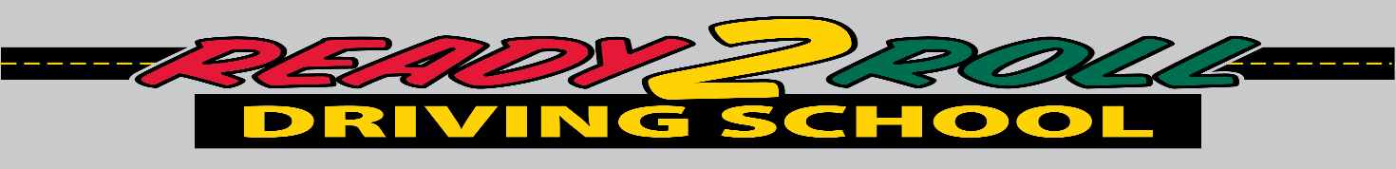**Student Registration Form**

*Ready 2 Roll Driving School – 183A Wakefield St – Rochester, NH 03867 (603)507-1805*

*Name: ________________________________________________________________________*

*Last First Full Middle Name*

*Date of Birth: ____________________ NH Students must have reached the age of 15 years 9 months by the first class.*

*Street Address: _________________________________________________________________*

*Town: ____________________________________ State: ___________ Zip: _____________*

*Mailing Address: ________________________________________________________________*

*Town: ____________________________________ State: ____________ Zip: _____________*

*Home Phone: _____________________ Parent’s Work Phone: __________________*

*Does the student have any mental, physical, medical or specific learning style that Ready 2 Roll Driving School should be aware of? NO ______ Yes _____*

*Has the student had any or is in on going court issues? No _____ Yes _____*

*If yes to any of the questions above please describe. All information will be kept confidential.*

*__________________________________________________________________________________________________________________________________________________________________________*

*Registration is on a first-come, first served basis.* ***A $200.00 non - refundable deposit is required at the time of registration*** *to hold the students’ place in the class. The remaining balance is due on the scheduled parent night.*

*Mail registrations to: Ready 2 Roll Driving School, 183A Wakefield St, Rochester, NH 03867*

***Please Specify Which Course You Would like To Be Enrolled In*** *__________________________________*

*Parent/ Legal Guardian Email_____________________________________________________________*

*Parent/Legal Guardian – Printed Name ____________________________________________________*

*Parent/ Legal Guardian - Signature ____________________________________________________*

***Thank you for choosing Ready 2 Roll Driving School, where the students always come first***