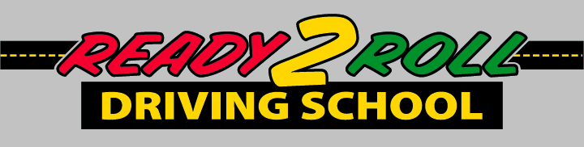Student Registration Form
Ready 2 Roll Driving School – 187 Wakefield St – Rochester, NH 03867 (603)335-3333

Name: ________________________________________________________________________
Last First Middle Name

Date of Birth: ____________________ NH Students must have reached the age of 15 years 9 months by the first class.

Street Address: _________________________________________________________________

Town: ____________________________________ State: ___________ Zip: _____________

Mailing Address: ________________________________________________________________

Town: ____________________________________ State: ____________ Zip: _____________

Home Phone: _____________________ Parent’s Work Phone: __________________
Does the student have any mental, physical, medical or specific learning style that Ready 2 Roll Driving School should be aware of? NO ______ Yes _____
Has the student had any or is in on going court issues? No _____ Yes _____
If yes to any of the questions above please describe. All information will be kept confidential.
__________________________________________________________________________________________________________________________________________________________________________

Registration is on a first-come, first served basis. A 100.00 deposit is due at registration. The remaining balance is due on the first night of class. If you need to cancel your place in the class, we ask that you provide a two-week notice, upon which your deposit will be refunded. If you cancel after that period, your $100.00 deposit will be forfeited.NO refunds will be given after the students has begun the course.,
Mail registrations to: Ready 2 Roll Driving School, 187 Wakefield St, Suite#2, Rochester, NH 03867

Please Specify Which Course You Would like To Be Enrolled In __________________________________

Parent/ Legal Guardian Email_____________________________________________________________

Parent/Legal Guardian – Printed Name ____________________________________________________

Parent/ Legal Guardian - Signature ____________________________________________________
Thank you for choosing Ready 2 Roll Driving School, where the students always come first

