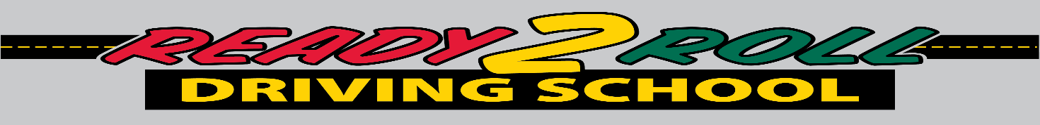Student Registration Form
Ready 2 Roll Driving School – 73 Pickering Rd, Unit 205 Rochester, NH 03839 (603) 507-1805

Name: ________________________________________________________________________
Last First Full Middle Name

Date of Birth: ____________________ NH Students must have reached the age of 15 years 9 months on or before the first class.

Street Address: _________________________________________________________________

Town: ____________________________________ State: ___________ Zip: _____________

Mailing Address: ________________________________________________________________

Town: ____________________________________ State: ____________ Zip: _____________

Home Phone: ________________________ Parent’s Work Phone: __________________
Does the student have any mental, physical, medical or specific learning style that Ready 2 Roll Driving School should be aware of? NO ______ Yes _____
Has the student had any or is in on going court issues? No _____ Yes _____
If yes to any of the questions above, please describe. All information will be kept confidential.
__________________________________________________________________________________________________________________________________________________________________________

Registration is on a first-come, first served basis. A $200.00 non-refundable deposit is required at the time of registration to hold the students’ place in the class. The remaining balance is due on the scheduled parent night.

Mail registrations to: Ready 2 Roll Driving School, 183A Wakefield St, Rochester, NH 03867

Please Specify Which Course You Would Like To Be Enrolled In__________________________________

Parent/ Legal Guardian Email_____________________________________________________________

Parent/Legal Guardian – Printed Name ____________________________________________________

Parent/ Legal Guardian - Signature ____________________________________________________
Thank you for choosing Ready 2 Roll Driving School, where the students always come first

