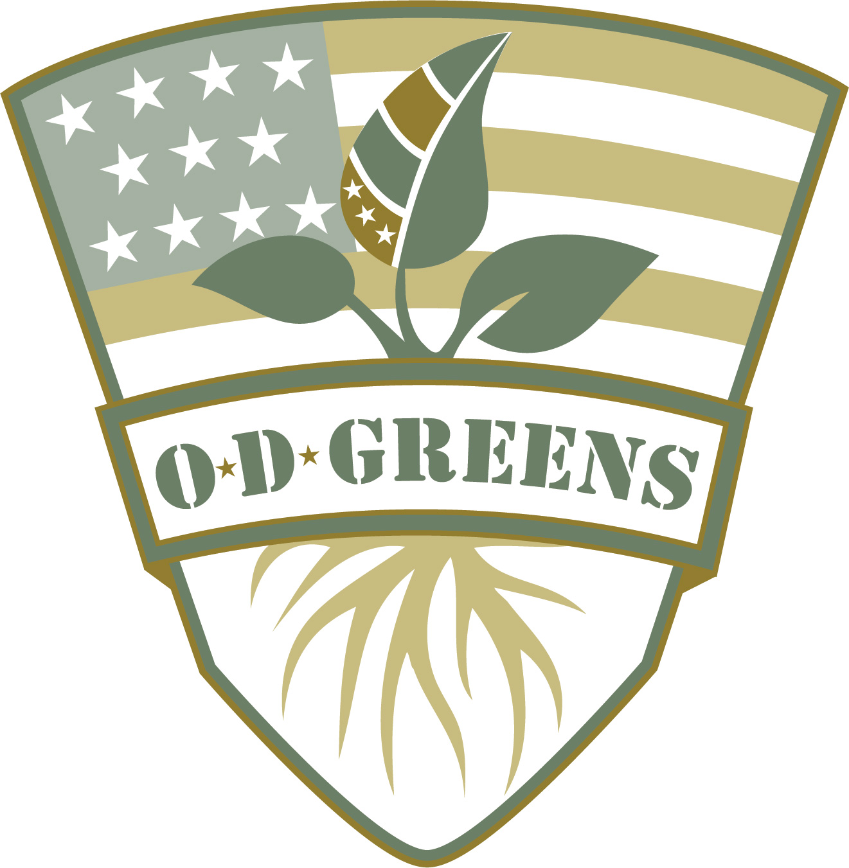

OD Greens LLC

6311 Cheryl Dr.

Painesville, OH 44077

ODGreens.com

ODGreensDon@gmail.com

440-251-0890 call or text

Community Supported Agriculture

**2019 Contract**

OD Greens LLC believes that healthy, civically engaged communities are a powerful force in the fights for fresh, healthy food and against hunger. Because of this, we have designed our products to strengthen the ties between people. Local agriculture offers not only a chance to grow local economies, but it also strengthens the bonds between people within communities. We believe that knowing the person who grows your food and where your food comes from should be an important part of the American lifestyle.

The Community Supported Agriculture (CSA) program is designed to support local, year- round small businesses and to provide nutritious, delicious greens and herbs to the Lake and Geauga county Community with 3-month, 6-month, and 1-year shares. We believe that even small programs can combat big problems in the world and we are very excited to invite you to embark on this adventure. And remember, that by purchasing produce from OD Greens YOU are helping to support training for disabled military veterans!

**About this CSA**

The OD Greens CSA will provide vertically grown, locally produced greens and herbs year-round, with some specialty items available throughout the year. (A tentative crop list is attached.) Our CSA is in its first year of operation. The CSA is harvested weekly, with share sizes expected to be around 1 – 2 lbs./week. Pickup, payment, and detailed share information is listed later in this document. CSA members accept both, the risks and rewards of farming when joining.

**Our Practices**

All of our products are grown locally within Willoughby, Ohio city limits using specialized growing techniques. Our farm uses towers in a vertical hydroponic system. All pest control is accomplished using OMRI (organic) certified controls and methods. We invite CSA members to come and learn about our farm and production techniques first hand on a Farm Tour, available for purchase at odgreens.com

**What’s New**

We are! As with anything, there will be growing pains along this learning process. We promise that we will do our best to communicate any issues with you along the way. Please do the same. If something needs to be done better or if you have a suggestion, please don’t hesitate to contact us!

Email: [ODGreensDon@gmail.com](mailto:ODGreensDon@gmail.com)

Call/Text: 440-251-0890

**Payment Policy**

We expect payment due in full when turning in the contract. This arrangement allows us to buy the seeds, transplants, and other inputs we need for the growing season, and pay their farm labor without waiting until harvest to generate revenue. The initial, CSA cycle will start around February 11th and will run year-round. Exact share size and products may vary slightly from week to week due to learning curve, timing, and conditions.

|  |
| --- |
| Each Share: 1-2 lbs/wk |
| 3 mo. (12 Weeks):  $180 ($15/week) |
| 6 mo. (24 Weeks):  $312 ($13/wk) |
| 1 year (48 weeks):  $528 ($11/wk) + a free Farm Tour |

**Pickup**

Produce will be available for pickup on Saturdays:

Willoughby from 10am-12pm

Mentor from 1-2pm

Painesville from 3-4pm

Members are responsible for picking up their own shares. If you or a friend are unable to pick up your share, it will be donated to a soup kitchen or a food bank.

**Locations**

Permanent pickup locations will be determined soon. You will be notified of the exact address your share will be picked up at.

Please note: Pick up days/times and locations are subject to change based upon demand and availability

**Contact Information**

Any questions or concerns regarding the OD Greens CSA program or CSA share should be directed to our email address:[ODGreensDon@gmail.com](mailto:ODGreensDon@gmail.com%20)  Please include “CSA” in the subject line. You may also contact us by phone/text at 440-251-0890. Thank you for supporting OD Greens, and disabled veterans!

**Agreement**

This contract establishes my participation with the OD Greens Community Supported Agriculture (CSA) program, I understand that this program is an experimental venture for OD Greens LLC, and that OD Greens LLC crops are susceptible to certain inherent risks (natural disaster, pests, unexpected crop failure, etc.) Thus, I understand that OD Greens cannot guarantee exact quantities, or selections, and by joining the OD Greens CSA I am acknowledging and accepting the consequences that those risks involve. I agree to pay the full amount of the CSA with the submission of this contract.

Checks can be made payable to : OD Greens LLC (Please write “CSA” in memo)

PayPal available on ODGreens.com

All information is confidential.

Signature:

Date:

Name (please print):

Address:

City:

Zip Code:

Phone:

Email:

|  |  |  |  |
| --- | --- | --- | --- |
| Each Share: 1-2 lbs/wk |  | Pick Up Location | Circle One |
| 3 mo. (12 Weeks):  $180 ($15/week) | Willoughby | Mentor | Painesville |
| 6 mo. (24 Weeks):  $312 ($13/week) | Willoughby | Mentor | Painesville |
| 1 year (48 weeks):  $528 ($11/week) + a free Farm Tour | Willoughby | Mentor | Painesville |

If you would like to grant permission for other individuals to pick up your produce, please

write their names, phone numbers, and e-mail below

**Crop List for the OD Greens CSA**

**Year-Round Greens and Herbs**

Greens

Herbs

**Arugula (Astro)**

A selection of regular arugula with less deeply lobed leaves and a slightly milder flavor. 

**Green Butter, Red Butter, Green Oakleaf, and Red Oakleaf**

These cored types increase the flavor, color, and overall elegance of a salad mix. One quick cut with a knife and heads easily fall into uniform, individual leaves

**Green Incised, Red Incised, Green Sweet Crisp, Red Sweet Crisp**

Romaine-like sweet flavor with iceberg-like crisp, crunchy texture. This collection will add not only great flavor, but will increase the loft and weight of a salad mix.

**New Red Fire**

Produces an impressive loose leaf head, excellent for the specialty market or gourmet restaurant. Crisp and sweet.

**Butterhead Lettuce**

Beautiful, large, dark red heads with nicely contrasting green centers. Excellent flavor and texture.

**Lemon Basil**

Sweet and tangy lemon basil. Very bright green, 2 1/2" long leaves with white blooms make this basil both attractive and intensely flavorful.

**Thai Basil**

Authentic Thai basil flavor. Try it as a flavorful garnish for sweet dishes. Green, 2" long leaves have a spicy, anise-clove flavor. Attractive purple stems and blooms. Called "Horapha" in its mother country. Edible Flowers: Use the flowers in any recipe that calls for basil, or to garnish drinks, salads, soups, pasta, and desserts. Intense flavor.

**Italian Large Leaf Basil**

Fragrant, flavorful, with extra-large leaves. This Genovese-type is essential for Neapolitan cuisine.