TRAINING UPPER BODY | Date Completed | Resting  HR/BP/BS | Sets/Reps | RPE  (1-10) | Cool Down  HR/BP/BS | Symptoms Or  Concerns
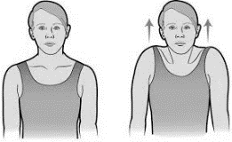
Shoulder Shrugs

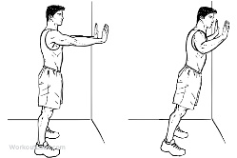
Wall Pushup
Tricep Dips
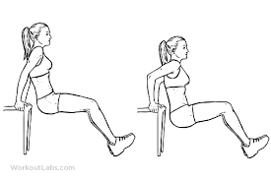
Shoulder Squeezes
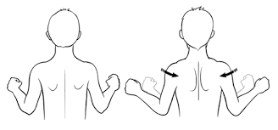

Progression:
WEEK 1-2
1 SET,10-15 repetitions
WEEK 2-3
2 SETS,10-15 repetitions
WEEK 3-4
3 SETS,10-15 repetitions
WEEK 4-5
Increase weight
1 SET,10-15 repetitions

Progress your resistance as you feel comfortable with the weight you started with and once the exercise becomes easy. Listen to your body, if you feel pain or discomfort with exercise, discontinue the exercise. Fatigue and mild soreness can be normal with resistance training.
For more information please visit the following link to our My Heart Fitness video which presents how to properly perform several exercises as well as guidelines to exercise safely:
https://myheartfitness.ca/resistance-training
TRAINING LOWER BODY | Date Completed | Resting  HR/BP/BS | Sets/Reps | RPE  (1-10) | Cool Down  HR/BP/BS | Symptoms or  Concerns
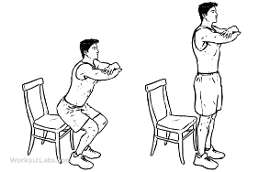
Squats

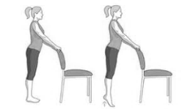
Calf Raises
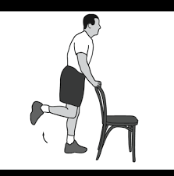
Hamstring Curls
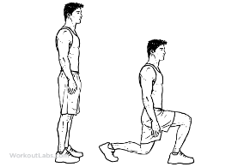
Lunges
TRAINING CORE | Date Completed | Resting  HR/BP/BS | Sets/Reps | RPE  (1-10) | Cool Down  HR/BP/BS | Symptoms or Concerns
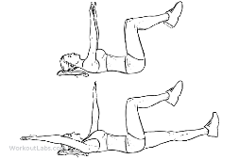
Dead Bug
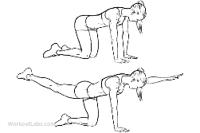
Bird Dog
10 Maximal Effort
Very Hard
Very, Very Hard
5
6
7
8
9

Rate of Perceived Effort
MY RPE Scale
- No effort
- Very light
- Light
- Moderate
- Some-what Hard

