TRAINING UPPER BODY | Date Completed | Resting  HR/BP/BS | Sets/Reps | RPE  (1-10) | Cool Down  HR/BP/BS | Symptoms or  Concerns
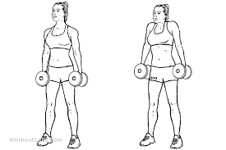
Shoulder Shrug

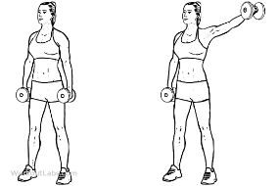
Lateral Shoulder Raise
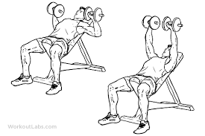
Chest Press
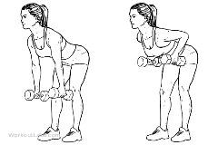
Back Rows
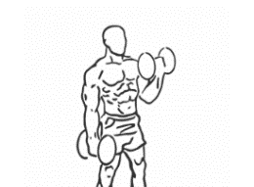
Bicep Curls
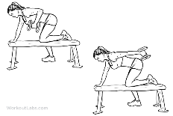
Tricep Extension
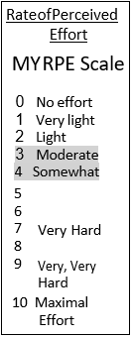
Progression:
WEEK 1-2
1 SET,10-15 repetitions
WEEK 2-3
2 SETS,10-15 repetitions
WEEK 3-4
3 SETS,10-15 repetitions
WEEK 4-5
Increase weight
1 SET,10-15 repetitions
Progress the number of repetitions with the weight you started with, as you feel comfortable. Once the resistance exercise becomes easy, progress the number of sets. Listen to you body. If you feel pain or discomfort with any exercise, discontinue the exercise. Fatigue and mild soreness can be normal with resistance training.
TRAINING LOWER BODY | Date Completed | Resting  HR/BP/BS | Sets/Reps | RPE  (1-10) | Cool Down  HR/BP/BS | Symptoms or  Concerns
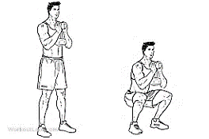
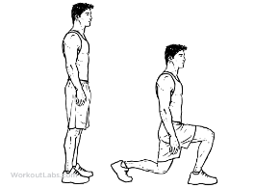
Squats

Calf Raises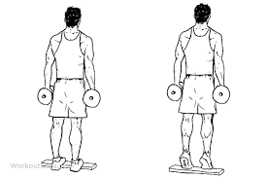
Hamstring Curls
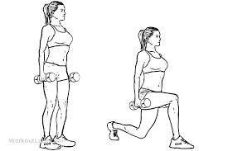
Lunges
TRAINING CORE | Date Completed | Resting  HR/BP/BS | Sets/Reps | RPE  (1-10) | Cool Down  HR/BP/BS | Symptoms or Concerns
Dead Bug
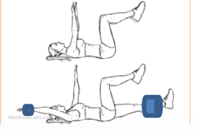
Bird Dog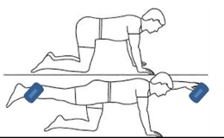

Progression:
WEEK 1-2
1 SET,10-15 repetitions
WEEK 2-3
2 SETS,10-15 repetitions
WEEK 3-4
3 SETS,10-15 repetitions
WEEK 4-5
Increase weight
1 SET,10-15 repetitions
Use this training log to record the resistance exercises you do. For more information, please visit the website link to the My Heart Fitness videos. You can follow along with the videos on your own with the guidelines to exercise safely:
https://myheartfitness.ca/resistance-training

