TRAINING UPPER BODY | TRAINING UPPER BODY | Date Completed | Resistance  (weight/band intensity) | Sets/Reps | RPE  (1-10) | Symptoms or  Concerns
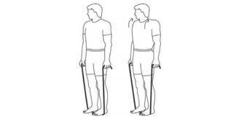  Shoulder Shrug | 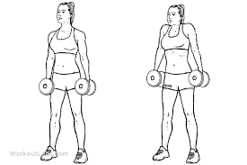  Shoulder Shrug
Lateral Shoulder Raise  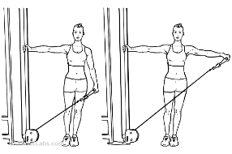 | 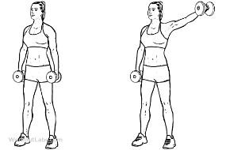  Lateral Shoulder Raise
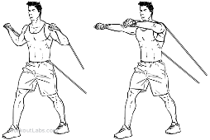  Chest Press | 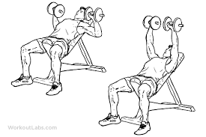  Chest Press
Back Rows  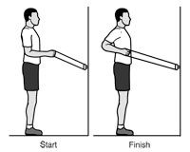 | 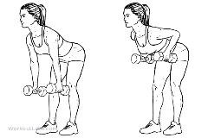  Back Rows
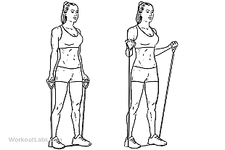  Bicep Curl | 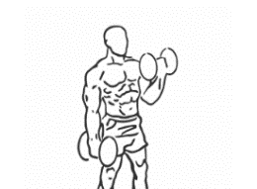  Bicep Curl
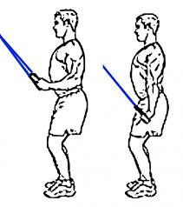  Tricep Extension | 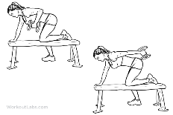  Tricep Extension
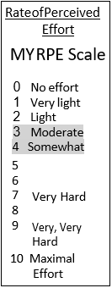

Progression:
WEEK 1-2
1 SET,10-15 repetitions
WEEK 2-3
2 SETS,10-15 repetitions
WEEK 3-4
3 SETS,10-15 repetitions
WEEK 4-5
Increase weight
1 SET,10-15 repetitions

Progress the number of repetitions with the weight you started with, as you feel comfortable. Once the resistance exercise becomes easy, progress the number of sets. Listen to your body. If you feel pain or discomfort with any exercise, discontinue the exercise. Fatigue and mild soreness can be normal with resistance training.

TRAINING LOWER BODY | TRAINING LOWER BODY | Date Completed | Resistance (Weight/band intensity) | Sets/Reps | RPE  (1-10) | Symptoms or  Concerns
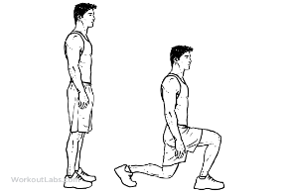  Squats  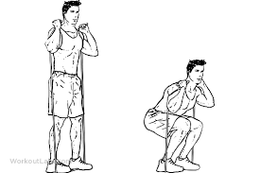 | 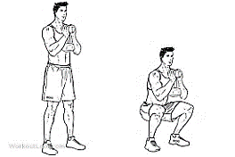  Squats
Calf Raises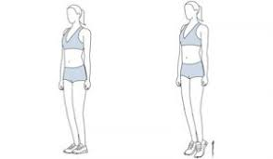 | Calf Raises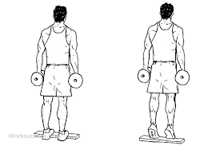
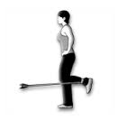  Hamstring Curls | Hamstring Curls
Lunges  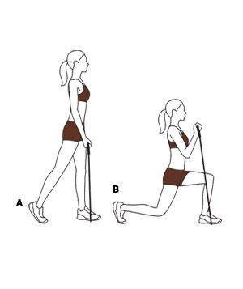 | 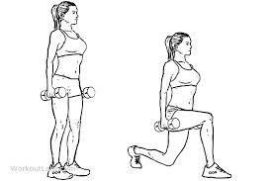  Lunges
TRAINING CORE | TRAINING CORE | Date Completed | Resistance (Weight/band intensity) | Sets/Reps | RPE  (1-10) | Symptoms or  Concerns
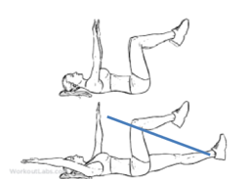  Dead Bug | Dead Bug  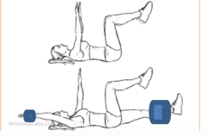
Bird Dog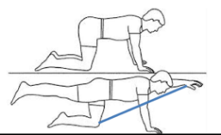  Use this training log to record the resistance exercises you do. For more information, please visit the website link to the My Heart Fitness videos. You can follow along with the videos on your own with the guidelines to exercise safely:  https://myheartfitness.ca/resistance-training | Bird Dog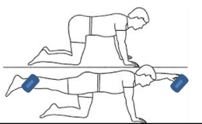

Progression:
WEEK 1-2
1 SET,10-15 repetitions
WEEK 2-3
2 SETS,10-15 repetitions
WEEK 3-4
3 SETS,10-15 repetitions
WEEK 4-5
Increase weight
1 SET,10-15 repetitions

