🏌️‍♂️ The Cathedral Cup Charity Golf Outing June 18, 2026
Presented by Knight of Columbus Council 17760
St. John the Baptist Cathedral Charleston, SC



Join us for a day of friendly competition, community spirit, and giving back all in support of a great cause! All proceeds support the Knight’s charities including Holy City Warming Shelter and Low Country Pregnancy Center.
📅 Date: June 18,2026 9 am check in and warm up on the driving range
📍 Venue: The Links at Stono Ferry Plantation. Hollywood, South Carolina
⏰ Time: 10 am shotgun start
Highlights Include:
- 18-hole scramble format
- Team & individual prizes
- Longest drive & closest to the pin contests
- Dinner & Awards
- $200 per player / $800 per team
- Includes green fees, cart, lunch & dinner
- Deadline: May 15,2026
Sponsorship Opportunities Available
Support a great cause while promoting your business!
Hole sponsors $200 per hole. Supply your company name and logo
Gold Sponsor $1,500 Includes 4 golfers and dinner plus a sponsor sign
Silver Sponsor. $1000. Includes 2 golfers and dinner plus a company sign

For more information or to register:
📞 Contact: Joe Shanahan 908-472-0470
📧 Email: Jshanahan331@gmail.com
🌐 Website: Knightsofcolumbus17760.org.
Checks Payable: Knights of Columbus – Mail to: Joe Shanahan-golf Chairman
1610 Indaba Way Charleston SC 29414

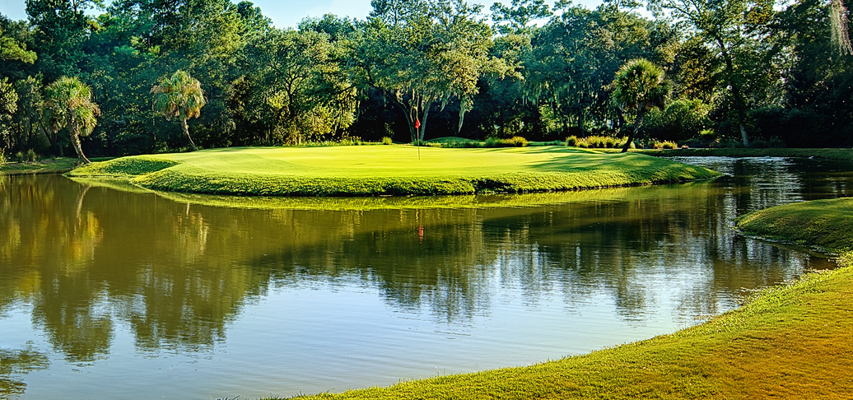
Team Name____________________________________________ email______________________________
Player 1________________________________________________ Cell_________________________
Player 2_________________________________________________ Cell_________________________

Player 3________________________________________________ Cell__________________________
Player 4________________________________________________ Cell___________________________


